Operation and Maintenance Documentation
INSTALLATION AND OPERATING MANUAL
WANAS Combo 430 V/H
WANAS Combo 630 V/H
WANAS Combo 830 V/H
WANAS Combo 1030 V/H
WANAS Combo 1330 H

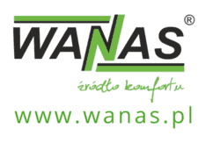
List of content
1. GENERAL 4
1.1. Purpose of the device 4
1.2. Delivery 4
1.3. Safety 5
1.4. Dimensions 7
1.5. Dimensions of Display V2 10
1.6. Characteristics 11
2. INSTALLATION 11
2.1. Installation of the device 11
2.2. Condensate drainage 12
2.3. Place of installation 13
2.3.1. Minimum access distances 14
2.4. Assembly positions 15
3. Controller operation 16
3.1. Description of the home screen view 16
3.1.1. Icons displayed on the screen 17
3.2. Interface functions (Main view) 18
3.2.1. Device Schedule Settings (“Programmes”) 18
3.2.2. „Party” mode 19
3.2.3. „Fireplace” mode 19
3.3. Main configuration menu (Settings) 19
4. Automatic settings – service menu 20
4.1. Setting: Gear I 21
4.2. Setting: Gear II 21
4.3. Setting:Gear III 22
4.4. Air power correction 22
4.5. Anti-freeze algorithm 23
4.5.1. temperature of the anti-freeze algorithm 23
4.6. Humidifier settings 24
4.7. Bypass settings 25
4.8. GHE Settings 25
4.9. Heating – cooling settings 27
4.9.1. Water exchanger 27
4.9.2. Freon exchanger 28
4.10. XF function settings 29
4.11. Ustawienia czas opóźnienia włączenia 3 biegu 30
4.12. EXTRA TEMP Additional sensor settings 30
4.13. Internet module settings 31
4.14. Temperature correction settings 32
4.15. Humidity sensor settings 32
4.16. Zone control settings 34
4.16.1. $CO2$ Operating algorithms 34
4.16.2. Activating the Zone Control Function 34
4.16.3. Adding $CO2$ sensors 35
4.17. ModbusRTU settings 35
4.18. Detail screen 36
5. Construction of an air-handling unit 38
6. Electrical diagrams 40
6.1. Wiring diagram for the Display V2 control board, part 1 40
6.2. Wiring diagram for the Display V2 control board, part 2 41
6.3. Wireing diagram of GEAR I or GEAR III 42
6.4. GHE circulation pomp connection diagram 42
6.5. Wiring diagram for the air intake selector tee 44
6.6. Wireing diagram of secondary heater 44
6.7. of water seconaday cooler connection 45
6.8. Connecting the secondary heater/cooler circulation pomp. 46
6.9. Connection of WANAS water heater/cooler with GHE 48
6.10. Connection of freon heater/cooler 49
6.11. Connection with Midea outside aggregate 50
6.12. Wiring diagram for connecting a zone damper to an air handling unit 51
6.13. Configuration of the actuator assembly for controlling a three-way valve. 52
6.14. Wiring diagram for the external temperature sensor 52
7. Modbus RTU 53
7.1. List of Modbus RTU registers 53
7.2. Data and hour settings 57
8. Problem-solving 60
8.1. Table of messages 60
9. Maintenance 61
9.1. Inspections and maintenance 61
9.2. Removal of the heat exchanger 61
10. Warranty and Service 63
10.1. Service 63
10.2. Warranty 63

GENERAL

Purpose of the device
A recuperator is used for ventilation of apartments, single-family houses, and offices. Fresh and filtered air is supplied to the rooms, the so-called "clean" rooms, living room, bedroom, and used air is extracted from the so-called "dirty" rooms, e.g. bathrooms, laundry rooms, kitchens, and wardrobes.
Continuous air exchange ensures better living comfort and removal of moisture from the building with simultaneous heat recovery.
The device is equipped with an automatic bypass used mainly in summer at night, where the supplied cool air does not pass through the exchanger but is supplied directly to the rooms, improving the comfort in the building.
As standard, each recuperator is equipped with a touch weekly controller. Using an additional module, the device can be connected to the Internet and controlled remotely. The design and manufacture of the product is based on harmonized standards.

If you intend to get rid of this product, do not dispose of it with normal household waste. According to the WEEE directive (Directive 2002/96/EC) in force in the European Union, separate methods of disposal must be used for used electrical and electronic equipment. The aim of the directive is to prevent the adverse effects of electronic waste on the environment through its collection, reuse, recycling and recovery. The appliance is marked with the symbol of a crossed-out wheelie bin, which serves as a reminder of the obligation to collect end-of-life equipment separately. For more information regarding the recycling of waste from this Product, please contact the municipal authorities in your area, with the appropriate waste disposal service. | 
The manufacturer declares that the product complies with the LVD 2006/95/EC Directive, relating to electrical devices operating within the specified voltage range. The product has been marked as a result of the conformity assessment procedure. | 

Delivery
Before installing the control unit, please ensure that all items in the kit are present.
If any of the following components are missing, please contact the retailer.
The kit should include: an air handling unit, a control panel, a MaxiControl humidity sensor, an evaporation mat in the humidifier, set of air filters, mounting brackets for the air handling uniti, screws for fixing the brackets to the wall, siphon.

Safety


The manufacturer waives any responsibility whatsoever for the damage resulting from improper installation and use of the product contrary to its intended use and this manual, and the resulting damage cannot be the basis for a complaint or warranty repairs.

- Installation of the device should be performed by appropriately qualified personnel.
- The device may only be operated by adults who have read the manual.
- It is forbidden to install the device in an installation without an efficient protective conductor and residual current device.
- It is forbidden to mount the controller below the recuperator.
- The electrical installation in which the device is connected must be equipped with overvoltage protection.
- The unit should be installed in a place where the temperature is between 5°C and 45°C. Too low ambient temperature may result in water vapour condensation on the casing of the device and, consequently, its failure.
- It is forbidden to turn on the device in the building where construction works are carried out.
- The siphon should be attached to the recuperator, it must not be damaged..
A damaged drain may lead to water leakage and flooding the unit. The room in which the device is located should be equipped with a drain in the floor. Do not place other electric and electronic devices under or in the immediate vicinity of the recuperator.

- Upon replacement of the filters, it is necessary to check that they are properly inserted and that the door is properly closed.
- Maintenance and filter replacement should be performed with the equipment disconnected from the 230 V mains.
- After maintenance work, always make sure that all drain and inlet valves are tight. Plumbing must be checked regularly.
- In the event of a water leak, stop using the device and disconnect it from the power supply. Subsequently, make sure to contact the Wanas customer service.
- The manufacturer bears no liability for damage caused by direct or indirect actions of people or animals, resulting from non-compliance with this manual, in particular the notes on installation, operation and maintenance of the device.

The control unit should operate continuously. Frequent switching off and restarting may accelerate wear and tear on components, particularly the fans.

Dimensions
Combo 430 | 630
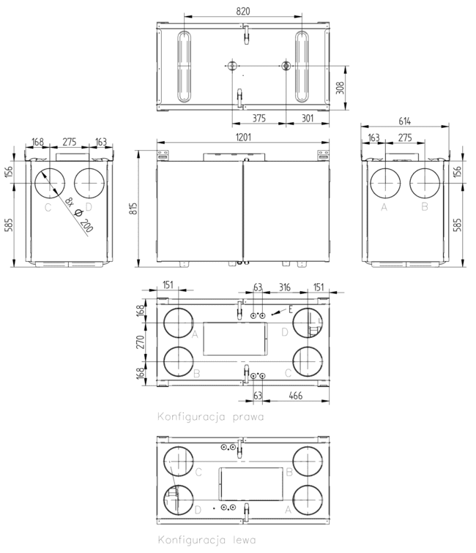
A-Air taken from outside of the building
B-Air taken from rooms
C-Air supplied to rooms
D-Air discharged outside the building

Combo 830 | 1030
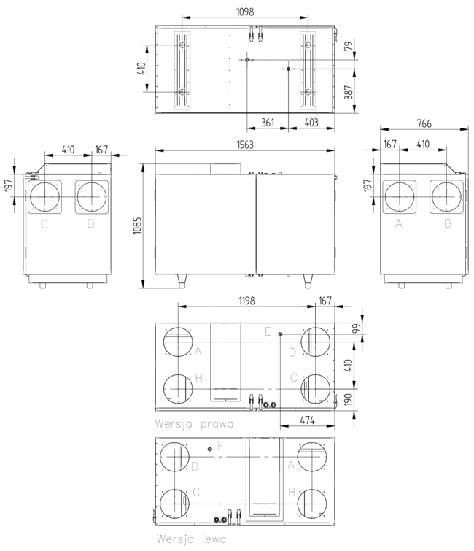

A-Air taken from outside of the building
B-Air taken from rooms
C-Air supplied to rooms
D-Air discharged outside the building

Combo 1330
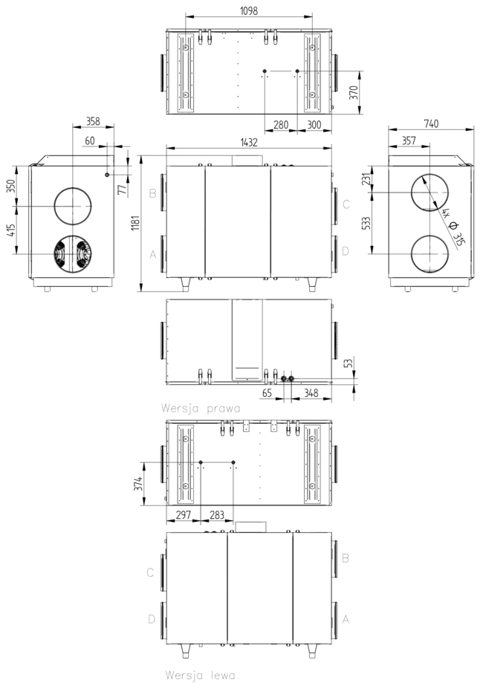

Dimensions of Display V2

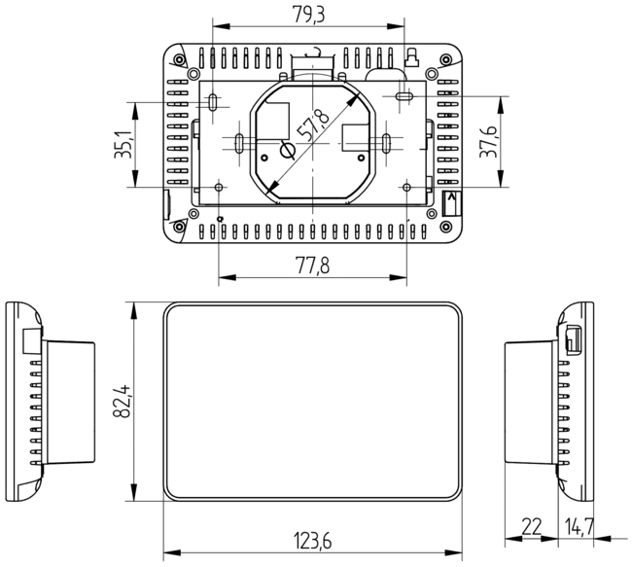

Characteristics
Performance charts and detailed technical specifications for individual device versions have been moved to dedicated Product Data Sheets. The latest documents for the control unit model you have purchased can be downloaded directly from the website.

INSTALLATION

Installation of the device
The installer is responsible for the installation of the device and adjustment of the capacity and should be performed only by a qualified and properly authorized person. Qualified specialists have practical experience and knowledge of ventilation systems, their installation and electrical safety regulations. The installation of the equipment and the adjustment of its capacity must comply with applicable legislation and the manufacturer’s requirements. For installations containing electrical components, appropriate SEP Group 1 qualifications (or equivalent) are required, whilst for the operation of refrigeration or automation systems, relevant industry certificates (e.g. F-GAZ, manufacturer’s authorisation) are required.
After 30 days of use, the device may be locked. A message will appear on the control unit – see the example screen below.
To unlock the device, you must enter the unlock code. This code can only be obtained by an installer via the manufacturer’s website after logging into the installer’s area. The device’s serial number (SN) is required to generate the unlock code.
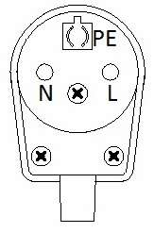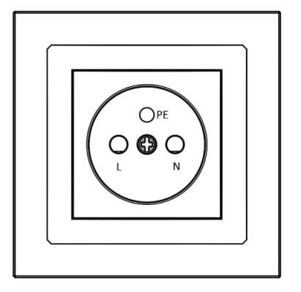
NOTE: The power cord should be connected as shown in the diagram. Connection other than that shown in the diagram will result in incorrect operation of the device or its damage.
The device may only be connected to an installation with a serviceable protective conductor.

Condensate drainage

Whilst the heat recovery unit is operating, particularly in cold conditions, water vapour condenses on the heat exchanger.
Condensate is drained via a Ø25 mm drain pipe located at the bottom of the unit. The unit should be situated in a location where the temperature is always above freezing, to prevent, amongst other things, the condensate drain from freezing. The drain pipe should be connected to a trap as shown in the diagram below.
Installation instructions:
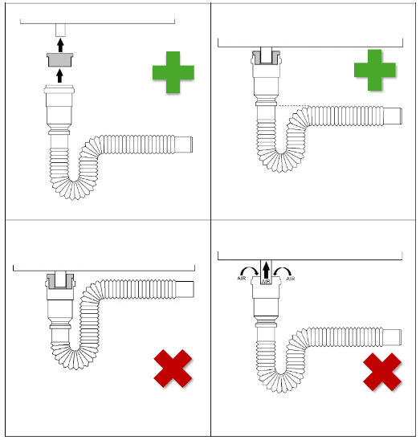
- The unit must be levelled. Wall-mounted units are fitted with levelling screws at the rear of the unit
- Before using the trap for the first time, it must be filled with water.
- The connection between the drain and the trap must be airtight – the unit must not draw in air through the drain pipe
- Incorrect connection may result in the appliance or the room becoming flooded – the manufacturer accepts no liability for this

AIR !
- It is forbidden to connect two siphons to a single T-piece!

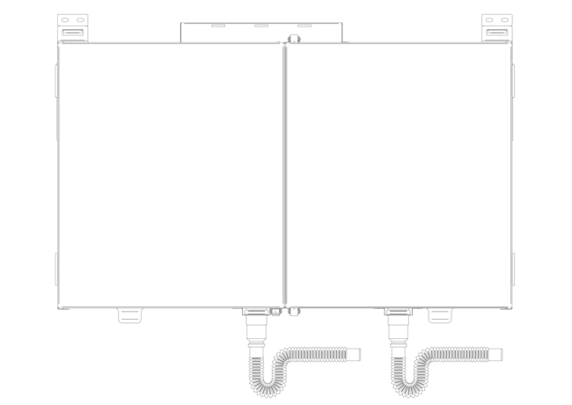

Place of installation
The device should only be installed in rooms where the temperature does not fall below 5°C during its period of use (particularly in winter). Installation in an attic or in unheated spaces is permitted only if the user ensures that the ambient temperature around the unit remains above 5°C throughout its entire service life. Failure to do so may result in damage to the unit and voiding of the warranty.
When installing the unit in an attic or other locations subject to temperature drops, the unit must not be switched off during the winter months to prevent condensation from forming on its components. It is recommended that the temperature be monitored and, if necessary, additional heating be provided for the installation area.

The heat recovery unit should be installed in such a way as to ensure access to it for maintenance and servicing.
The use of mechanical ventilation in the rooms where a fireplace will be installed requires the user to install a fireplace with a closed combustion chamber (air can only be taken from outside the building) and a carbon monoxide sensor. It is forbidden to install a fireplace with air intake from
the room.
It is forbidden to turn off the unit in winter, if installed in the attic. Turning off the unit may
result in water vapour condensation on the unit walls and on the fans.
Holes for wall plugs should be drilled in accordance with the manufacturer’s instructions for the specific type of plug and in line with the type of substrate:
- When installing in concrete or solid brick, it is recommended to use a hammer drill and select the appropriate drill bit in accordance with the anchor manufacturer’s instructions (usually a concrete drill bit, with hammer action).
- When working on a substrate of ceramic hollow blocks or aerated concrete, it is recommended to use a non-hammer drill to avoid expanding and weakening the wall structure.
- In all cases, follow the manufacturer’s instructions regarding the diameter and depth of the hole, as well as the method of fixing the anchor.

Minimum access distances

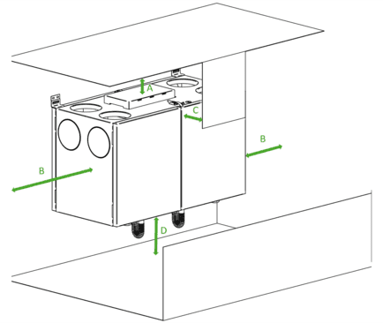

Model | A  [mm] | B  [mm] | C  [mm] | D  [mm]
Combo 430 | 630 | min. 130 | min. 400 | min. 650 | min. 250
Combo 830 | 10304 | min. 200 | min. 500 | min. 900 | min. 250
Combo 13304 | min. 200 | min. 500 | min. 600 | min. 250

Assembly positions
Assembly on stand | Assembly of Vertical Control Units (Wall-mounted) | Assembly of flat unit (suspended)
Larger air handling units, as well as selected models of vertical and horizontal units, are designed for installation on a dedicated floor-standing stand (frame). The stand must be placed on a stable and level surface. | Smaller units are designed for wall mounting (on load-bearing walls, partition walls or other vertical structures). Dedicated mounting brackets and screws are supplied with the units. If mounting on a different type of surface (e.g. plasterboard), other fixing elements suitable for that type of surface must be used. | Flat-design air handling units are designed as standard for ceiling-mounted installation (on ceilings, slabs or other horizontal structures) with the access doors facing downwards. The unit is fitted with special brackets. The brackets must be secured to the supporting structure using suitable fasteners designed for this purpose.

 | 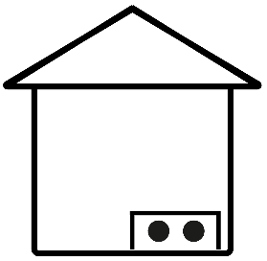 | 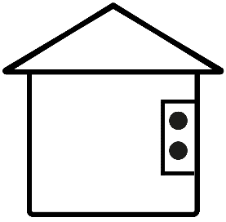 | 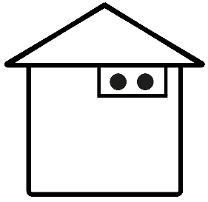
 | Assembly on stand | Wall mounted | Assembly on celing
Black 200 V  Black 300 V | + | + | -
250 H | + | + | -
340 V, 340 H | + | + | -
400 V, 400 H | + | + | -
600 V, 600 H | + | + | -
Combo 430 V/H  Combo 630 V/H | + | + | -
Combo 830 V/H  Combo 1030 V/H  Combo 1330 H | + | - | -
800 V/H  915 H  1315 H | + | - | -
345 XF  545 XF  845 XF  1345 XF | - | - | +

Controller operation

Description of the home screen view
Weekday, hour
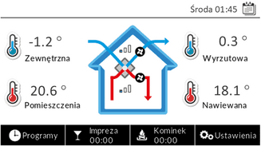
Icon indicating the supply fan is running
Icon indicating that the exhaust fan is running

Button to access the work schedule settings | Party mode button | Fireplace mode buton | Butto to access the main menu

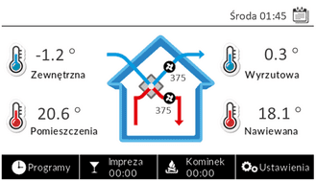
Supply air flow rate
Exhaust air flow rate
Home screen– The display shows the current key air temperatures and fan gear or current air flow rate (in $\frac{m^{3}}{h}$), on which the central unit is currently operating (depending on the equipment). Furthermore, at the top, on the left-hand side (next to the date) icons may appear to indicate that auxiliary systems are in operation, such as a bypass, a heater, a cooler, a ground-source heat exchanger (GHE) and a humidifier.

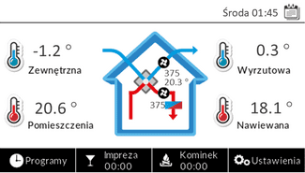 | 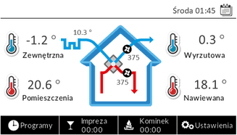

Temperature before additional heat exchanger | Icon indicating additional heat exchanger | Temperature after additional heat exchanger | Temperature in AHU after heating eg. by grund heat exchanger | Icon-indicating an extra temp sensor is outside

Home screen – Appearance of the version with an additional supply air temperature sensor, used in installations with a secondary heater, humidifier or heating/cooling unit, or with an outdoor temperature sensor in GHE installations (right-hand diagram).

Icons displayed on the screen
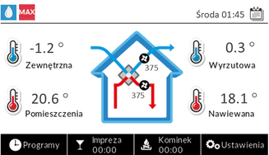
Icons indicating the current status of a function
Icons indicating the current status of a function (Left top corner of screen)
 | Active anti-freez system |  | 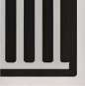 | Active ground heat exchanger (GHE)
 | Active by-pass / By-pass in open position |  |  | Maximum expenditure reached
 | Active cooling moe |  |  | Minimum expenditure reached
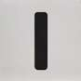 | Forced mode – Gear I |  |  | Active humidifier
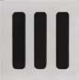 | Forced mode – Gear III |  |  | Active holiday mode
 | Active heating mode

Interface functions (Main view)

Device Schedule Settings (“Programmes”)
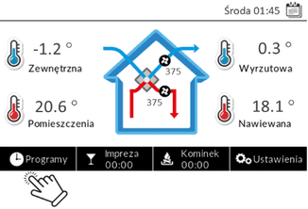 | 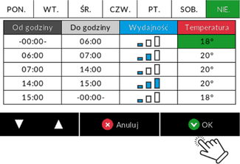
Setting the device’s gears in the schedule
Comfort temperature
Weekly schedule (in the interface: ‘Programmes’) – This function allows you to define the control unit’s automatic operating mode by setting the required fan speed (Speed) and the setpoint for the comfort temperature during defined time slots throughout the week.
Setting the appropriate fan speed in the schedule has a direct impact on the rate of air exchange in the building:
Gear | Intended use | Recommended context of use
Gear I | Savings/Suport | Periods of prolonged absence of residents or at night, when minimum ventilation is required.
Gear II | Comfort / Standard | Periods when occupants are present in the building (standard continuous ventilation). Recommended as the basic level of comfort ventilation.
Gear III | Intensive ventilation | Temporary, forced ventilation (e.g. after cooking, when guests have visited, or to quickly reduce pollutants or humidity).
Comfort temperature (setpoint) – serves as a reference for the automatic control of the modules responsible for heating, cooling and humidity control. The system aims to achieve the comfort temperature. This temperature is maintained in the room by controlling the operation of the following components:
- By-pass,
- Heater (heating support),
- Cooler (cooling support),
- Grunt Heat Echanger (GHE),
- Humidifier

„Party” mode
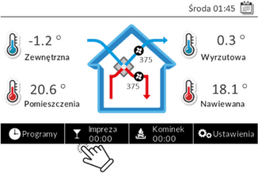 | 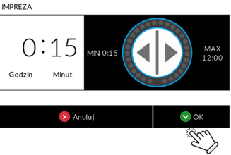 | 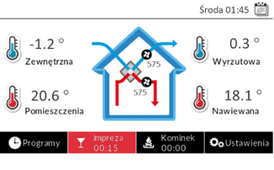
„Party” mode – When activated, this forces the control unit to operate continuously in Gear III for a defined period. Setting range: from 15 minutes to 12 hours.

„Fireplace” mode
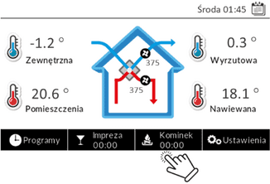 | 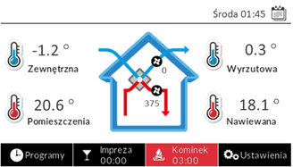
„Fireplace” mode – When activated, only the supply fan operates at increased capacity for 3 minutes, in order to create positive pressure in the building.

Main configuration menu (Settings)
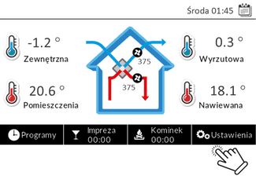
After selecting the Settings icon on the home screen, the user gains access to the control panel’s main configuration menu.
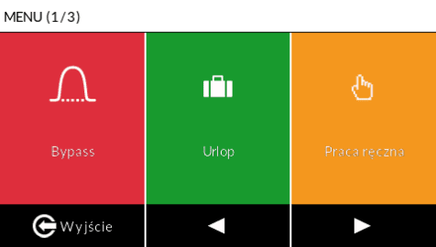 | 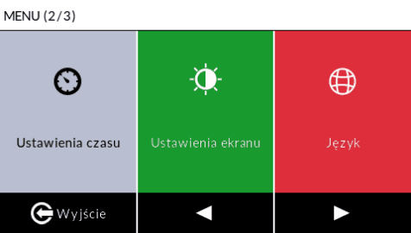 | 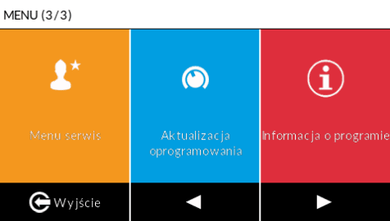

Bypass | On/Off „Bypass” function
Holiday | On/Off „Holiday” function
Manual mode | A diagnostic and service module for manually controlling outputs (relays, fans) in order to check that they are working properly. Access restricted to service engineers only.
Time settings | Date and time settings menu
Screen settings | Screen settings menu
Language | Language selection menu
Menu Servis | Service menu. Access restricted to service engineers only.
Software up date | Launching a software update
Software information | Displaying the current software version
The air handling unit can be expanded with additional extension modules. Depending on the hardware configuration, the main configuration menu (Settings) may include an extended range of options.
Humidifier RH% | On/Off of humidifier function
Heating | On/Off the ‘Heating’ function
Cooling | On/Off the ‘Cooling’ function
Ground Heat Exchanger | On/Off GHE function
Sensors | Displaying current sensor readings
Zone damper | On/Off Zone damper function

Automatic settings – service menu
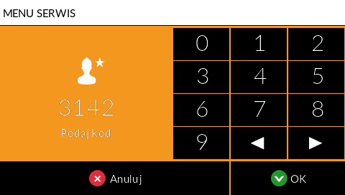
ATTENTION!: This configuration level (Service Menu) is intended solely for qualified service personnel or the installer. Access is only possible after entering the authorisation code: 3142. Please note that unauthorised tampering with the settings may result in the device malfunctioning and may invalidate the manufacturer’s warranty.

Gear I Power | Setting of Gear I performance
Gear II Power | Setting of Gear II performance
Gear III Power | Setting of Gear IIIperformance
Air inlet power correction | Adjustment of the supply fan’s capacity relative to the extract fan’s capacity.
Air outlet power correction | Adjustment of the exhaust fan’s output in relation to that of the supply fan.
Antifreez alghorytm | Selecting one of the available modes for protecting the heat exchanger against freezing
Humidifier settings | Configuring the settings for the additional humidifier
Bypass settings | Configuring the settings for bypass
GHE function | Activating the Ground Heat Exchanger (GHE) function
GHE settings | Configuring the settings for GHE
Heating – cooling | Configuring the settings for heating, cooling and heat pomp
XF Function | Activating the XF function
XF settings | Configuring advanced settings relating to the XF function
Delay time for engaging 3rd gear | Setting the additional time for which the fans continue to run at Gear III after the contacts close (post-force time).
Additional sensor EXTRA TEMP | Configuring an additional temperature sensor
Internet module | Configuration of the internet module
Temperature correction | It enables the installer to calibrate and adjust the readings provided by the temperature sensors fitted in the control unit.
Humidity sensors settings | Sensors configuration
Zone control | Enabling and configuring zone-based damper control functions
Modbus | Modbus RTU communication protocol settings
Detail screen | Detailed work data

Setting: Gear I
This section allows you to set the minimum capacity for the air handling unit (GEAR I). Depending on whether the unit is fitted with the XF flow balancing system or operates in standard mode (without XF), two different interfaces are available for setting GEAR I. GEAR I is used to ensure the minimum ventilation capacity recommended during prolonged periods when occupants are absent from the building.
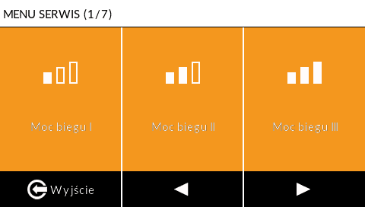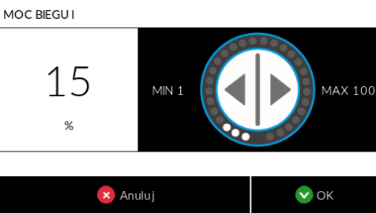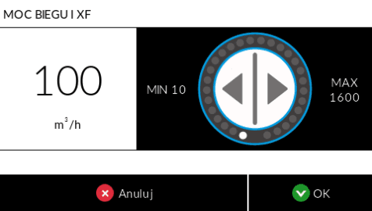

Setting: Gear II
This section allows you to set the optimum/comfort performance (GEAR II). Depending on whether the unit is fitted with the XF flow balancing system or is operating in standard mode (without XF), two different interfaces are available for setting GEAR II. GEAR II is designed to ensure optimum ventilation performance, recommended for continuous operation of the air handling unit during periods when occupants are present.
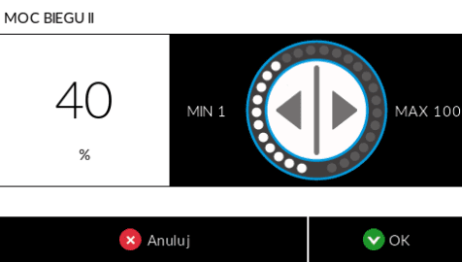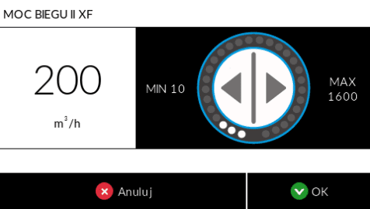

Setting:Gear III
This section allows you to set the maximum output (GEAR III). Depending on whether the unit is fitted with the XF flow balancing system or is operating in standard mode (without XF), there are two different interfaces available for setting GEAR III. GEAR III is mainly used for intensive ventilation of rooms and the building (e.g. after cooking or to achieve a rapid air change)
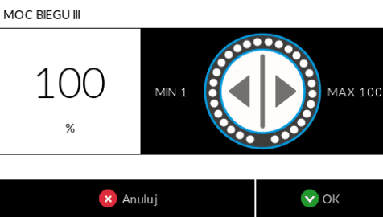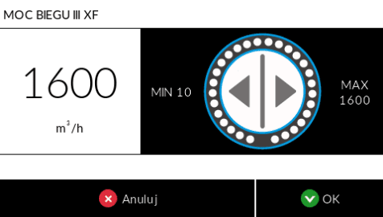

Air power correction
These functions are used to quickly adjust fan performance, enabling precise balancing of the supply and extract air flows within the system.
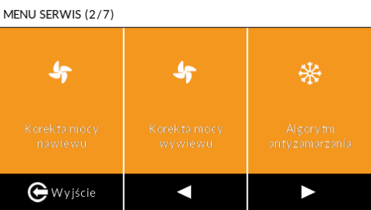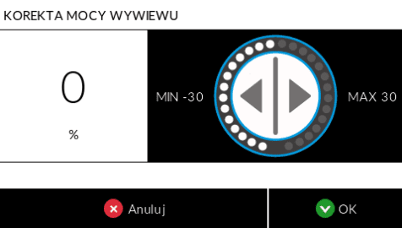
NOTE: When the XF function (automatic flow balancing) is active, the supply fan’s output can only be adjusted when it is necessary to create over or under pressure in the building.
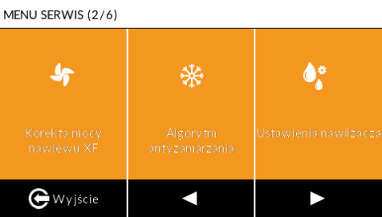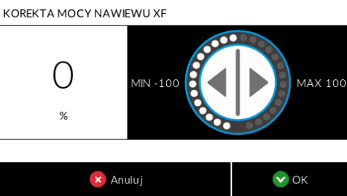

Anti-freeze algorithm
The anti-freeze algorithm is designed to protect the heat exchanger in the air handling unit from icing caused by condensate freezing when outside temperatures are low. By default, ‘Heater + Fan’ mode is active, and the Activation Temperature is set to 0°C.

In cold conditions, localised (spot) icing may occur in the lower part of the heat exchanger. This does not affect its proper operation and is a normal occurrence that does not constitute grounds for a complaint.
Protection mode | Action (Objective and Outcome) | Service Parameters and Conditions
Reducing the fan speed | Protection of the heat exchanger by gradually reducing the supply fan’s output. The extract fan continues to operate as normal | Start: Reduction begins when the intake temperature falls below the activation temperature AND the exhaust temperature falls below 10°C. Stop Limit: A drop in the exhaust temperature to 5°C causes the supply fan to stop. Restart: This occurs when the exhaust temperature rises above 10°C.
Primary heater | Maintaining a safe exhaust temperature whilst maintaining the nominal fan speeds. | The system is activated when the temperature at the air intake falls below the activation temperature and the temperature at the exhaust falls below 5°C.  The system is deactivated when the exhaust temperature rises above 10°C or the temperature at the air intake rises above the activation temperature.
Primary heater + fan | A combination of reduced airflow and heater operation to ensure maximum protection. | When the exhaust temperature drops to 8°C, the supply fan stops and the pre-heater is switched on. Timed Override: If the pre-heater has been running for less than 5 minutes, it is forced to continue running for the remaining time (up to a total of 5 minutes).
Air inlet protection | Preventing excessively cold air from entering rooms during periods of extremely low temperatures. | Activation Conditions: The outdoor temperature (intake) is below zero, AND the supply air temperature is 7°C lower than the room temperature. Forced Operation: Supply air 5%, Extract air 50%, primary heater activated. Deactivation: The mode switches off when the supply air temperature rises to a level equal to the room temperature minus 2°C.
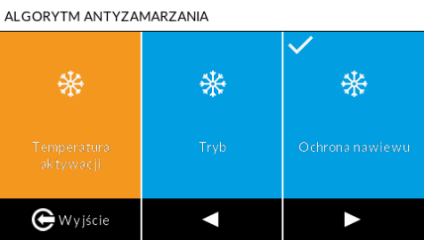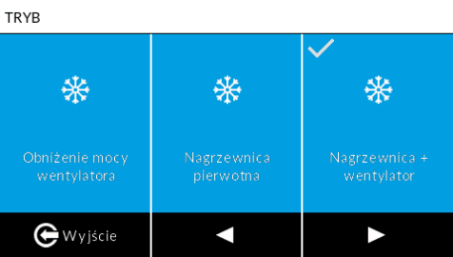

temperature of the anti-freeze algorithm

The Activation Temperature is a critical outdoor temperature threshold, set by the installer in the Service Menu, below which the system automatically switches to standby mode and begins regulating the operation of the unit. This is to prevent the heat exchanger from icing up as a result of condensate freezing. The Activation Temperature is set to 0°C by default. Below this threshold, depending on the selected mode, protective mechanisms are activated (e.g. the pre-heater is switched on or the supply fan speed is reduced).
Tip: For buildings with high humidity (e.g. new-builds), it is recommended that this threshold be set to 0°C. The drier the air in the building, the lower the temperature can be set – for example, down to -3°C.
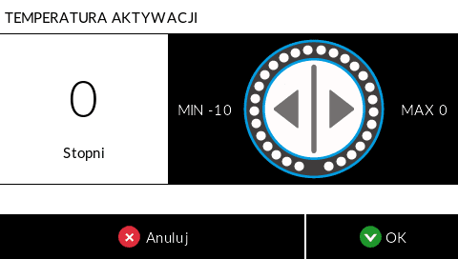

Humidifier settings
This section allows you to configure and set the parameters for the optional air humidifier module fitted to the air handling unit. Correct configuration is essential for maintaining the setpoint humidity level in the rooms.
Menu Option | Purpose and function | Specifications and Technical Notes
ON/OFF | Enabling/Disabling the main function of the humidifier. | Once the humidifier function has been activated, the ‘Humidifier RH%’ icon will appear in the main menu.
Solenoid valve opening time | The length of time for which the mat is sprayed with water. This is intended to ensure that the mat is thoroughly soaked in a single cycle. | This time depends mainly on the water pressure in the system. The installer adjusts the time to the optimum setting.  The optimum setting is when the mat is wet but the water does not overflow into the drip tray.
Solenoid valve closing time | The length of the pause between successive watering cycles. This is to prevent the mat from drying out. | This time depends mainly on the air flow. NOTE: Incorrect times result in increased water consumption and reduced efficiency.
Humidifier heater | Activating the humidifier’s heating function. | This component improves the humidifier’s performance and increases the temperature of the supply air
Heater start-up temperature | Setting the air temperature threshold upstream of the humidifier, below which the humidifier’s heater is activated.
Heater cut-off time | Heater switch-off time. | This is a function that delays the activation of the heater.
Periodic flushing | Weekly humidifier pad cleaning function. Removes dirt and salt deposits, flushing them down the drain. | Flushing takes place automatically once a week, every Sunday at 5.00. The flushing cycle lasts 10 minutes.
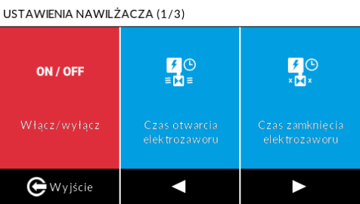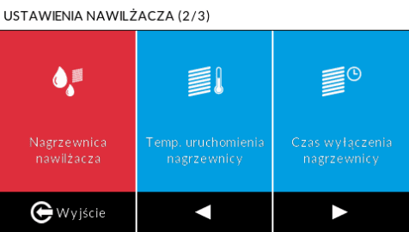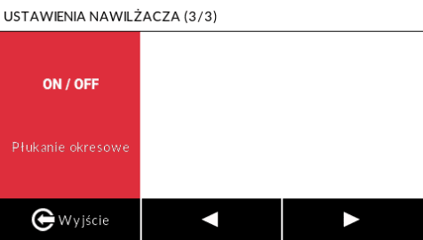

Bypass settings
This section is used to configure and manage the automatic bypass (heat exchanger bypass). The bypass function is used to cool rooms at night during the summer, when it is hot inside the house and the outside temperature is lower at night. When the bypass is open, the air bypasses the heat exchanger and cool air is fed directly into the rooms
The bypass is opened when all three conditions are met simultaneously:
- The outside temperature is lower than the temperature inside the room.
- The comfort temperature in the weekly programme has not been reached
- The outdoor temperature is higher than the lower activation temperature for the bypass.
Menu Option | Purpose and function | Specifications and Technical Notes
Lower Bypass Activation Temperature | Setting the minimum outdoor temperature threshold below which the bypass will close. | A key factor in maintaining the temperature within a building.
Performance Adjustment | Setting to increase fan speed when the bypass is active. | This is designed to cool the room more quickly in order to improve comfort.  • 0% – no increase in capacity,  - 100% – capacity doubled.
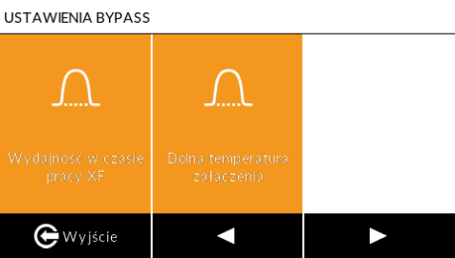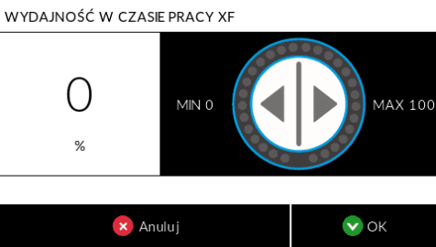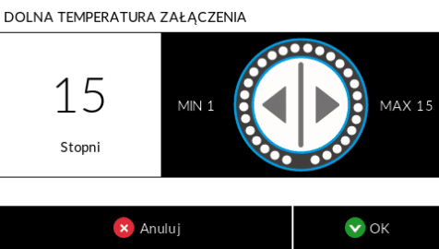

GHE Settings
„GHE function”- Once the function has been activated in the service menu, its icon appears in the user menu. The ‘GWC Settings’ section allows you to configure the temperature thresholds for automatically switching the unit to draw air from the Ground Heat Exchanger (GWC) instead of from the wall air intake. The GWC function is also used with a glycol heat exchanger to activate the circulation pump for preheating or pre-cooling the air before it enters the heat recovery unit.

The GHC requires the installation of an external sensor EXTRA TEMP. It is not possible to operate the GHC function and the heating/cooling function simultaneously, as they share the EXTRA TEMP input.
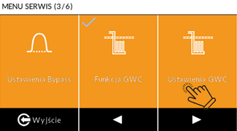

Menu Option | Purpose and function | Specifications and Technical Notes
GHE minimal temp. | Setting the lower outdoor temperature threshold that activates the GHE during the winter. | The temperature below which the GHE will activate.
GHE max temp. | Setting the upper threshold for the outdoor temperature that activates the GHE during the summer. | The temperature at which the GHE will activate.
Adjustment of airflow rate for GHE | It allows the supply fan power to be increased in order to compensate for the additional air resistance caused by the air flowing through the GHE. | The correction is set as a percentage (e.g. 0–100%). It is required if the flow resistance of the GHE differs from that of the wall intake. The correction is only available when the XF function is deactivated.

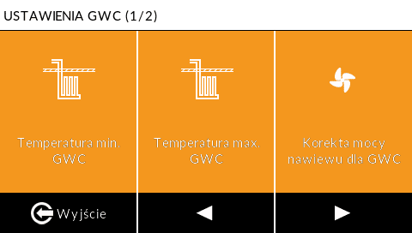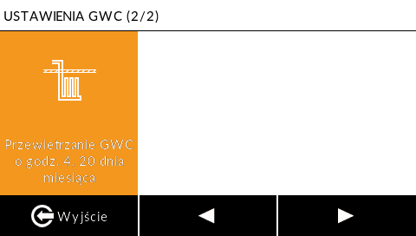

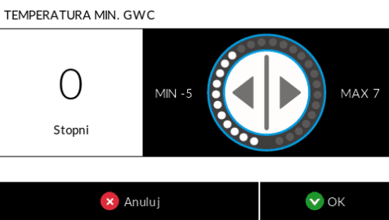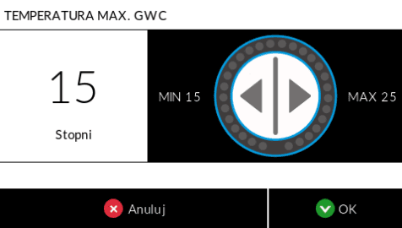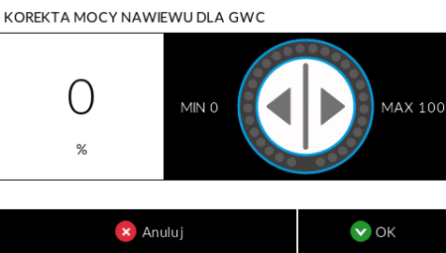

Heating – cooling settings
This section is used for the advanced configuration of optional heat exchangers and for activating and configuring the heat pump mode (in the case of freon heat exchangers)
Instalation scenario | Functions to be activated | Technical note
Water exchanger | You should activate the Heating and Cooling functions (without the heat pump). | It is used to control external water heaters/coolers.
Freon Exchanger | The Heating, Cooling and Heat Pump functions should be activated. | The Heat Pump function utilises advanced 0–10 V modulation logic

Water exchanger
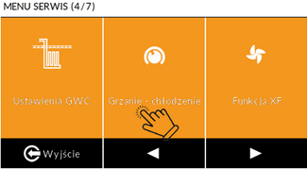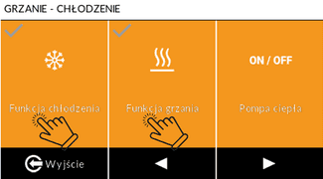
Once the heating and cooling functions have been activated in the service menu, the icons for switching on Heating and Cooling appear in the main menu for the user.
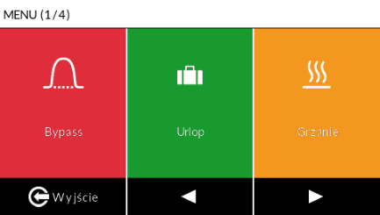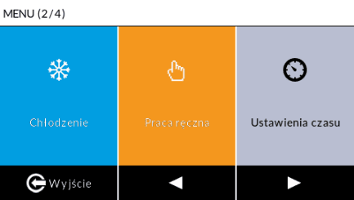
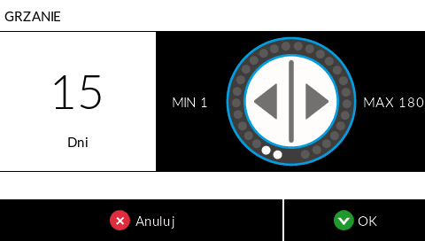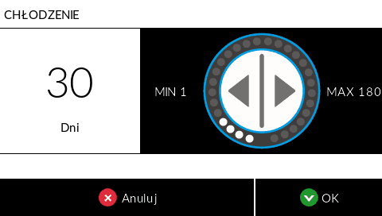
Enabling the Heating and Cooling functions in the Service Menu causes the relevant icons to appear in the user’s main menu. Once enabled, the user can set the number of days for which the function is to remain active.
- Heating activation: This occurs when the room temperature is lower than the comfort temperature (set in the weekly programme). A hysteresis of 2°C is applied.
- Cooling activation: This occurs when the room temperature is higher than the comfort temperature (set in the weekly programme). A hysteresis of 2°C is applied.

Freon exchanger
This section is used to configure the control of the refrigerant heat exchanger, which heats or cools the air supplied to the rooms. Control is achieved by modulating the intensity using a 0–10 V voltage signal on the heat recovery unit controller. Activating this function disables the standard algorithms for the Heating and Cooling functions. An outdoor unit is required to operate the heat pump functions. The system aims to achieve the comfort temperature set in the weekly programme.
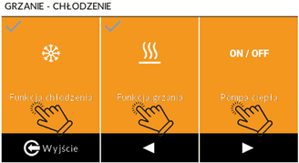
Menu option | Purpose and function | Specifications and Technical Requirements
Control Type | Selecting the type of control system depending on the manufacturer of the compatible control unit (unit) | Type I and Type II specify which outputs the voltage should be sent to and how the modes (HEATING/COOLING) are controlled.
System stabilisation time | This indicates the rate at which the 0–10 V voltage at the recuperator output increases. | This time is required for the system to stabilise. If the outdoor unit is switched off frequently, this time should be extended as much as possible.
Minimum compressor running time | The time after which the compressor may stop again. | This prevents the compressor’s service life from being shortened as a result of excessively frequent on/off cycles.
Minimum compressor shutdown time | The minimum number of minutes after which the compressor can restart (start-up). | Required to stabilise the refrigerant pressure.
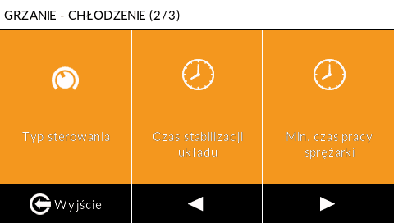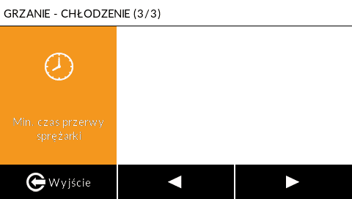
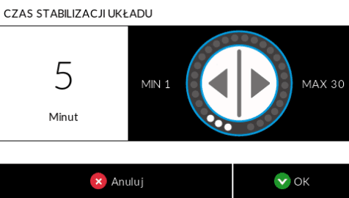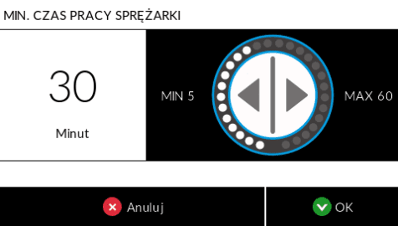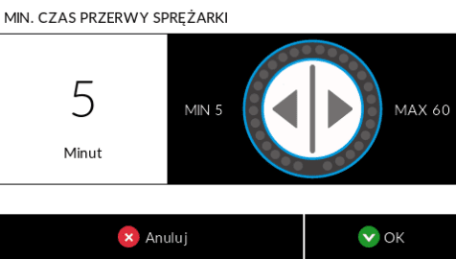
Control type | Outside unit
TYPE I | In accordance with the manufacturer’s documentation for the outdoor unit
TYPE II | MIDEA, ROTENSO, KASAI, GREE

XF function settings
This section deals with automatic air flow balancing (constant air flow).
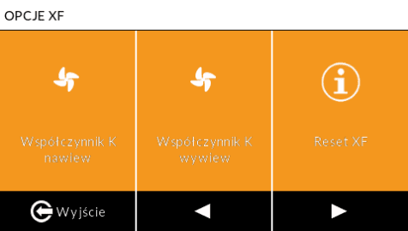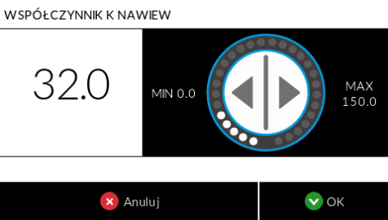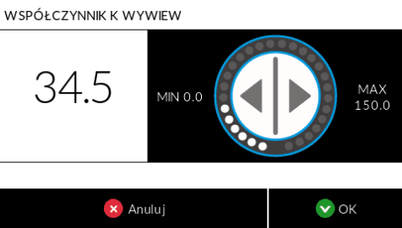
Menu option | Purpose and function | Specifications and Technical Notes
XF Function | Activating the XF Function | Allows the flow rate to be set to $\frac{m^{3}}{h}$. The unit maintains recovery at the maximum level.
XF Options | Configuration of additional, advanced settings relating to calibration and flow balancing. | This includes the supply air K-factor and the extract air K-factor.  Reset XF
K Factor inlet | A module for the precise calibration of air flow measurements through fans. | The ‘K’ factor is intended to ensure that the measured air volume values correspond to the actual fan flow rate.
K Factor outlet | A module for the precise calibration of air flow measurements through fans.. | The ‘K’ factor is intended to ensure that the measured air volume values correspond to the actual fan flow rate.
Reset XF | Allows the algorithm that checks the correct operation of the XF system to be reset | It is appropriate to use this button when the XF function has been activated on the controller despite the absence of sensors.
Each control unit has the relevant ‘K’ factor pre-programmed. When updating the software, please check that the factors entered are correct. The K factors are available on our website under the tab dowload.

Ustawienia czas opóźnienia włączenia 3 biegu
Ustawienie dodatkowego czasu, przez który wentylatory pracują na biegu III po rozwarciu styków na płycie głównej „BIEG III”. Ma to na celu dokładne przewietrzenie pomieszczeń i usunięcie zanieczyszczeń (np. po użyciu kuchni czy łazienki).
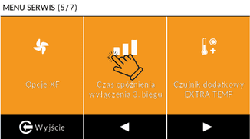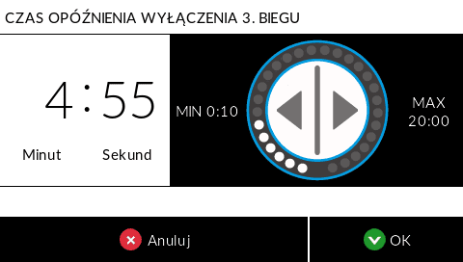

EXTRA TEMP Additional sensor settings
This section allows you to configure and calibrate an additional temperature sensor connected to the EXTRA TEMP connector on the control unit’s main board. This sensor is essential for the correct operation of the secondary heater/cooler and the ground heat exchanger (GHE).
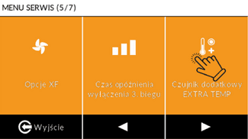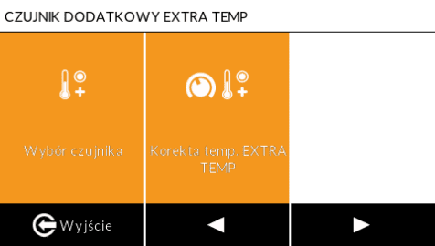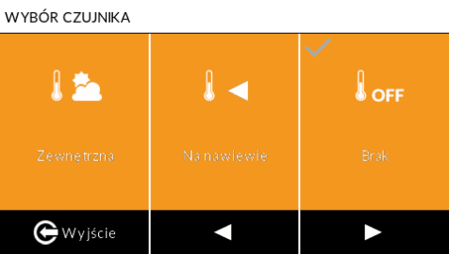
Menu option | Purpose and function | Specifications and Technical Notes
Choosing a sensor | Identifying where the sensor is physically installed, which determines its role in the automation system. | The available options are: External (for GWHE or Supply air (for Secondary Heater/ Cooler).
Temp correction | It enables the installer to adjust the value indicated by the temperature sensor. | Used, where necessary, to calibrate the temperature sensors fitted in the control unit.
Configuration Requirements:
Function | System message | Required Action by the Installer (EXTRA TEMP Sensor)
GWC | ‘GHE – Fit the sensor to the wall of the building’. | Requires a sensor to be installed outdoors.
Heat/Cool (Heating/Cooling) | "Heat/cool - fit the sensor behind the heater or radiator ". | Requires a sensor to be fitted in the supply air duct. The sensor must be positioned at least 1 m behind the heater/cooler.
Selecting the Extra Temp sensor changes the appearance of the home screen
View of the home screen after selecting ‘On Supply Air
View of the home screen after selecting ‘External’

Internet module settings
This section allows you to configure and activate the WANAS Mobile Control internet modules, which are optional extras on some units, used for remote management of the air handling unit via the internet. This applies to the following models: WANAS Mobile Control W-15, WANAS Mobile Control W-19 Wi-Fi and WANAS W-25 Wi-Fi.
To activate remote control, connect the module to the control panel and to the Ethernet network. Once connected to the internet, go to the service menu, then to the internet module, enable the module and select ‘Register internet module’. You must then enter the code displayed on the dedicated website https://emodul.pl/login and follow the instructions below to complete the registration process.
Please note: The operating and commissioning documentation is supplied with the module.

Category | Menu Option | Purpose and description | Technical notes
Madule managmnt | Module ON/OFF | Turning the Internet module on or off.
Madule managmnt | Register internet module | Allows the control panel to be paired with a user account for remote control. Displays the Registration Code. | Procedure: Enter the code on the website https://emodul.pl/login
Madule managmnt | Informations | Display detailed data and the module’s status. | Checking the MAC address or connection status.
Net configuration | DHCP ON/OFF | Enable automatic assignment of network parameters (IP address, subnet mask, gateway). | Recommended: ON. Manual configuration required (lower options) if DHCP is disabled.
Net configuration | IP address | Manually setting the device’s address on the local network.
Net configuration | Network mask | Manual subnet mask configuration.
Net configuration | Gate address | Manual configuration of the gateway address.
Net configuration | DNS address | Manually setting the DNS server address.

Temperature correction settings
This function allows the values indicated by the temperature sensors fitted in the air handling unit to be adjusted.
NOTE: Adjustments to the displayed temperature are optional and should only be carried out by the installer when necessary to ensure measurement accuracy and the correct operation of the control unit’s algorithms.
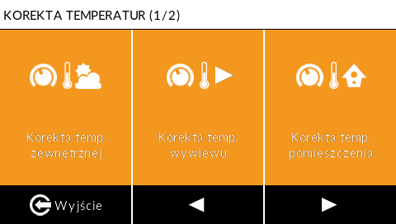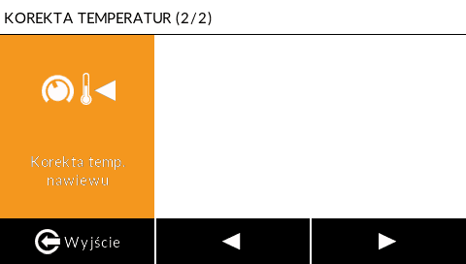

Humidity sensor settings
This section allows you to manage and configure the settings for wireless humidity sensors (Maxi Control).
Menu option | Purpose and function | Specifications and Technical Requirements
Add / remove a sensor | Registering a new humidity sensor or deactivating (removing) an existing one. | Used to pair (register) sensors with the control unit.
Humidity settings – room | Setting the humidity threshold below which the humidifier switches on automatically, or GEAR I if there is no humidifier. | Recommended humidity level for the room: 40–45 %
Humidity settings – bathroom | Setting the humidity threshold value above which the humidifier switches off automatically or GEAR III is activated. | Recommended humidity level for the bathroom: 70–80%
Parameter preview | It allows you to display and view the current parameters for wireless humidity sensors. | Displays the set humidity, current humidity and the temperature measured by the sensor in a given zone (e.g. Room, Bathroom).
To register a sensor in a selected room, you must initiate the pairing process. To do this, go to the humidity sensor settings in the service menu. Click ‘Add/Remove Sensor’. Then briefly press the pairing button on the device (sensor). Detailed pairing instructions for humidity sensors are included in the user manual for the relevant humidity sensor.
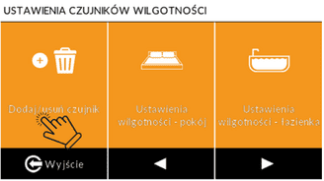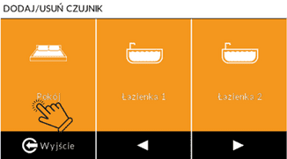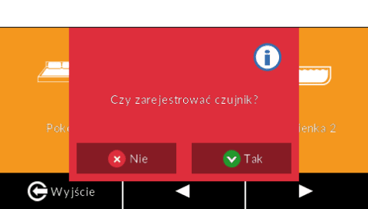
Sensors settings:
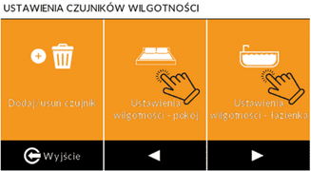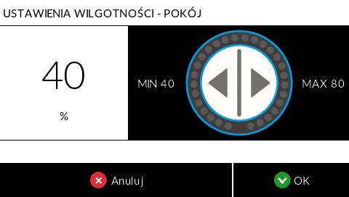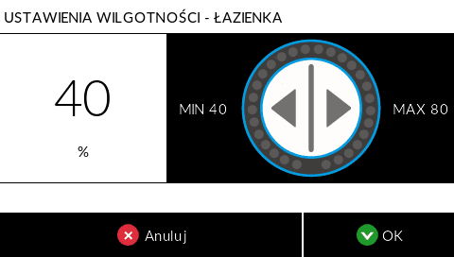
The current values read by the sensors are monitored in the main menu, under the ‘Sensors’ tab.
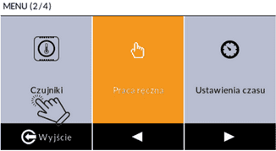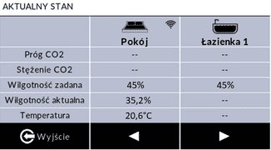

Zone control settings
The Zone Control function enables the heat recovery unit to be intelligently adjusted to the current demand for fresh air in two zones of the building – day and night. To this end, it uses ${CO}_{2}$ sensors to automatically increase the ventilation rate, which improves comfort, boosts energy efficiency and helps maintain good air quality.

${CO}_{2}$ Operating algorithms
Mode | ${CO}_{2}$ sensors qty. | Throttle Control Logic
First Mode | Two sensors (in the Day and Night Zones) | The damper is controlled by both sensors. Fresh air is automatically directed to the zone where the ${CO}_{2}$reading is higher. The unit’s capacity is automatically adjusted according to the ${CO}_{2}$ level
Second Mode | One sensor (Night Zone) | The damper is controlled by a single ${CO}_{2}$ sensor, which is dedicated to the night zone. By default, the damper directs the air flow to the day zone. Once the sensor in the night zone detects that the ${CO}_{2}$ concentration has exceeded the set threshold, the airflow is automatically redirected to the night zone. The unit’s capacity is automatically adjusted according to the ${CO}_{2}$ level.
Third Mode | No sensor registered | The control panel’s operation depends solely on the weekly schedule. The activation time and operating time for the night zone must be set manually. The control panel’s output is regulated according to the weekly schedule
The algorithm works on the basis of two ${CO}_{2}$concentration thresholds
Thresholds | Value | Settings | The Coercion Effect
First | Below the second threshold. | A fixed value that cannot be edited. | Forcing the control unit to operate in GEAR I
Second | Range: 400–1,500 ppm | Set by the user in the Service Menu > Zone control > Switch-on value for Gear II. | Force the unit to work on GEAR II
Trzeci | >1600 ppm | A fixed value that cannot be edited. | Force the unit to work on GEAR III

Activating the Zone Control Function
To fully activate the Zone Control function, please follow these steps:
  - In the Menu Service > Zone Control, select ‘Enable/Disable damper’.
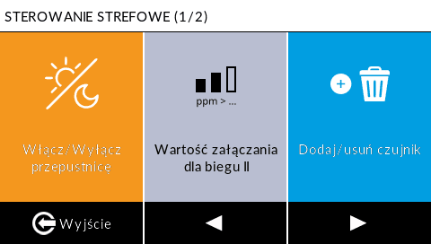
  - Next, in the Main Menu, activate the ‘Zone damper’ function.
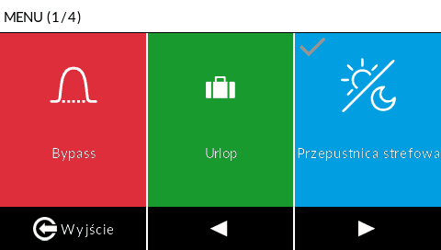

Adding ${CO}_{2}$ sensors
To activate Mode 1 or Mode 2, the sensors must be registered with the controller
:
- Selecting a Zone: From the controller menu, select the zone (room) in which the sensor is to be registered. | 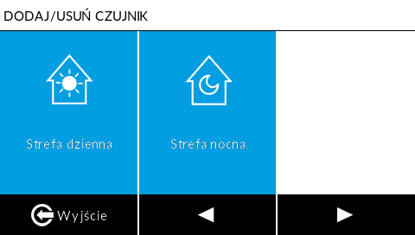
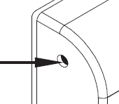  - Pairing: Briefly press the pairing button on ${CO}_{2}$ Control sensor. | NOTE: Detailed pairing instructions for a specific sensor model can be found in its user manual.  The sensors can be purchased from sklepie WANAS.
- Confirmation: The controller confirms that registration has been successful.

ModbusRTU settings
This section allows you to configure the communication parameters of the air handling unit controller using the Modbus RTU protocol. This protocol enables the air handling unit to be controlled and its current parameters to be monitored using external automation systems or computers.
Menu option | Purpose and Function
Turn on/off | Enabling or disabling the main Modbus communication function.
Transmission speed | Setting the data transfer rate.
Address | Defining a unique device address on a Modbus network.
Selecting a mode | Setting the key data transmission parameters (parity bit, data bits, stop bit).
The list of Modbus RTU registers can be found in a separate chapter (patrz)

Detail screen
The Detailed Screen section is a diagnostic panel that displays, in real time, a complete set of operating parameters for the air handling unit, including sensor readings, function statuses and fan performance status.
Main Category | Parameter | Value / Context
I. Capacity and Pressure | Supply/exhaust mode | Current fan speed.
I. Capacity and Pressure | Set supply/extract air flow rate | The power level set for the fan (as a percentage).
I. Capacity and Pressure | Supply/exhaust air flow | Currently measured air flow ($\frac{m^{3}}{h}$)
I. Capacity and Pressure | Set flow rate | Target flow rate.
I. Capacity and Pressure | Supply/exhaust airflow rates | Current fan speed.
I. Capacity and Pressure | Set/Actual pressure difference | Setpoint and measured pressure difference.
II. Tempreatures and sensors | Outdoor, Exhaust, Extract, Supply | Current temperature readings.
II. Tempreatures and sensors | Extra Temp | Reading from the EXTRA TEMP sensor
III. Work mode | Bypass, Holiday, Humidifier RH %, Heating, Cooling, GHC damper | Current ON/OFF status
IV. Status of Safeguards and Outputs | Anti-freeze, Air intake protection, Air intake vent protection, Fire protection | Security activity status.
IV. Status of Safeguards and Outputs | Heat pomp | Current ON/OFF status
IV. Status of Safeguards and Outputs | Humidifier heater | Output status: ON/OFF
IV. Status of Safeguards and Outputs | GEAR i, GEAR III | Gear activation status (e.g. via a voltage-free contact).
IV. Status of Safeguards and Outputs | Output 0-10 V | Input status.
IV. Status of Safeguards and Outputs | Cooker hood | Output/signal status.
V. Zone Control and Humidity | Day/night zone  ${CO}_{2}$ threshold/Status | Current CO2 concentration threshold and zone activation status.
V. Zone Control and Humidity | Bedroom / Bathroom 1 / Bathroom 2: Assigned / Condition | Setpoint for relative humidity (RH %) or CO2 and current function status.

Construction of an air-handling unit

- Air extracted from rooms
- Air supplied to rooms
- Filter ePM 10 50%
- Supply fan
- Heat exchanger
- Control
- Preheater
- Bypass
- Exhaust fan
- Air discharged outside
- Air drawn in from outside the building (air intake)
- Filters ISO CORASE 75%
- Humidifier evaparative mat
- Huiidifier nozzles
- Secondary heaters
- Water/freao exchanger (option)
Combo 430 | 630

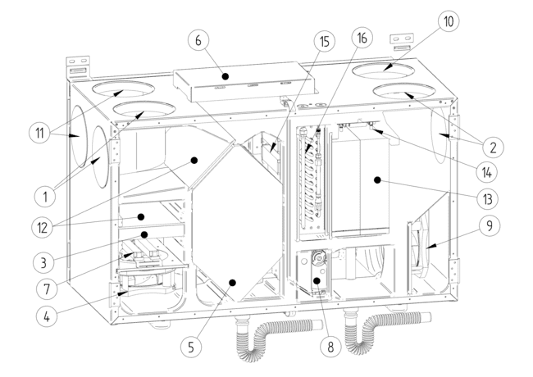
Combo 830 | 1030
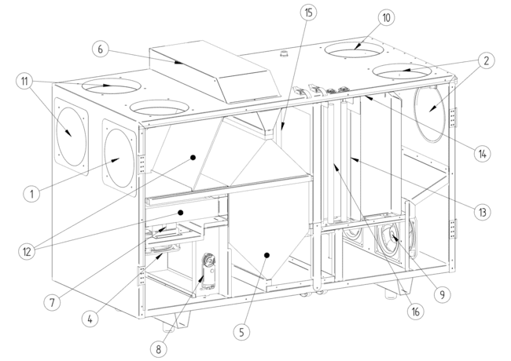
Combo 1330
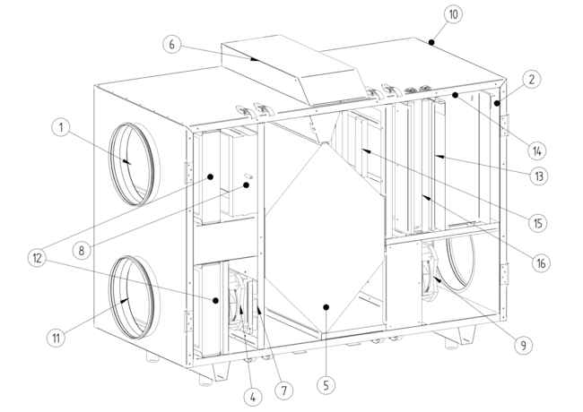

Electrical diagrams

Wiring diagram for the Display V2 control board, part 1
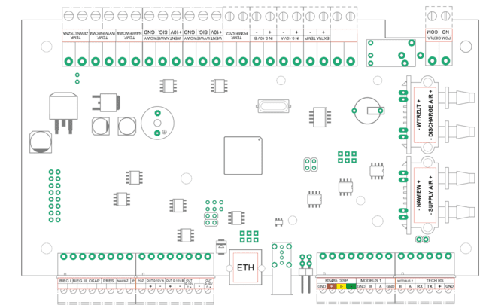

Wiring diagram for the Display V2 control board, part 2
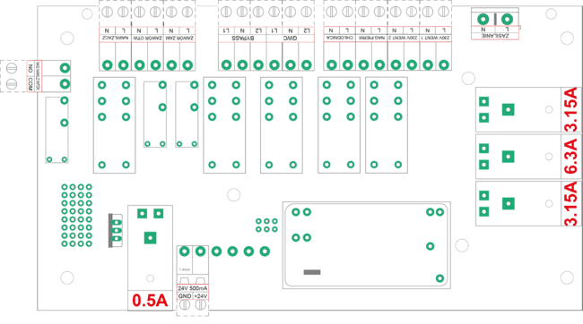

Wireing diagram of GEAR I or GEAR III

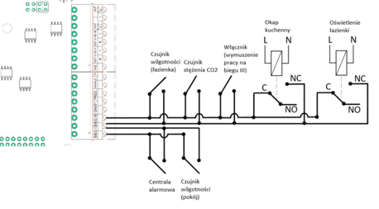
NOTE !
The hood and bathroom lighting functions must be connected to the control unit via a relay

GHE circulation pomp connection diagram
NOTE: Connection of a GHE pump when the unit’s power rating is 500W or less.
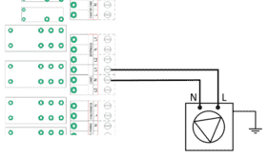

NOTE: Connection of a GHE pump when the unit’s power rating is over 500W .

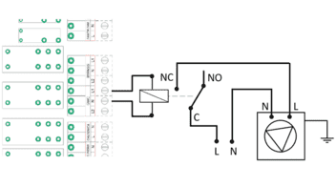

Wiring diagram for the air intake selector tee
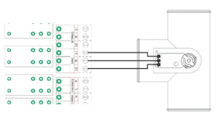

Wireing diagram of secondary heater
NOTE: Connection of a secondary heater when the unit’s power rating is 500W or less.
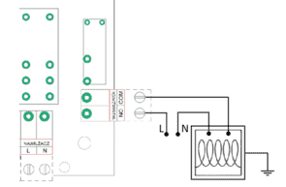

NOTE: Connection of a secondary when the unit’s power rating is over 500W.
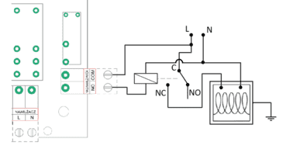
NOTE: Connection instructions when using the V2 controller to control, for example, a gas boiler on an ON/OFF basis. The controller acts as a weekly programmer and a thermostat.
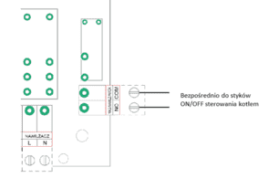
To control the boiler, we use the controller’s weekly programme and the ‘secondary heater’ option.

of water seconaday cooler connection
NOTE: How to connect the secondary water cooler pump when the appliance’s power rating is 500W or less.
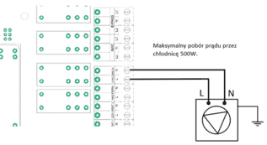

Connecting the secondary heater/cooler circulation pomp.
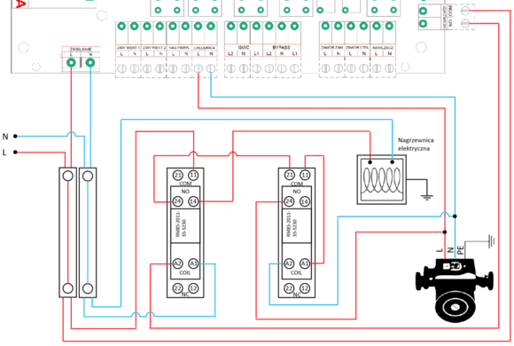
Wiring diagram for connecting the circulation pump and the electric secondary heater to the water heat exchanger in the air handling unit (configuration: Heating in winter / Cooling in summer).

Connection of WANAS water heater/cooler with GHE
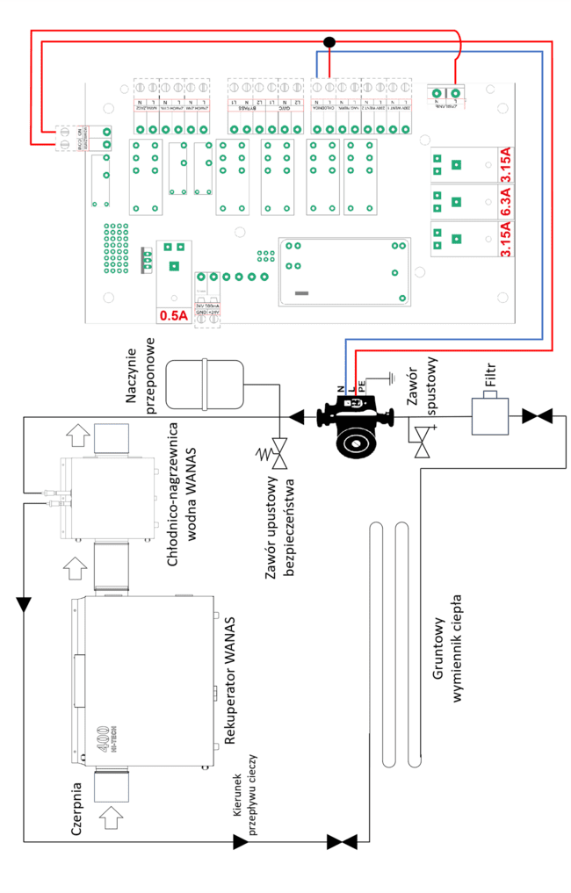
The heat exchanger, installed downstream of the heat recovery unit, is used exclusively in summer to cool the air supplied to the building.

Connection of freon heater/cooler
The diagram shows the connection to the Midea unit
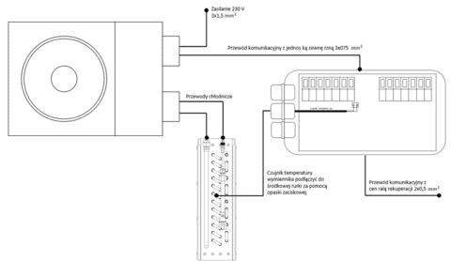
Przewód komunikacyjny z centralą rekuperacji 6x0,5 ${mm}^{2}$

Do not connect the freon heater/cooler controller to the ‘Cooler’ output on the heat recovery unit controller. This is a 230V power supply output and may cause permanent damage to the freon heater/cooler controller.
NOTE: Once the system has been connected, carry out a nitrogen leak test, followed by a vacuum leak test at 0.5 bar. Fill the system with R32 refrigerant. If the distance from the outdoor unit exceeds 5 metres, top up the refrigerant: 12g of refrigerant for each additional metre of pipework. Do not add any refrigerant if the distance is less than 5 metres.

Connection with Midea outside aggregate
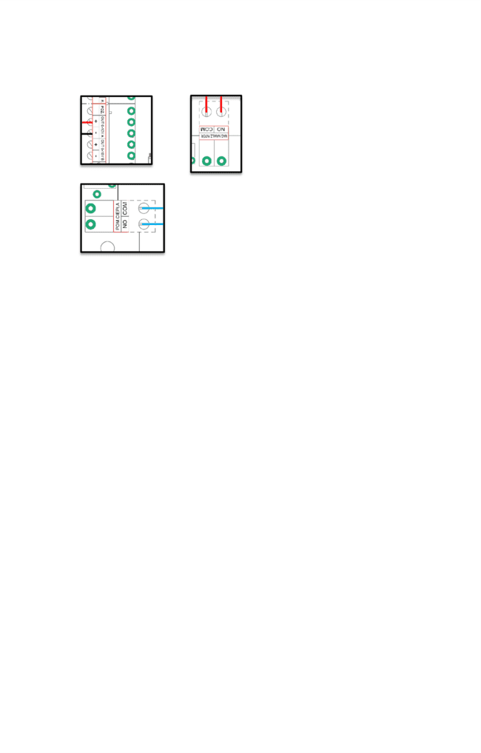
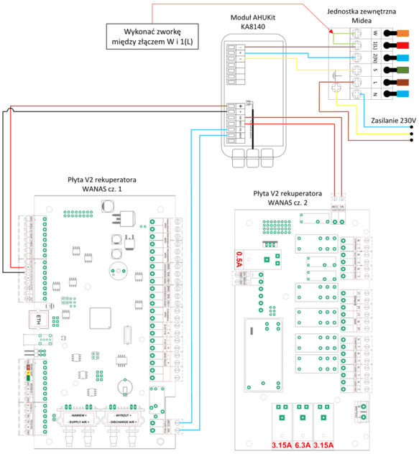

Wiring diagram for connecting a zone damper to an air handling unit
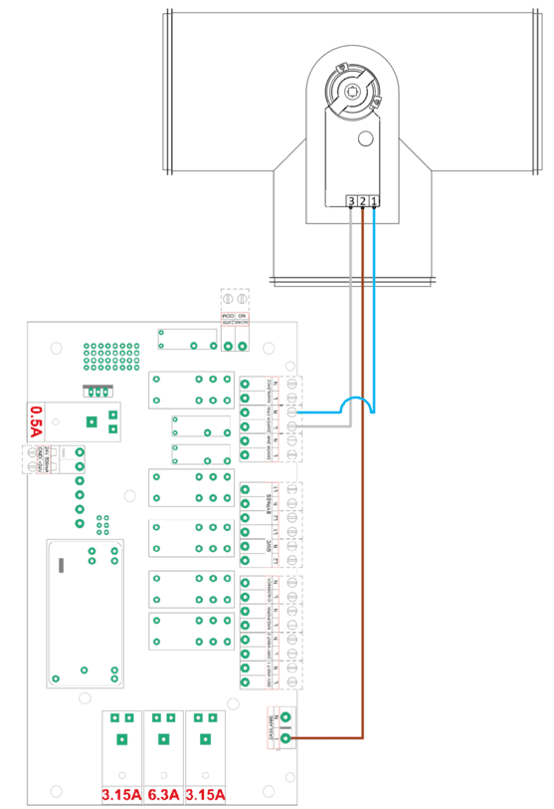

Configuration of the actuator assembly for controlling a three-way valve.
To ensure the correct operation of the control damper in a ventilation system, the actuator must be fitted correctly. The actuator controls the position of the internal baffle, which directs the air flow to the selected duct branch. Two installation options are shown below, allowing the direction of the actuator’s operation to be adapted to the installation requirements.
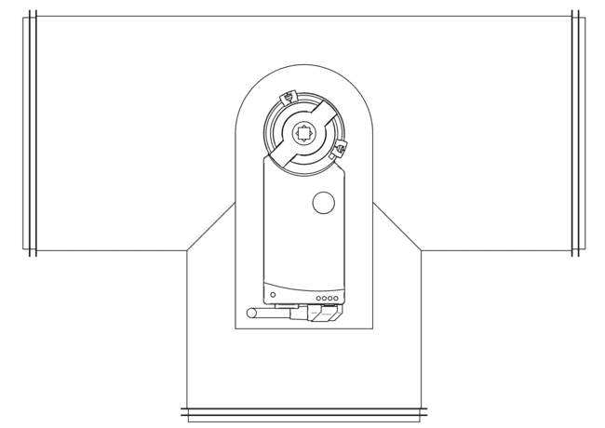 | 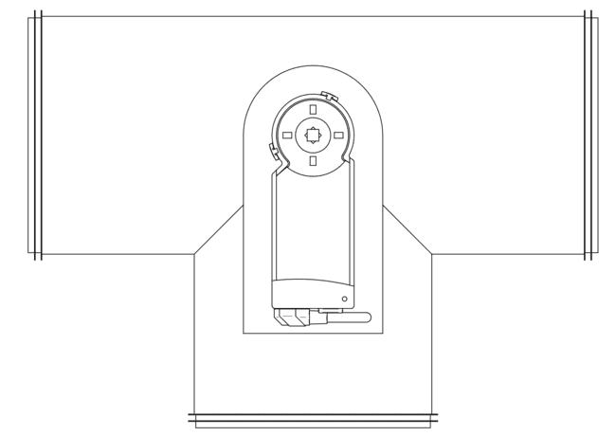
Configuration No.1 | Configuration No. 2
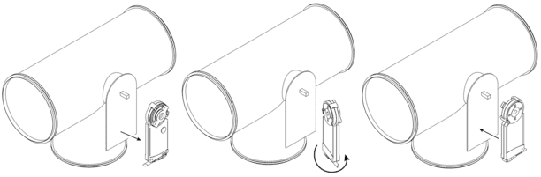

Wiring diagram for the external temperature sensor
The outdoor temperature sensor is connected to the EXTRA TEMP socket.
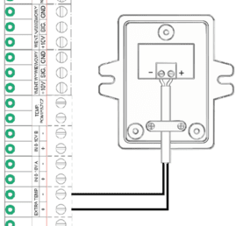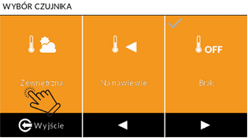
In the service menu, activate the sensor and select the external temperature sensor function.

Modbus RTU

The Wanas ST-340 V2 heat recovery unit controller has two built-in RS485 slave communication ports, which allow the air handling unit to be controlled using the Modbus RTU protocol in half-duplex mode. It is recommended to use the MODBUS 2 connector for control.
The control unit can be operated and current parameters viewed by reading from and writing to a single register or a group of registers.
Default data transmission settings:
Speed: 19200 b/s
Parity bit: even (even)
Data bit 8
Alloy bit: 1
Controller address: 1

Commands:
0x03 – reading 16-bit registers;
0x06 – the value of a 16-bit register;
0x10 – a set of 16-bit registers;

List of Modbus RTU registers
1 | 0 | R | Airflow supply | Cuent value m3/h | Decimal | 0 | 1600 |  | 0 – no function XF, step size 1 m3/h
2 | 1 | R | Airflow exhaust | Cuent value m3/h | Decimal | 0 | 1600 | - | 0 – no function XF, step size 1 m3/h
3 | 2 | R | Supply gear | Current gear | Decimal | 0 | 3 | 1 | 0 - pause 1- empty house, 2 - work 3 -  ventilation
4 | 3 | R | Exhaust gear | Current gear | Decimal | 0 | 3 | 1 | 0 - pause 1- empty house, 2 - work 3 -  ventilation
5 | 4 | R | Temp. outside | Current temp. | Decimal | 0 | 65535 |  | 0=> 0°C  65535=> -0,1°C The method of conversion is described opposite.  63066 – sensor error  step size 0,1°C
6 | 5 | R | Temp. exhaust | Current temp. | Decimal | 0 | 65535 | -
7 | 6 | R | Temp. supply | Current temp. | Decimal | 0 | 65535 | -
8 | 7 | R | Temp. indor | Current temp. | Decimal | 0 | 65535
9 | 8 | R/W | Weekday | Weekly schedule | Decimal | 0 | 6 | 0 | Select the day in the schedule for which the end of the zone, the zone cycle and the zone temperature are to be set; 0 – Sunday, 1 – Monday, 2 – Tuesday, 3 –  Wednesday, 4 – Thursday, 5 – Friday, 6 – Saturday
10 | 9 |  | Reserved | Reserved | - |  |  |  | Reserved
11 | 10 | R/W | End of Zone 1  (beginning of zone 2) | Zone from weekly schedule | Decimal | 15 | 1380 | 300 | A value expressed in minutes.Step size 15 minutes.
12 | 11 | R/W | End of Zone 2  (beginning of zone 3) | Zone from weekly schedule | Decimal | 30 | 1395 | 600 | A value expressed in minutes.Step size 15 minutes.
13 | 12 | R/W | End of Zone 3  (beginning of zone 4) | Zone from weekly schedule | Decimal | 45 | 1410 | 900 | A value expressed in minutes.Step size 15 minutes.
14 | 13 | R/W | End of Zone 4  (beginning of zone 5) | Zone from weekly schedule | Decimal | 60 | 1425 | 1200 | A value expressed in minutes.Step size 15 minutes.
15 | 14 | R/W | Gear zone 1 | Zone from weekly schedule | Decimal | 0 | 3 | 1 | 0 - pause 1- empty house, 2 - work 3 -  ventilation
16 | 15 | R/W | Gear zone 2 | Zone from weekly schedule | Decimal | 0 | 3 | 1 | 0 - pause 1- empty house, 2 - work 3 -  ventilation
17 | 16 | R/W | Gear zone 3 | Zone from weekly schedule | Decimal | 0 | 3 | 1 | 0 - pause 1- empty house, 2 - work 3 -  ventilation
18 | 17 | R/W | Gear zone 4 | Zone from weekly schedule | Decimal | 0 | 3 | 1 | 0 - pause 1- empty house, 2 - work 3 -  ventilation
19 | 18 | R/W | Gear zone 5 | Zone from weekly schedule | Decimal | 0 | 3 | 1 | 0 - pause 1- empty house, 2 - work 3 -  ventilation
20 | 19 | R/W | Temp. zone 1 | Zone from weekly schedule | Decimal | 10 | 30 | 20 | Step size 1°C
21 | 20 | R/W | Temp. zone 2 | Zone from weekly schedule | Decimal | 10 | 30 | 20 | Step size 1°C
22 | 21 | R/W | Temp. zone 3 | Zone from weekly schedule | Decimal | 10 | 30 | 20 | Step size 1°C
23 | 22 | R/W | Temp. zone 4 | Zone from weekly schedule | Decimal | 10 | 30 | 20 | Step size 1°C
24 | 23 | R/W | Temp. zone 5 | Zone from weekly schedule | Decimal | 10 | 30 | 20 | Step size 1°C
25 | 24 | R/W | Device address | Modbus address | Decimal | 1 | 254 | 1
26 | 25 | R/W | Baud Rate | Communication speed | Decimal | 0 | 6 | 3 | 0:2400; 1:4800; 2:9600; 3:19200; 4:38400;  5:57600; 6:115200
27 | 26 | R/W | Communication parameters |  | Decimal | 0 | 5 | 1 | 0:N-8-1; 1:E-8-1; 2:0-8-1; 3:N-8-2; 4:E-8-2;5:0-8-2  Bit evenness: N - none; E - even; 0-  odd. Alloy bit 1 or 2. 8 dana bit
28 | 27 |  | Reserved | Reserved | - | - |  | - | Reserved
29 | 28 |  | Reserved | Reserved | - | - |  |  | Reserved
30 | 29 | R | EXTRA TEMP | Current temp. | Decimal | 0 | 65535 |  | Ass on points 5-8
31 | 30 | R | GHE | Current operating status of the device | Decimal | 0 | 1 | - | 0 – not active, 1 – active
32 | 31 | R | Bypass | Current operating status of the device | Decimal | 0 | 1 |  | 0 – not active, 1 – active
33 | 32 | R | Humidifier | Current operating status of the device | Decimal | 0 | 1 | - | 0 – not active, 1 – active
34 | 33 | R | Heate | Current operating status of the device | Decimal | 0 | 1 | - | 0 – not active, 1 – active
35 | 34 | R | Cooler | Current operating status of the device | Decimal | 0 | 1 | - | 0 – not active, 1 – active
36 | 35 | R | Holiday | Current operating status of the device | Decimal | 0 | 1 | - | 0 – not active, 1 – active
37 | 36 | R | Filters change | Filter wear | Decimal | 0 | 252 | - | 0: Change required; 1-252;days to change
38 | 37 | R | Errors |  | Binary |  | - | - | Errors table.
39 | 38 | R/W | GHE | Activate/  deactivate.  (Main  menu) | Decimal | 0 | 1 | 0 | 0 – not active, 1 – active
40 | 39 | R/W | Bypass | Activate/  deactivate.  (Main  menu) | Decimal | 0 | 1 | 0 | 0 – not active, 1 – active
41 | 40 | R/W | Humidifier | Activate/  deactivate.  (Main  menu) | Decimal | 0 | 1 | 0 | 0 – not active, 1 – active
42 | 41 | R/W | Heater | Activate/  deactivate.  (Main  menu) | Decimal | 0 | 180 | 0 | Validity: up to 180 days.
43 | 42 | R/W  R/W  R/W | Cooler | Activate/  deactivate.  (Main  menu) | Decimal | 0 | 180 | 0 | Validity: up to 180 days..
44 | 43 | R/W  R/W  R/W | Holiday | Activate/  deactivate.  (Main  menu) | Decimal | 0 | 30 | 0 | Validity: up to 30 days.
45 | 44 | R/W  R/W  R/W | Fireplace function | Activate/  deactivate. | Decimal | 0 | 180 | 0 | Validity: up to 180 secunds
46 | 45 | R/W | Party function | Activate/  deactivate. | Decimal | 0 | 720 | 0 | Validity: up to s. 720 min(12h)
47 | 46 | R | Gear 1 input | Information about the digital input | Decimal | 0 | 1 | - | 0 – not active, 1 – active
48 | 47 | R | Gear3 input | Information about the digital input | Decimal | 0 | 1 | - | 0 – not active, 1 – active
49 | 48 | R | Hood input | Information about the digital input | Decimal | 0 | 1 | - | 0 – not active, 1 – active
50 | 49 | R | Firesafety input | Information about the digital input | Decimal | 0 | 1 | -I | 0 – not active, 1 – active
51 | 50 | R/W | Data |  | Decimal |  |  | - | Data table
52 | 51 | R/W | Hour |  | Decimal |  |  | - | Hour table
53 | 52 | R/W | Power/Flow Gear 1 | Set value | Decimal | 1 / 10 | 100 / 1600 | 15 / 100 | Power/Flow gear 1
54 | 53 | R/W | Power/Flow Gear 2 | Set value | Decimal | 1 / 10 | 100 / 1600 | 40 / 200 | Power/Flow gear 2
55 | 54 | R/W | Power/Flow Gear 3 | Zadana wartość | Decimal | 1 / 10 | 100 / 1600 | 100 / 1600 | Power/Flow gear 3
56 | 55 | R | Humidity sensor | Humidity sensor room | Decimal | 0 | 100 | -
57 | 56 | R | Humidity sensor | Humidity sensor bathroom1 | Decimal | 0 | 100 | -
58 | 57 | R | Humidity sensor | Humidity sensor bathroom 2 | Decimal | 0 | 100 | -
59 | 58 | R | Co2 sensor | Co2 PPM | Decimal | 0 | 9999 | - | Day zone
60 | 59 | R | Co2 sensor | Co2 PPM | Decimal | 0 | 9999 | - | Night zone
61 | 60 | R | Co2 sensor | Co2 Humidity | Decimal | 0 | 100 | - | Day zone
62 | 61 | R | Co2 sensor | Co2 Humidity | Decimal | 0 | 100 | - | Night zone
63 | 62 | R/W | Zone dumper | Activate/  deactivate. | Decimal | 0 | 1 | 0 | 0 – not active, 1 – active
64 | 63 | R | Anti freez | Anti freez (reads) | Decimal | 0 | 1 | - | 0 – not active, 1 – active
65 | 64 | R | Primary heater | Primary heater (reads) | Decimal | 0 | 1 | - | 0 – not active, 1 – active
66 | 65 | R | Humidity sensor | Temp. sensor (reads) | Decimal | 0 | 65535 | - | 0=> 0°C  65535=> -0,1°C  63066 — sensor error Step size 0,1°C
67 | 66 | R | Humidity sensor | Temp. sensor bathroom 1 (Reads) | Decimal | 0 | 65535 | -
68 | 67 | R | Humidity sensor | Temp. sensor bathroom 2 (Reads) | Decimal | 0 | 65535 | -
69 | 68 | R | Co2 sensor | Co2 temp. Day zone (reads)) | Decimal | 0 | 65535 | -
70 | 69 | R | Co2 sensor | Co2 temperatura Strefa temp. Night zone (reads) | Decimal | 0 | 65535 | -
71 | 70 | R | Zone dumper | Current operating status of the device | Decimal | 0 | 1 | 0
72 | 71 | R | Reading status values in the service menu | Current status of functions in the service menu | Binary | - | - | -
73 | 72 | R/W | Manual gear selection | Manual gear selection | Decimal | 0 | 3 | - | 0,1,2,3 correspond to the same runs
74 | 73 | R/W | Manual temp. setting | Manual temp. setting | Decimal | 10 | 30 | 20 | Step size 1°C
75 | 74 | R | Software version number | Software version number | Decimal | 0 | 0 | 0

Data
Day | Day | Day | Day | Day | Month | Month | Month | Month | Year | Year | Year | Year | Year | Year | Year
0 | 0 | 0 | 0 | 0 | 0 | 0 | 0 | 0 | 0 | 0 | 0 | 0 | 0 | 0 | 0
Hour
Hour | Hour | Hour | Hour | Hour | Hour | Hour | Hour | Hour | Minute | Minute | Minute | Minute | Minute | Minute | Minute
0 | 0 | 0 | 0 | 0 | 0 | 0 | 0 | 0 | 0 | 0 | 0 | 0 | 0 | 0 | 0

Errors
- | - | - | - | - | Pressure sensor supply | Pressure sensor exhaust | EXTRA TEMP supply | EXTRA TEMP outside | Temp. sensor. humidifier | Temp. sensor. exhaust | Temp. sensor.. supply | Temp. sensor. extract | Temp. sensor. intake | Supply fan | Exhaust fan
0 | 0 | 0 | 0 | 0 | 0 | 0 | 0 | 0 | 0 | 0 | 0 | 0 | 0 | 0 | 0

Data and hour settings

Data

Data
Day | Day | Day | Day | Day | Month | Month | Month | Month | Year | Year | Year | Year | Year | Year | Year
0 | 0 | 0 | 0 | 0 | 0 | 0 | 0 | 0 | 0 | 0 | 0 | 0 | 0 | 0 | 0

Value = Year-2000 eq.; 23=2023
Bites from 1 to 7 represent the year. We write the year by subtracting 2000
Bit shifting should be used to store the data. The day is shifted by 11 bits, the month by 7, and the year is not shifted.
Example of a date: 31.01.2022
Data
Day | Day | Day | Day | Day | Month | Month | Month | Month | Year | Year | Year | Year | Year | Year | Year
1 | 1 | 1 | 1 | 1 | 0 | 0 | 0 | 1 | 0 | 0 | 1 | 0 | 1 | 1 | 0

Hour

Hour
Hour | Hour | Hour | Hour | Hour | Hour | Hour | Hour | Hour | Minute | Minute | Minute | Minute | Minute | Minute | Minute
0 | 0 | 0 | 0 | 0 | 0 | 0 | 0 | 0 | 0 | 0 | 0 | 0 | 0 | 0 | 0

Bit shifting should be used to store data.
Example of storing the time 01:30
Hour
Hour | Hour | Hour | Hour | Hour | Hour | Hour | Hour | Hour | Minute | Minute | Minute | Minute | Minute | Minute | Minute
0 | 0 | 0 | 0 | 0 | 0 | 0 | 0 | 1 | 0 | 0 | 1 | 1 | 1 | 1 | 0

To set the date and time, you will need a converter, e.g. https://www.simonv.fr/TypesConvert/?integers

Setting the time on the controller using qmodmaster:
- On the converter page, in Auto mode, enter the hour or minutes (separately); then combine
the first 8 bits of the hour and the minutes
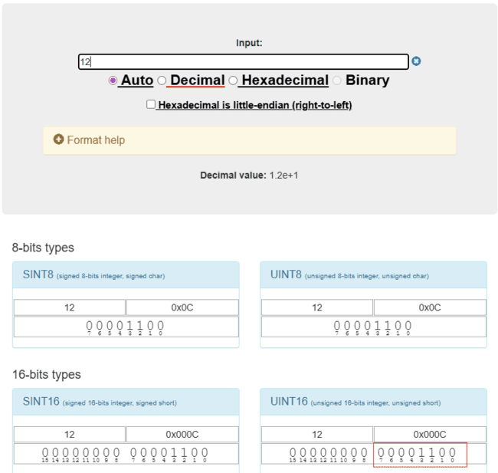

- Enter the value into the converter in Binary mode. Enter the resulting value into the Modbus communication programme
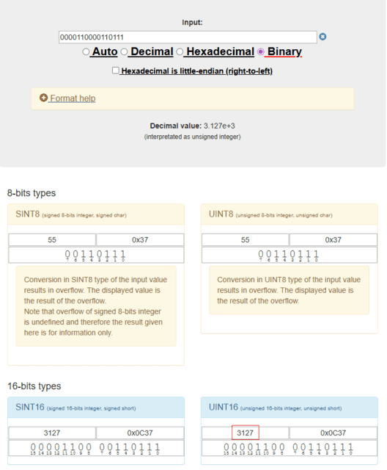
The code above sets the time to 12:55.
The date should be set in the same way: year (7 bits), month (4 bits) and day (5 bits).
PLEASE NOTE! If there is no communication via the Modbus RTU protocol, remove the jumper.

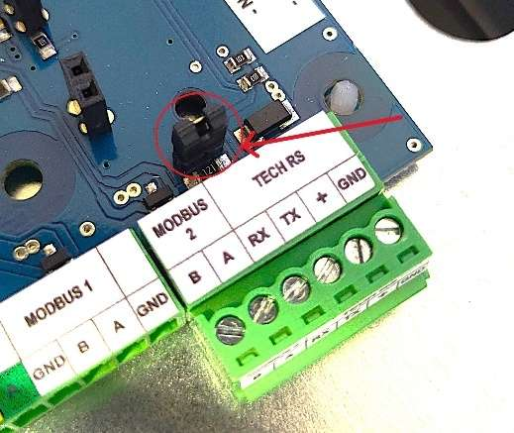

Problem-solving
The control of AHU automation system continuously monitors components and functional algorithms. Should any anomalies be detected, the controller immediately signals the event via a visual display and an audible alarm from the control panel.
If a diagnostic message appears, you must immediately read and document (note down) the message displayed on the control unit. All servicing must be carried out after disconnecting the unit from the mains supply.

Table of messages
Message | Possible cause | User action
Controller blocked | The installer did not enter the unlock code | Contact the installer or manufacturer to generate the correct unlock code
Controller locked – The message is still displayed despite the code being correct | Software error | The need to update the device
Incorrect software version | Different versions of the driver/board software | The need to update the device
Replace the filters and check the condition of the external air intake. | A message generated by a timer reminding you to replace the filters and check the air intake. | You should acknowledge the message and check the condition of the filters and air intakes
Replace the humidifier cartridge | A message generated by a timer reminding you to replace the humidifier mat | Please accept the message and check the condition of the humidifier pad
Supply fan fault | Loose electrical connectors  Blown fuse  Faulty fan circuit board | - Check the electrical connections on the fan terminals  - Check the fuse on the power supply board – the first one from the power supply connector (3.15A)  - Contact the service department
Błąd wentylatora wywiewu | Loose electrical connectors  Blown fuse  Faulty fan circuit board | - Check the electrical connections on the fan terminals  - Check the fuse on the power supply board – the first one from the power supply connector (3.15A)  - Contact the service department
Incorrect air flow measurement | Contaminants in the measuring system, blocked filter | - Check the condition of the filters and ducts in the XF system. Ensure they are free from dirt, condensation or kinks.  - Contact the service department
Malfunction of the pressure sensor | A faulty or disconnected sensor whilst the XF system is active | - Check that the pressure sensor is connected  - Contact the service department
The module is not connected to the Internet! | No cable is connected to the Ethernet socket | You must connect the module to an Ethernet port or disable the function in the service menu
No communication with the wireless sensor | No signal | Change the sensor location
No communication with the CO2 sensor | No signal | Change the sensor location
Module registration error | An incorrect code has been entered via the control panel | Please regenerate the code and enter it again
Low battery level | Low battery warning | Please replace the batteries in the wireless device

Maintenance

Inspections and maintenance
Maintenance work must be carried out with the unit disconnected from the mains. Maintenance of the unit includes replacing the filters and the humidifier pads and an inspection of the external intake and humidifier nozzles 5. It is recommended that filters be replaced at least every 180 days. Filters that are excessively dirty may cause the air handling unit to operate more noisily and less efficiently. The level of dirt on the system’s external air intake should be checked periodically, twice a year. During the summer months, the water level in the siphons should also be checked. A message reminding you to replace the filters appears on the control unit every 180 days..
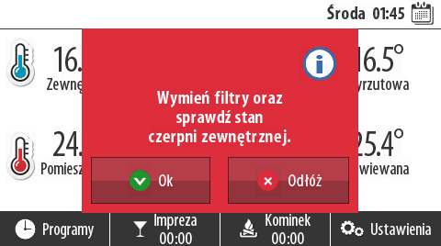

Removal of the heat exchanger
Before starting work, disconnect the air handling unit from the 230 V mains supply. As the components fit together very tightly, the heat exchanger should be removed by two people. First, grasp the strap provided for removing the heat exchanger, and then, using it, carefully slide the heat exchanger out.
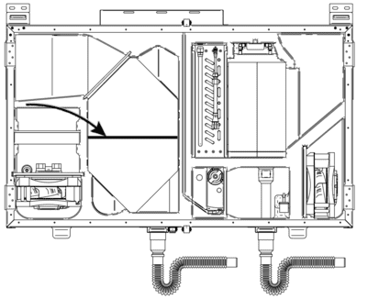

Combo 830 | 1030
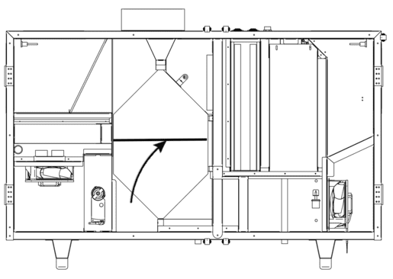
Combo 1330
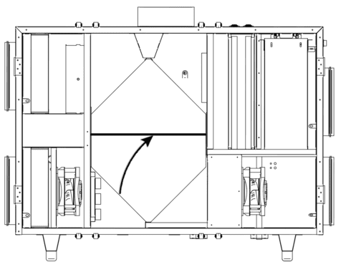

Warranty and Service

Service
All faults must be reported to WANAS, providing a detailed description of the problem in the form „Zgłoszenia serwisowego” available on website www.wanas.pl in tab „Kontakt”. Complaints made during the warranty period will be considered within 14 days and resolved within 30 days of the date of submission. The code required to unlock the controller can be obtained from the retailer.

Warranty
- The manufacturer provides a 24-month warranty covering the correct operation of the device
- The warranty period begins on the date the user purchases the device
- The warranty is granted and valid upon presentation of the proof of purchase for the control unit
- The warranty does not cover faults arising from incorrect use, maintenance or installation of the device
- The air handling unit should operate continuously from the moment it is first switched on, except when maintenance work is being carried out.
- The manufacturer accepts no liability for faults arising from a power cut
- The warranty does not cover damage caused by power surges or lightning strikes
- The cost of an unjustified service call is borne by the customer
- The company provides maintenance services throughout Poland.
- The warranty does not cover devices in which spare parts not recommended by the manufacturer have been used. Information on spare parts is available in the service section.
- The warranty is valid provided that the user uses only genuine WANAS filters.

Contact the Service Department
Tel: | +48 535 958 222
Service request | Clickhere!

Refers to COMBO 430 and 630
Refers to COMBO 430 and 630
There are 2 siphons in Combo series AHU
A stand is required to install the device. Information on the mounting dimensions of the stands and how to purchase them can be found on the website www.wanas.pl/produkt/stolik/.
Applies to devices in the Combo series

