Operation and Maintenance Documentation
INSTALLATION AND OPERATING MANUAL
Water heat exchanger 334
Water heat exchanger 444

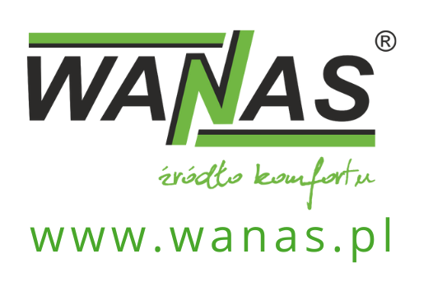
Contents
1. General information 3
1. Device dimensions 4
2. 334 Water heat exchanger specifications 6
2.1. 334 water exchanger specifications 6
2.2. 334 water exchanger specifications 40% ethylene glycol solution 7
3. 444 water exchanger specifications 8
3.1. Medium - water 8
3.2. Medium - 40% ethylene glycol 9
4. Schematic diagram of connection 10
5. Warranty and Service 11
5.1. Service 11
5.2. Warranty 11

General information
The heat exchanger is used to expand the capabilities of the WANAS COMBO heat recovery unit to include heating and cooling. Proper connection of the heat exchanger to the water circuit is essential for correct operation..
WANAS 334:
- Maximum heating capacity of the heat exchanger: 3.1 kW
- Maximum cooling capacity of the heat exchanger: 3.01kW
WANAS 444:
- Maximum heating capacity of the heat exchanger: 7.3 kW
- Maximum cooling capacity of the heat exchanger: 7.3 kW

If you intend to dispose of this product, do not throw it away with ordinary household waste. In accordance with Directive 2012/19/EU (WEEE) in force in the European Union, electrical and electronic equipment must undergo a separate disposal process. The aim of the directive is to prevent the negative environmental impact of electronic waste through its collection, reuse, recycling and recovery. The appliance is marked with the crossed-out wheelie bin symbol, which serves as a reminder of the obligation to collect end-of-life equipment separately. For further information on collection points and how to dispose of electronic waste, please contact your local council or a waste management company. | 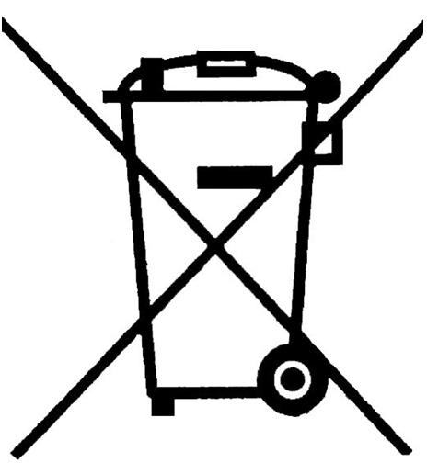
The manufacturer declares that the product complies with the ‘Low Voltage Directive 2014/35/EU (LVD)’﻿, concerning the safety of electrical equipment operating within a specified voltage range. The product meets the essential requirements of the directive and has been marked with the ‘CE’﻿ mark following a conformity assessment procedure. | 

Device dimensions
WANAS 334
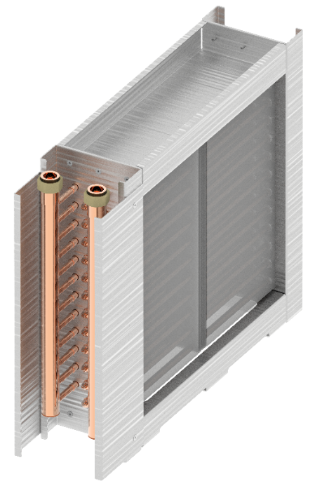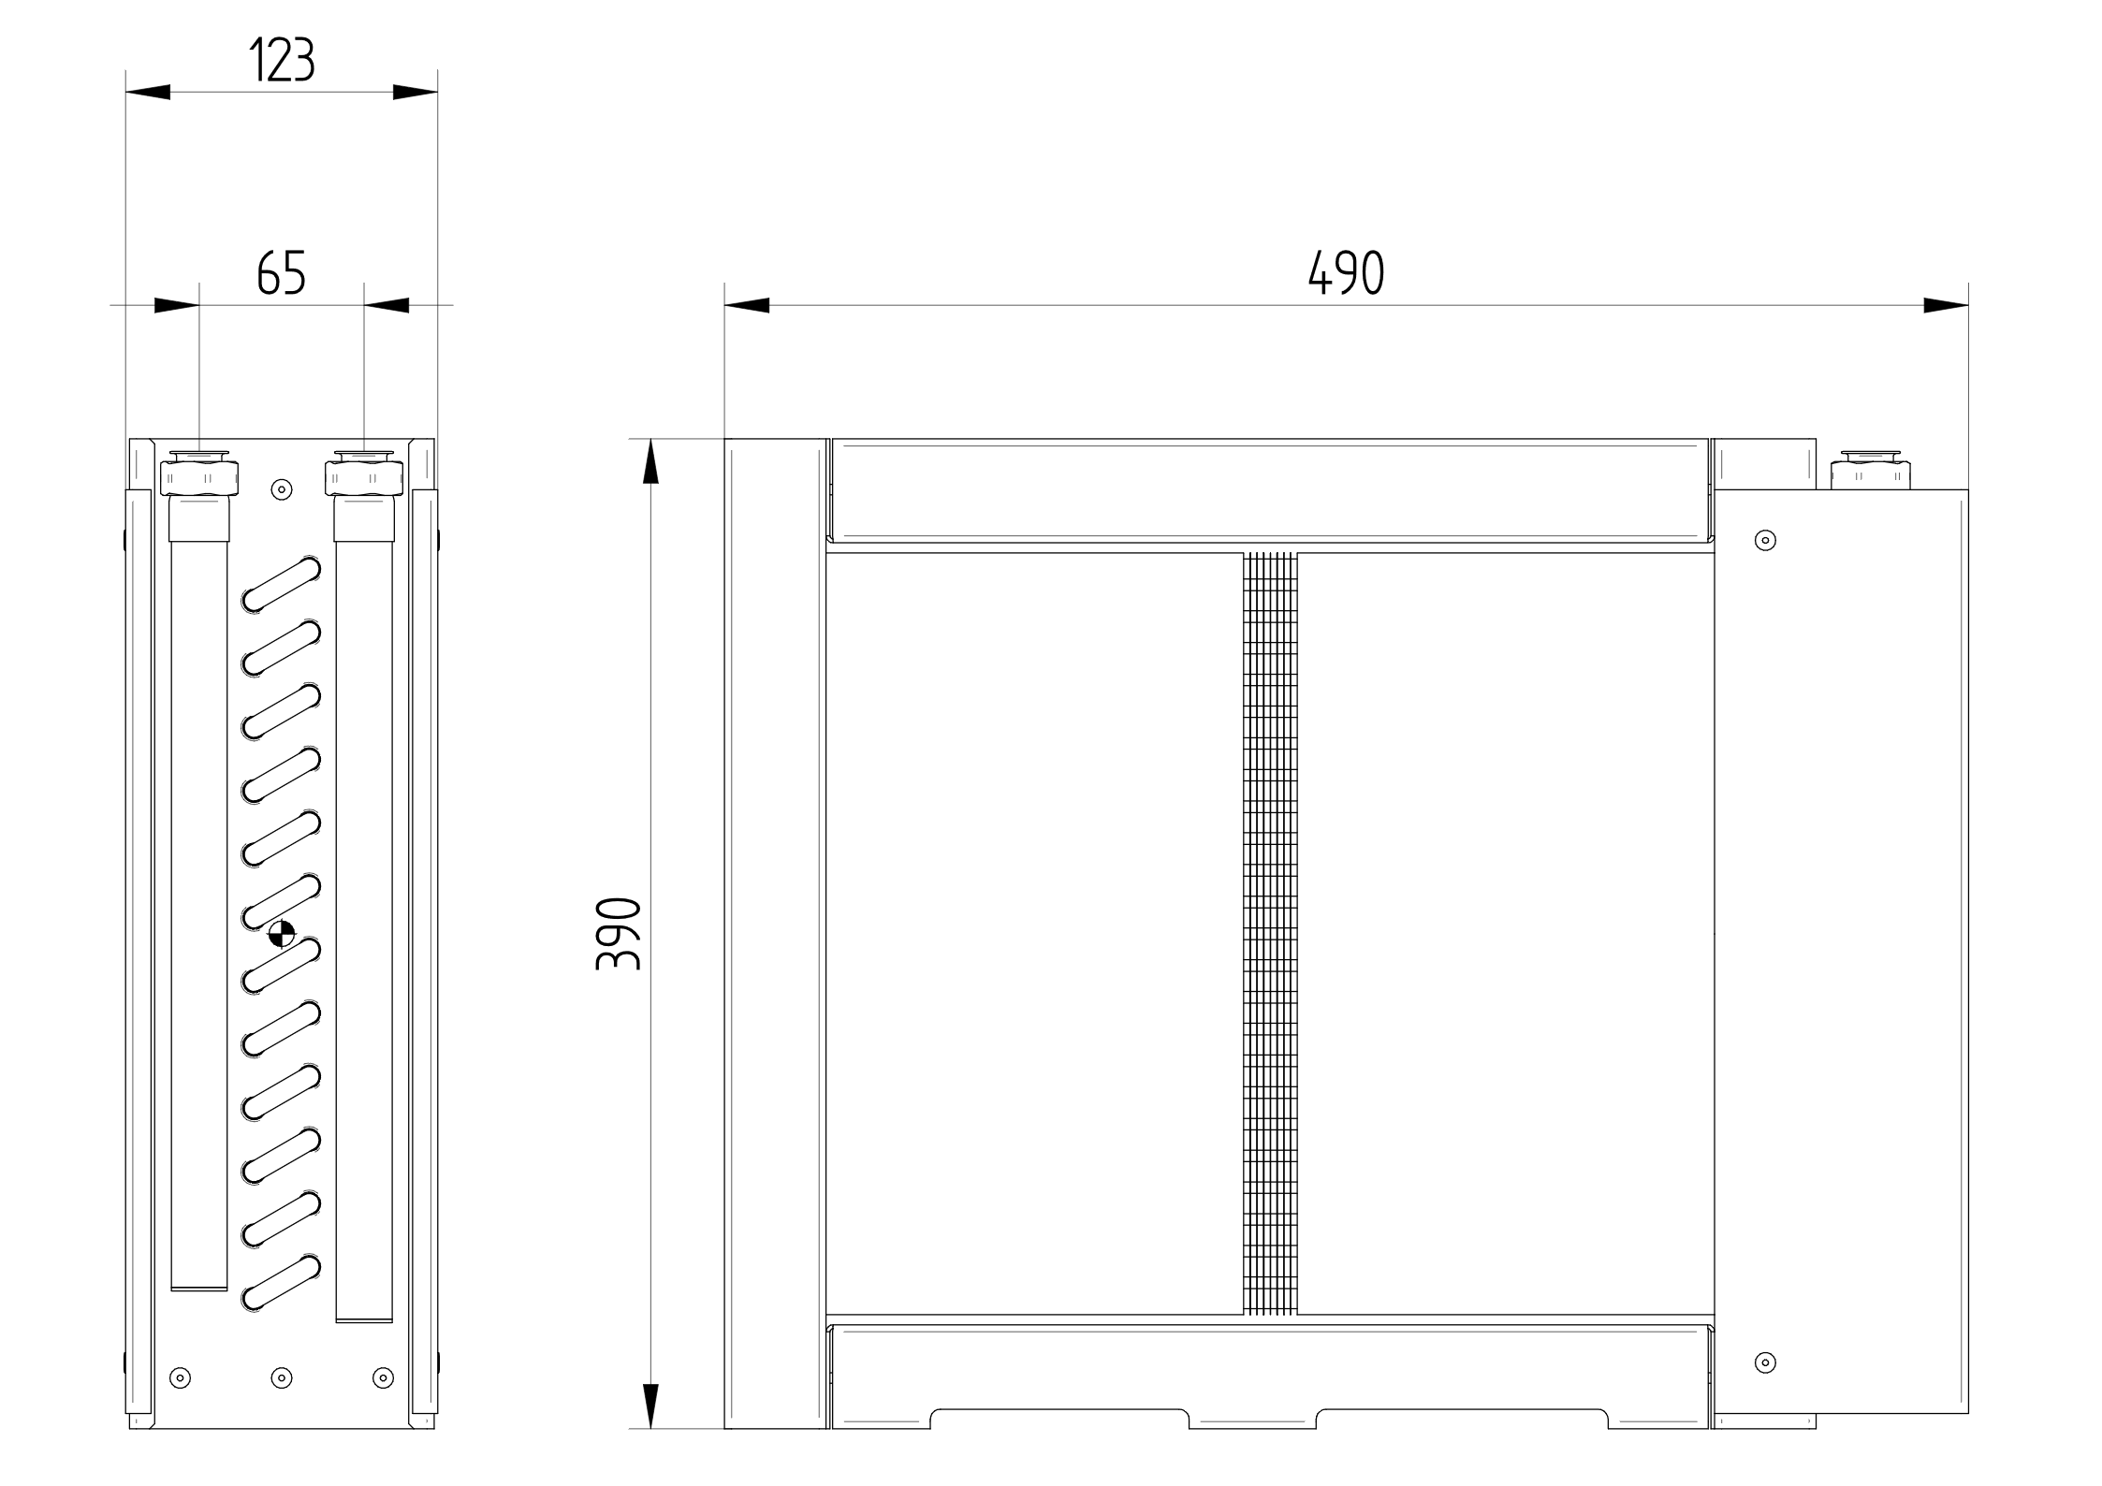

NOTE: The actual appearance and colour of the device may differ from the illustration shown.

WANAS 444
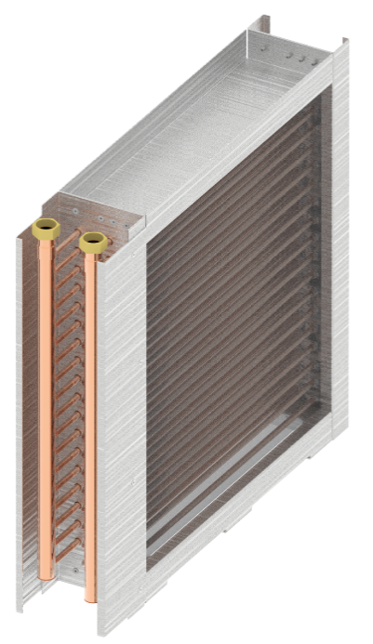
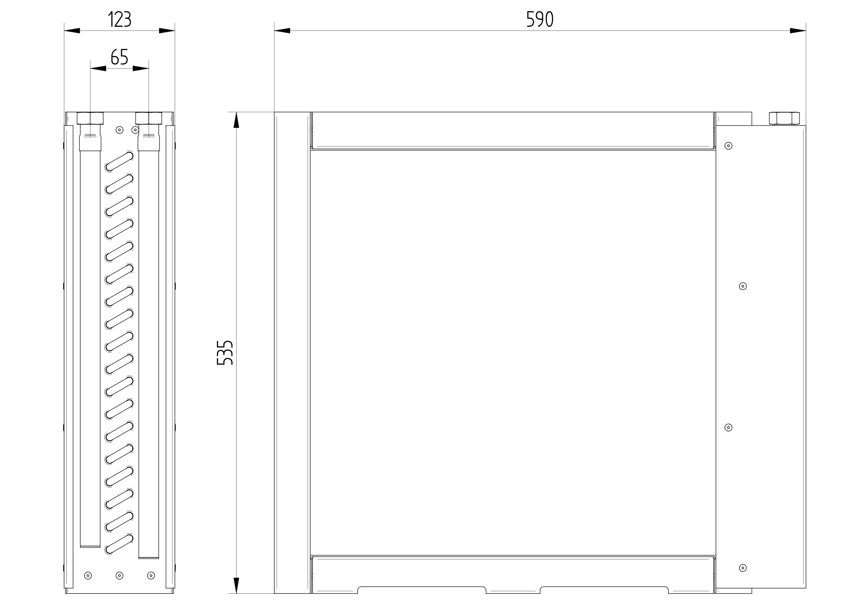
NOTE: The actual appearance and colour of the unit may differ from the illustration shown.

334 Water heat exchanger specifications

334 water exchanger specifications
COOLING FUNCTION – medium water
Air flow | Temperature before the heat exchanger | Humidity before the heat exchanger | Temperature after the heat exchanger | Humidity after the heat exchanger | Cooling capacity
[m^3/h] | °C | % | °C | % | [kW]
100 | 28 | 35 | 9,6 | 93,5 | 0,7
150 | 28 | 35 | 10,8 | 90,1 | 1,0
200 | 28 | 35 | 11 | 89,4 | 1,3
250 | 28 | 35 | 11,3 | 88,5 | 1,6
300 | 28 | 35 | 11,6 | 87,5 | 1,8
350 | 28 | 35 | 11,9 | 86,5 | 2,1
400 | 28 | 35 | 12 | 85,5 | 2,3
450 | 28 | 35 | 12,6 | 84,5 | 2,5
600 | 28 | 35 | 13,3 | 82 | 3,1
HEATING FUNCTION – medium water
Air flow | Temperature before the heat exchanger | Humidity before the heat exchanger | Temperature after the heat exchanger | Humidity after the heat exchanger | Cooling capacity
[m^3/h] | °C | % | °C | % | [kW]
100 | 18 | 50 | 39,1 | 14,7 | 0,7
150 | 18 | 50 | 37,5 | 16 | 1,0
200 | 18 | 50 | 36,3 | 17 | 1,3
250 | 18 | 50 | 35,3 | 18 | 1,5
300 | 18 | 50 | 34,8 | 18,5 | 1,7
350 | 18 | 50 | 34,6 | 18,7 | 2,0
400 | 18 | 50 | 34,3 | 19,1 | 2,2
450 | 18 | 50 | 34 | 19,4 | 2,5
654 | 18 | 50 | 33,1 | 20,4 | 3,1
For cooling: Supply water temperature 7°C. Return water temperature 8.2°C.
For heating: Supply water temperature 43°C, return water temperature 39°C.

334 water exchanger specifications 40% ethylene glycol solution
COOLING FUNCTION – medium 40% ethylene glycol solution
Air flow | Temperature before the heat exchanger | Humidity before the heat exchanger | Temperature after the heat exchanger | Humidity after the heat exchanger | Cooling capacity
[m^3/h] | °C | % | °C | % | [kW]
100 | 28 | 35 | 8,7 | 93,8 | 0,8
150 | 28 | 35 | 10 | 90,5 | 1,1
200 | 28 | 35 | 11 | 87,6 | 1,3
250 | 28 | 35 | 11,9 | 85 | 1,5
300 | 28 | 35 | 12,6 | 82,6 | 1,7
350 | 28 | 35 | 13,2 | 80,8 | 1,9
400 | 28 | 35 | 13 | 81,5 | 2,2
450 | 28 | 35 | 13,1 | 81,1 | 2,4
600 | 28 | 35 | 13,7 | 79,4 | 3,1
HEATING FUNCTION – 40% ethylene glycol solution
Air flow | Temperature before the heat exchanger | Humidity before the heat exchanger | Temperature after the heat exchanger | Humidity after the heat exchanger | Cooling capacity
[m^3/h] | °C | % | °C | % | [kW]
100 | 18 | 50 | 43,6 | 11,6 | 0,9
150 | 18 | 50 | 41,6 | 12,9 | 1,2
200 | 18 | 50 | 40,0 | 14 | 1,5
250 | 18 | 50 | 38,6 | 15 | 1,8
300 | 18 | 50 | 37,5 | 16 | 2,0
350 | 18 | 50 | 36,6 | 16,8 | 2,2
400 | 18 | 50 | 35,7 | 17,6 | 2,4
450 | 18 | 50 | 35 | 18,3 | 2,6
654 | 18 | 50 | 33,2 | 20,3 | 3,1

For cooling: Supply water temperature 6°C. Return water temperature 6.8°C.
For heating: Supply water temperature 49°C, return water temperature 44.5°C

444 water exchanger specifications

Medium - water
COOLING FUNCTION – medium water
Air flow | Temperature before the heat exchanger | Humidity before the heat exchanger | Temperature after the heat exchanger | Humidity after the heat exchanger | Cooling capacity
[m^3/h] | °C | % | °C | % | [kW]
300 | 28 | 35 | 9,3 | 94,3 | 2,2
450 | 28 | 35 | 10 | 92,3 | 3,1
600 | 28 | 35 | 10,7 | 90,4 | 3,9
750 | 28 | 35 | 11,2 | 88,8 | 4,7
900 | 28 | 35 | 11,7 | 87,3 | 5,4
1050 | 28 | 35 | 12,1 | 85,9 | 6,1
1200 | 28 | 35 | 12,5 | 84,6 | 6,7
1350 | 28 | 35 | 12,9 | 83,4 | 7,3
HEATING FUNCTION – medium water
Air flow | Temperature before the heat exchanger | Humidity before the heat exchanger | Temperature after the heat exchanger | Humidity after the heat exchanger | Cooling capacity
[m^3/h] | °C | % | °C | % | [kW]
300 | 18 | 50 | 38,5 | 15,2 | 2,1
450 | 18 | 50 | 37,5 | 16 | 3,0
600 | 18 | 50 | 36,7 | 16,7 | 3,8
750 | 18 | 50 | 35,9 | 17,4 | 4,6
900 | 18 | 50 | 35,3 | 18 | 5,3
1050 | 18 | 50 | 34,7 | 18,6 | 6,0
1200 | 18 | 50 | 34,2 | 19,1 | 6,6
1350 | 18 | 50 | 33,8 | 19,6 | 7,3
For cooling: Supply water temperature 7°C. Return water temperature 7.9°C.
For heating: Supply water temperature 43°C, return water temperature 40°C.

Medium - 40% ethylene glycol
COOLING FUNCTION – medium 40% ethylene glycol
Air flow | Temperature before the heat exchanger | Humidity before the heat exchanger | Temperature after the heat exchanger | Humidity after the heat exchanger | Cooling capacity
[m^3/h] | °C | % | °C | % | [kW]
300 | 28 | 35 | 10,0 | 90,3 | 2,1
450 | 28 | 35 | 11,2 | 86,8 | 2,9
600 | 28 | 35 | 11,2 | 86,9 | 3,8
750 | 28 | 35 | 11,6 | 85,6 | 4,6
900 | 28 | 35 | 12 | 84,3 | 5,4
1050 | 28 | 35 | 12,4 | 83,1 | 6,1
1200 | 28 | 35 | 12,8 | 81,9 | 6,7
1350 | 28 | 35 | 13,2 | 80,7 | 7,3
HEATING FUNCTION – medium 40% ethylene glycol
Air flow | Temperature before the heat exchanger | Humidity before the heat exchanger | Temperature after the heat exchanger | Humidity after the heat exchanger | Cooling capacity
[m^3/h] | °C | % | °C | % | [kW]
300 | 18 | 50 | 39,4 | 14,4 | 2,2
450 | 18 | 50 | 37,4 | 16,1 | 3,0
600 | 18 | 50 | 35,8 | 17,5 | 3,6
750 | 18 | 50 | 34,8 | 18,6 | 4,3
900 | 18 | 50 | 35 | 18,4 | 5,2
1050 | 18 | 50 | 34,6 | 18,7 | 6,0
1200 | 18 | 50 | 34,3 | 19,1 | 6,6
1350 | 18 | 50 | 33,9 | 19,5 | 7,3
For cooling: Supply water temperature 5.9°C. Return water temperature 6.7°C.
For heating: Supply water temperature 46°C, return water temperature 42.6°C.

Schematic diagram of connection
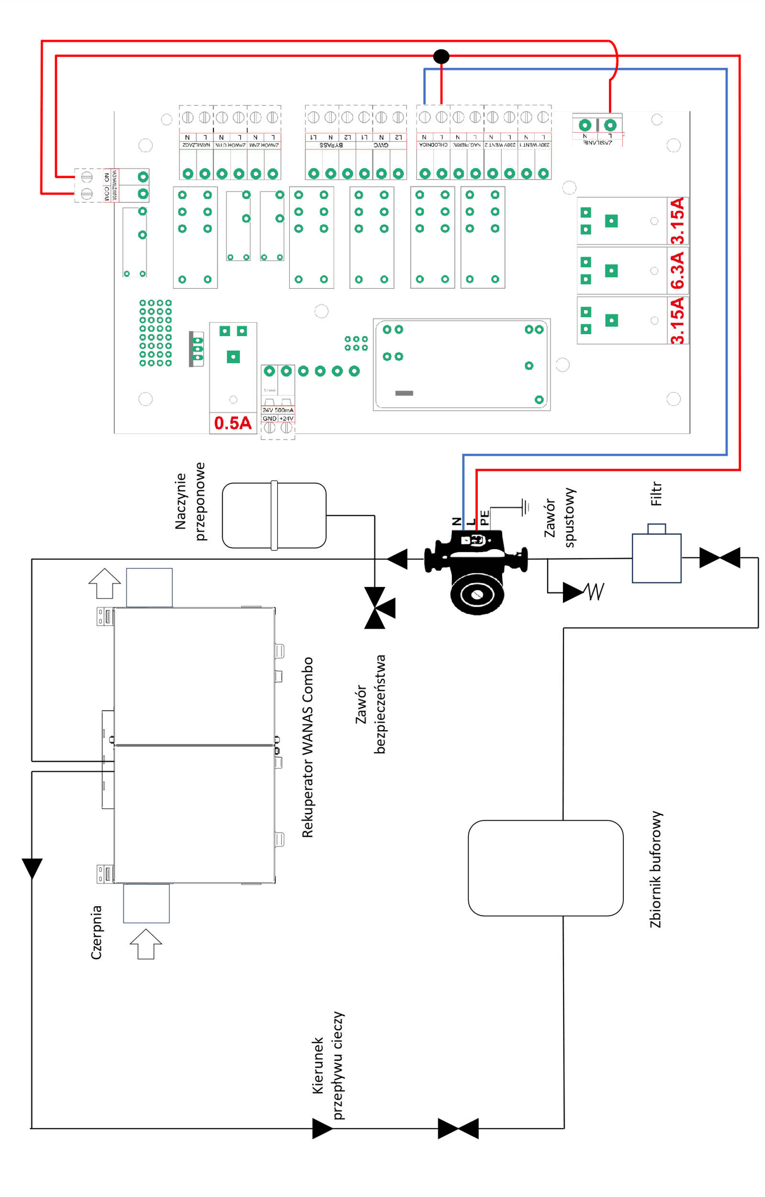

Warranty and Service

Service
All faults must be reported to WANAS with a detailed description of the problem using the ‘Service Request’ form available at www.wanas.pl under the ‘Contact’ tab. Claims made during the warranty period will be assessed within 14 days and resolved within 30 days of the date of submission.

Warranty
- The manufacturer provides a 24-month warranty covering the correct operation of the device.
- The warranty period is calculated from the date of purchase of the device by the user.
- The warranty is granted and valid upon presentation of the device’s proof of purchase.
- The warranty does not cover faults arising from incorrect use, maintenance or installation of the device.
- The cost of an unjustified service call shall be borne by the customer making the claim.
- The company provides servicing throughout Poland.

Contact the service department
Tel: | +48 535 958 222
Service request | Click here

