Operation and Maintenance Documentation
INSTALLATION AND OPERATING MANUAL
WANAS 340

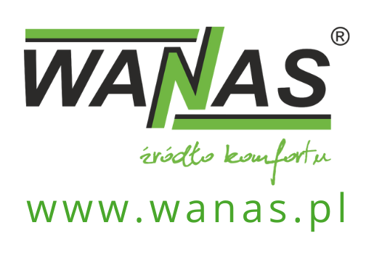
List of content
1. General 3
1.1. Purpose of device 3
1.1. Delivery 4
1.2. Safety 4
1.3. Dimensions 5
1.4. Charakteristics 7
2. Installation 8
2.1. Installation of the device 8
2.2. Condensate drainage 8
2.3. Place of installation 9
2.3.1. Minimum access distances 11
2.4. Assembly positions 12
2.5. Assembly of wall panel 13
3. Controller operation 14
3.1. Operation via SCP room control panel 14
3.2. Using the mobile app (first-time set-up) 15
3.3. Remote control of the heat recovery unit – via a web browser 18
3.4. Time modes 21
3.5. Bypass 21
3.6. Software update 21
5. Electrical diagrams 23
5.1. Control board electric diagram 23
5.2. Diagram of additional elements connection to device 24
6. Maintanance 25
6.1. Inspections and maintenance 25
6.2. Exchander deassembly 25
7. Modbus RTU 26
7.1. List of Modbus RTU registers 26
8. Warranty and service 29
8.1. Service 29
8.2. Warranty 29

General

Purpose of device
A recuperator is used for ventilation of apartments, single-family houses, and offices. Fresh and filtered air is supplied to the rooms, the so-called "clean" rooms, living room, bedroom, and used air is extracted from the so-called "dirty" rooms, e.g. bathrooms, laundry rooms, kitchens, and wardrobes.
Continuous air exchange ensures better living comfort and removal of moisture from the building with simultaneous heat recovery.
The device is equipped with an automatic bypass used mainly in summer at night, where the supplied cool air does not pass through the exchanger but is supplied directly to the rooms, improving the comfort in the building.
As standard, each recuperator is equipped with a touch weekly controller. Using an additional module, the device can be connected to the Internet and controlled remotely. The design and manufacture of the product is based on harmonized standards.
If you intend to get rid of this product, do not dispose of it with normal household waste. According to the WEEE directive (Directive 2002/96/EC) in force in the European Union, separate methods of disposal must be used for used electrical and electronic equipment. The aim of the directive is to prevent the adverse effects of electronic waste on the environment through its collection, reuse, recycling and recovery. The appliance is marked with the symbol of a crossed-out wheelie bin, which serves as a reminder of the obligation to collect end-of-life equipment separately. For more information regarding the recycling of waste from this Product, please contact the municipal authorities in your area, with the appropriate waste disposal service. | 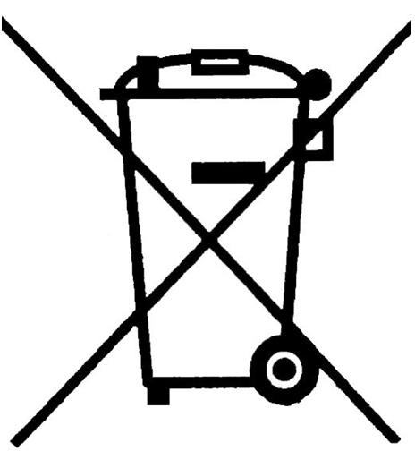
The manufacturer declares that the product complies with the LVD 2006/95/EC Directive, relating to electrical devices operating within the specified voltage range. The product has been marked as a result of the conformity assessment procedure. | 

Delivery
Before installing the control unit, please ensure that all items in the kit are present.
If any of the following components are missing, please contact the retailer.
The kit should include: an air handling unit, a control panel, set of air filters, mounting brackets for the air handling unit , screws for fixing the brackets to the wall , siphon .

Safety

The manufacturer waives any responsibility whatsoever for the damage resulting from improper installation and use of the product contrary to its intended use and this manual, and the resulting damage cannot be the basis for a complaint or warranty repairs.
- Installation of the device should be performed by appropriately qualified personnel.
- The device may only be operated by adults who have read the manual.
- It is forbidden to install the device in an installation without an efficient protective conductor and residual current device.
- It is forbidden to mount the controller below the recuperator.
- The electrical installation in which the device is connected must be equipped with overvoltage protection.
- The unit should be installed in a place where the temperature is between 5°C and 45°C. Too low ambient temperature may result in water vapour condensation on the casing of the device and, consequently, its failure.
- It is forbidden to turn on the device in the building where construction works are carried out.
- The siphon should be attached to the recuperator, it must not be damaged.

A damaged drain may lead to water leakage and flooding the unit. The room in which the device is located should be equipped with a drain in the floor. Do not place other electric and electronic devices under or in the immediate vicinity of the recuperator.

- Upon replacement of the filters, it is necessary to check that they are properly inserted and that the door is properly closed.
- Maintenance and filter replacement should be performed with the equipment disconnected from the 230 V mains.
- After maintenance work, always make sure that all drain and inlet valves are tight. Plumbing must be checked regularly.
- In the event of a water leak, stop using the device and disconnect it from the power supply. Subsequently, make sure to contact the Wanas customer service.
- The manufacturer bears no liability for damage caused by direct or indirect actions of people or animals, resulting from non-compliance with this manual, in particular the notes on installation, operation and maintenance of the device.
The control unit should operate continuously. Frequent switching off and restarting may accelerate wear and tear on components, particularly the fans.

Dimensions

340 H
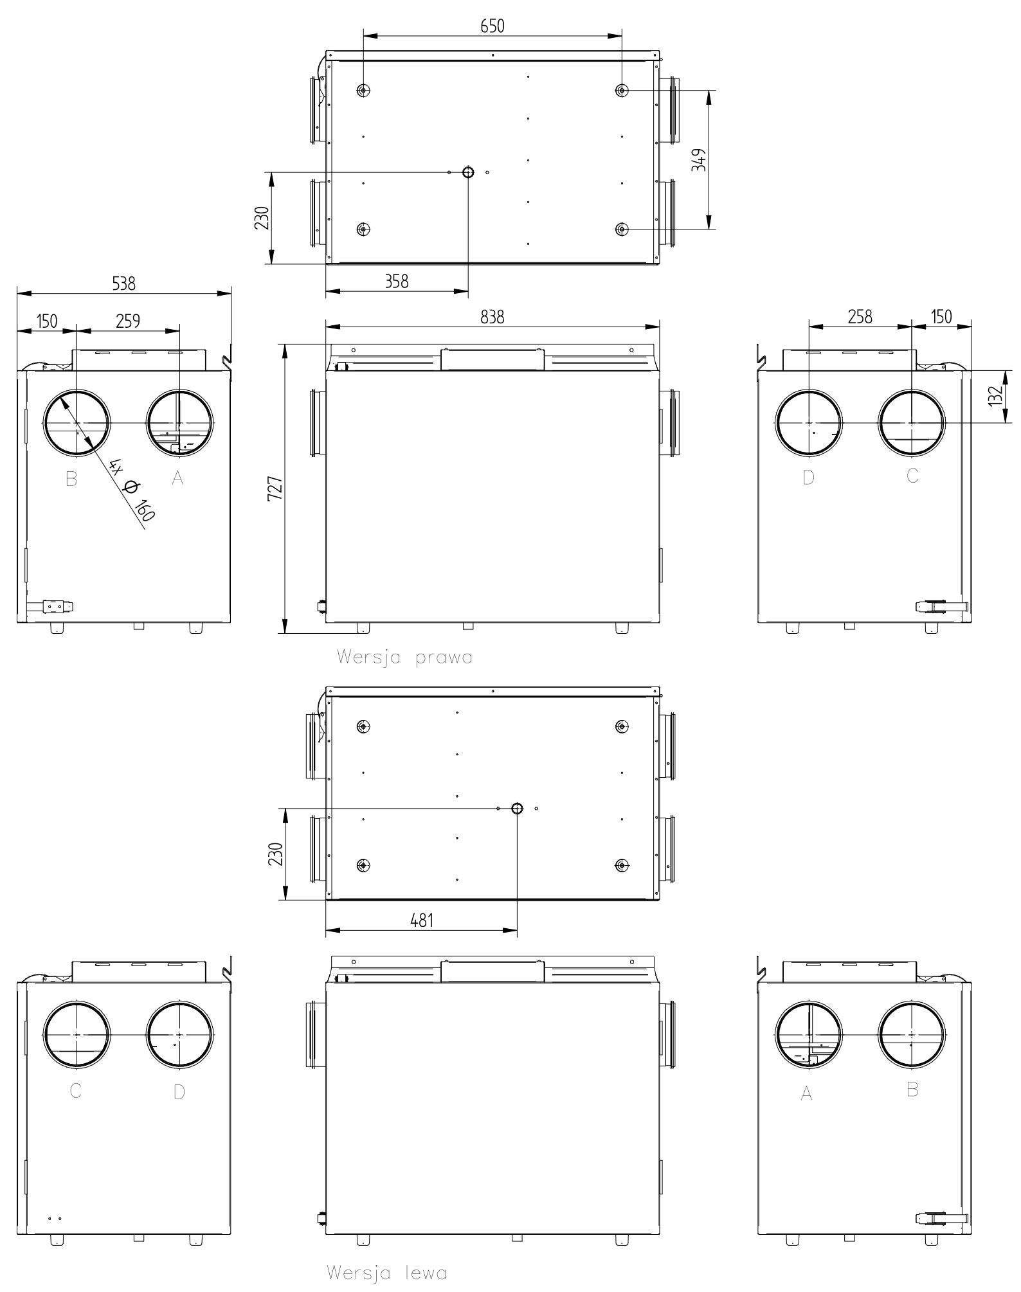
A-Air taken from outside of the building
B-Air taken from rooms
C-Air supplied to rooms
D-Air discharged outside the building

340 V
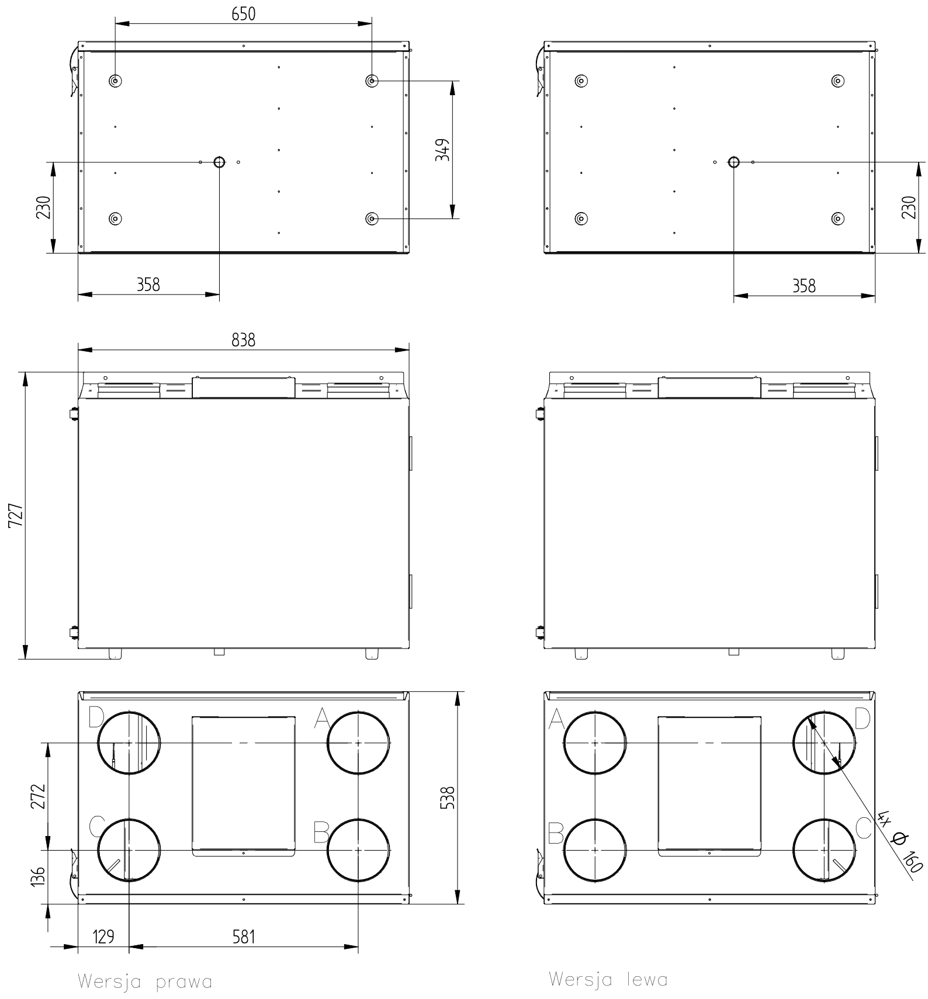

A-Air taken from outside of the building
B-Air taken from rooms
C-Air supplied to rooms
D-Air discharged outside the building

Charakteristics
Performance charts and detailed technical specifications for individual device versions have been moved to dedicated Product Data Sheets. The latest documents for the control unit model you have purchased can be downloaded directly from the website..

Installation

Installation of the device
The installer is responsible for the installation of the device and adjustment of the capacity and should be performed only by a qualified and properly authorized person. Qualified specialists have practical experience and knowledge of ventilation systems, their installation and electrical safety regulations. The installation of the equipment and the adjustment of its capacity must comply with applicable legislation and the manufacturer’s requirements. For installations containing electrical components, appropriate SEP Group 1 qualifications (or equivalent) are required, whilst for the operation of refrigeration or automation systems, relevant industry certificates (e.g. F-GAZ, manufacturer’s authorisation) are required
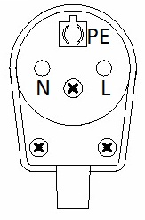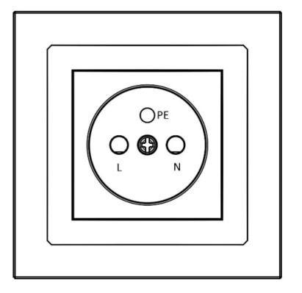
NOTE: The power cord should be connected as shown in the diagram. Connection other than that shown in the diagram will result in incorrect operation of the device or its damage.
The device may only be connected to an installation with a serviceable protective conductor

Condensate drainage
Whilst the heat recovery unit is operating, particularly in cold conditions, water vapour condenses on the heat exchanger.
Condensate is drained via a Ø25 mm drain pipe located at the bottom of the unit. The unit should be situated in a location where the temperature is always above freezing, to prevent, amongst other things, the condensate drain from freezing. The drain pipe should be connected to a trap as shown in the diagram below..

Installation instructions:
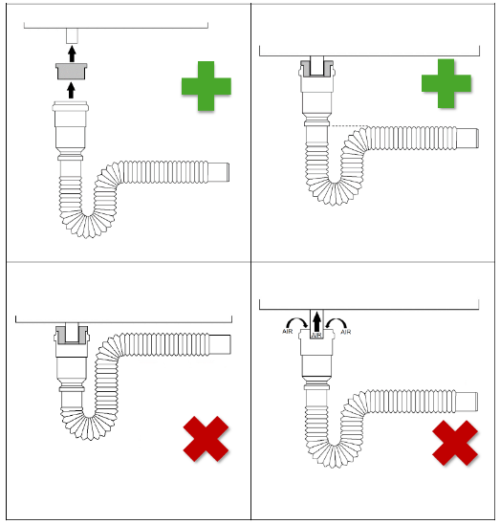
- The unit must be levelled. Wall-mounted units are fitted with levelling screws at the rear of the unit.
- Before using the trap for the first time, it must be filled with water.
- The connection between the drain and the trap must be airtight – the unit must not draw in air through the drain pipe.
- Incorrect connection may result in the appliance or the room becoming flooded – the manufacturer accepts no liability for this

AIR !
It is forbidden to connect two siphons to a single T-piece!

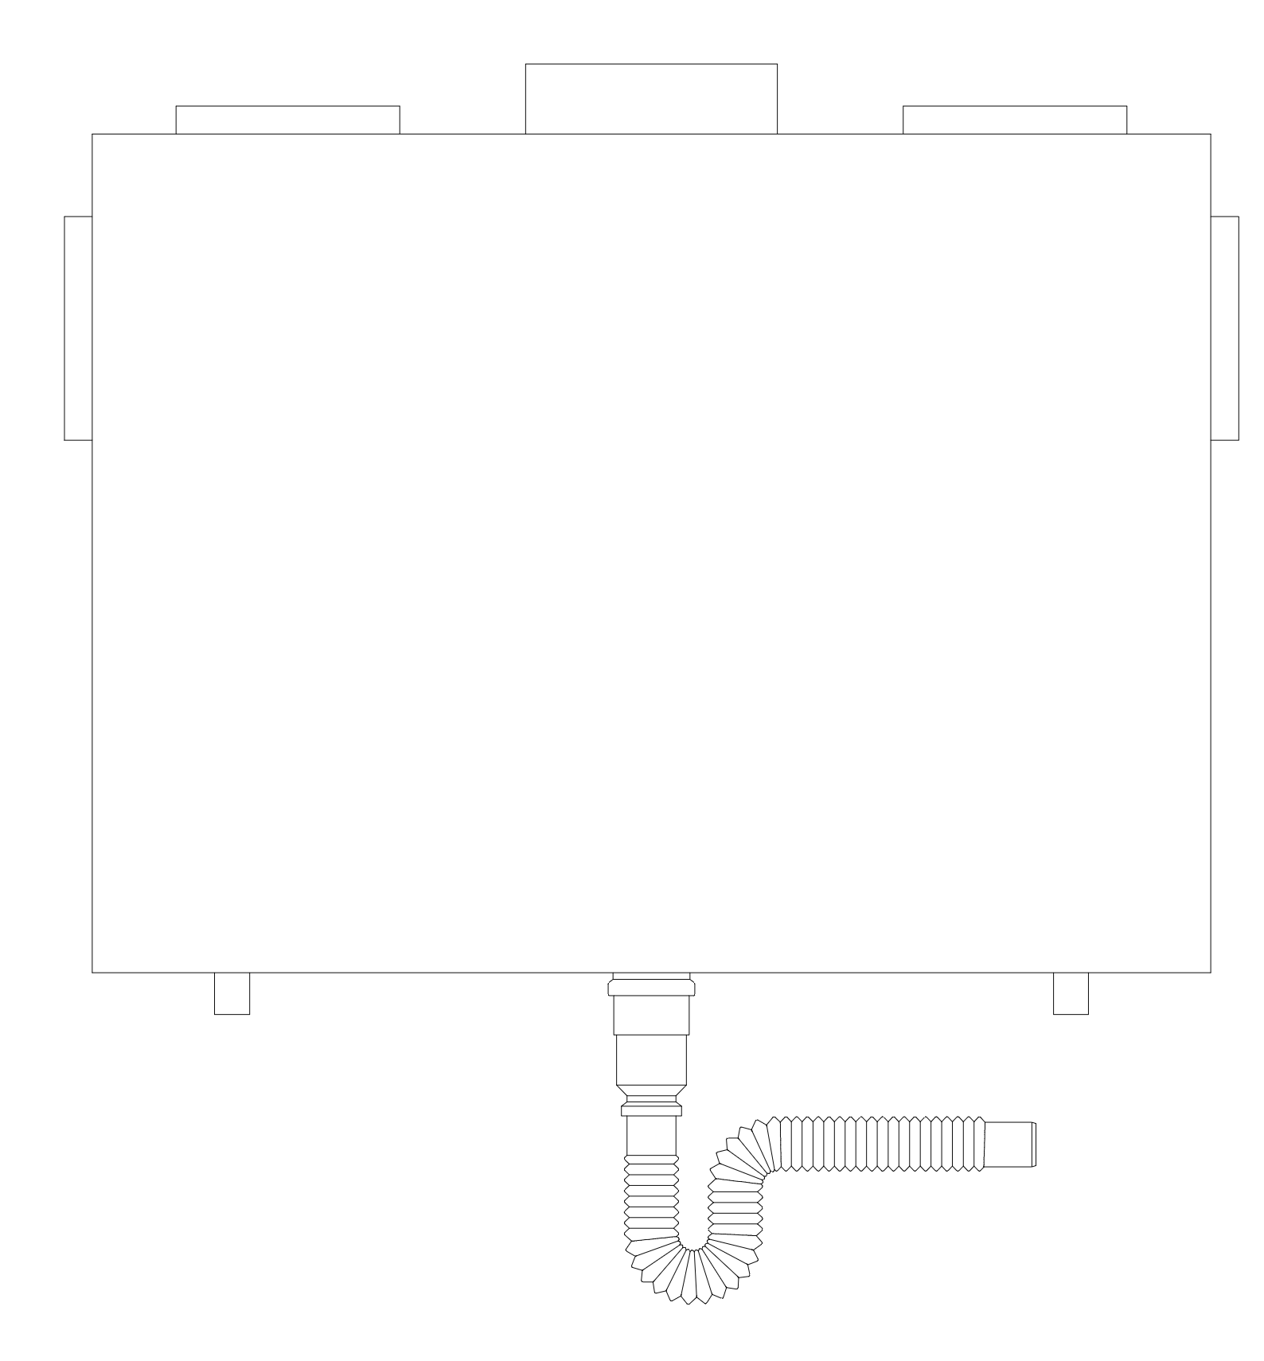

Place of installation
The device should only be installed in rooms where the temperature does not fall below 5°C during its period of use (particularly in winter). Installation in an attic or in unheated spaces is permitted only if the user ensures that the ambient temperature around the unit remains above 5°C throughout its entire service life. Failure to do so may result in damage to the unit and voiding of the warranty.
When installing the unit in an attic or other locations subject to temperature drops, the unit must not be switched off during the winter months to prevent condensation from forming on its components. It is recommended that the temperature be monitored and, if necessary, additional heating be provided for the installation area.
The heat recovery unit should be installed in such a way as to ensure access to it for maintenance and servicing.
The use of mechanical ventilation in the rooms where a fireplace will be installed requires the user to install a fireplace with a closed combustion chamber (air can only be taken from outside the building) and a carbon monoxide sensor. It is forbidden to install a fireplace with air intake from
the room.
It is forbidden to turn off the unit in winter, if installed in the attic. Turning off the unit may
result in water vapour condensation on the unit walls and on the fans.
Holes for wall plugs should be drilled in accordance with the manufacturer’s instructions for the specific type of plug and in line with the type of substrate:
- When installing in concrete or solid brick, it is recommended to use a hammer drill and select the appropriate drill bit in accordance with the anchor manufacturer’s instructions (usually a concrete drill bit, with hammer action).
- When working on a substrate of ceramic hollow blocks or aerated concrete, it is recommended to use a non-hammer drill to avoid expanding and weakening the wall structure.
- In all cases, follow the manufacturer’s instructions regarding the diameter and depth of the hole, as well as the method of fixing the anchor

Minimum access distances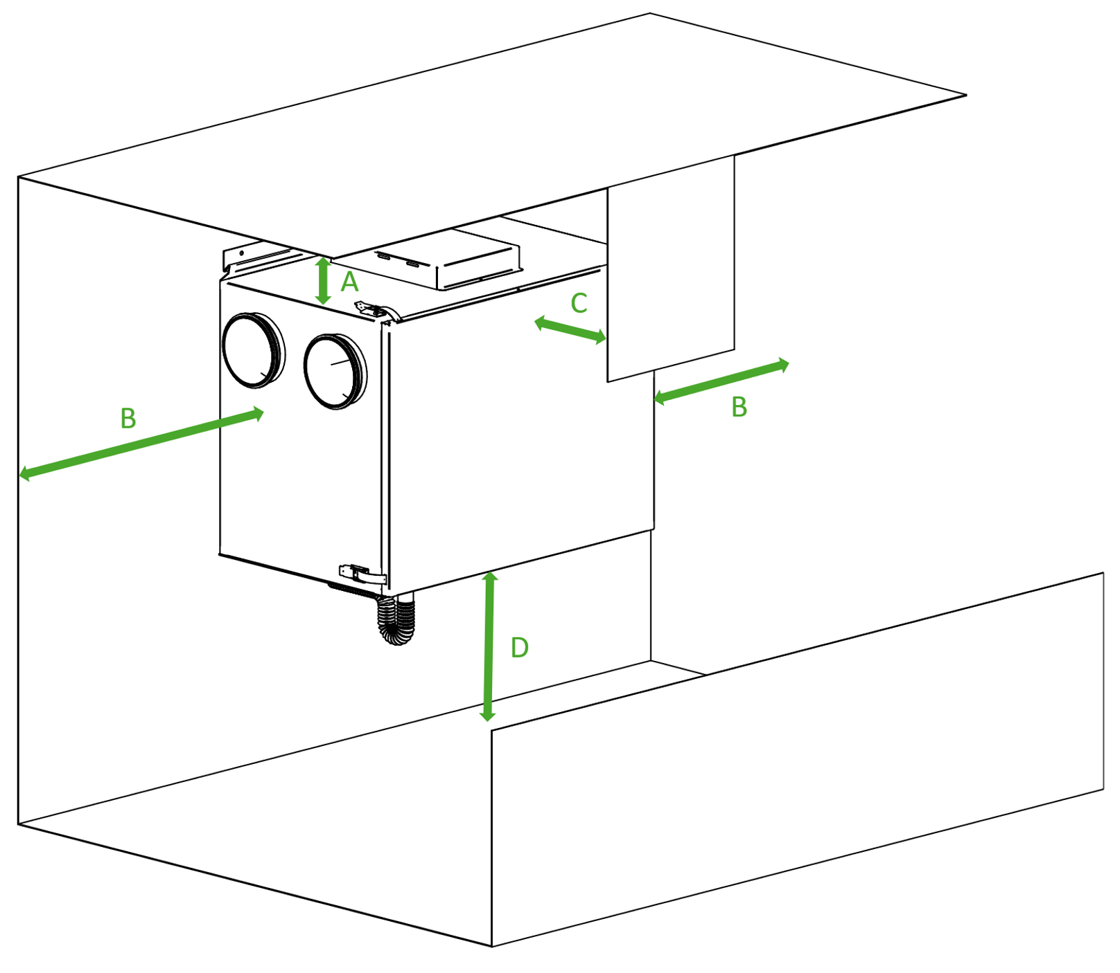
Model | A  [mm] | B  [mm] | C  [mm] | D  [mm]
340 H | min. 130 | min. 400 | min. 850 | min. 250
340 V | min. 400 | min. 100 | min. 850 | min. 250

Assembly positions
Assembly on stand | Assembly of Vertical Control Units (Wall-mounted) | Assembly of flat unit (suspended)
Larger air handling units, as well as selected models of vertical and horizontal units, are designed for installation on a dedicated floor-standing stand (frame). The stand must be placed on a stable and level surface. | Smaller units are designed for wall mounting (on load-bearing walls, partition walls or other vertical structures). Dedicated mounting brackets and screws are supplied with the units. If mounting on a different type of surface (e.g. plasterboard), other fixing elements suitable for that type of surface must be used. | Flat-design air handling units are designed as standard for ceiling-mounted installation (on ceilings, slabs or other horizontal structures) with the access doors facing downwards. The unit is fitted with special brackets. The brackets must be secured to the supporting structure using suitable fasteners designed for this purpose.

 | 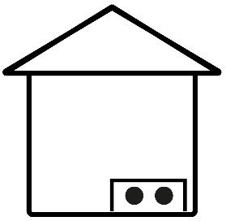 | 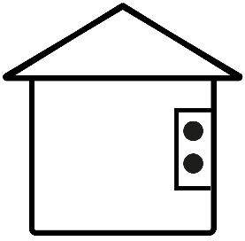 | 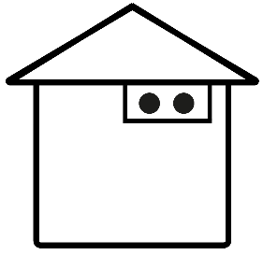
 | Assembly on stand | Wall mounted | Assembly on celing
Black 200 V  Black 300 V | + | + | -
250 H | + | + | -
340 V, 340 H | + | + | -
400 V, 400 H | + | + | -
600 V, 600 H | + | + | -
Combo 430 V/H  Combo 630 V/H | + | + | -
Combo 830 V/H  Combo 1030 V/H  Combo 1330 H | + | - | -
800 V/H  915 H  1315 H | + | - | -
345 XF  545 XF  845 XF  1345 XF | - | - | +

Assembly of wall panel
The room panel is designed for wall mounting in dry rooms only. The panel must not be used in conditions where water vapour condensation occurs. It must be protected from contact with water and must not be installed directly beneath an air handling unit..
The panel should be installed in accordance with the following guidelines.
Detach the mounting frame from the rear housing of the panel. The frame is secured to the panel housing by snap-fits. You can use a flat-bladed screwdriver to detach the frame. Connect the transmission and power supply wires linking the panel to the heat recovery unit to the panel’s terminals. The cable connecting the panel to the heat recovery unit should be recessed into the wall. The cable connecting the panel to the heat recovery unit must not be routed alongside the building’s mains electricity cables. The cable should also not run near equipment emitting strong electromagnetic fields. Drill holes in the wall and use screws to secure the mounting frame in the chosen position on the wall, ensuring it is correctly aligned (UP). Then secure the panel to the mounting frame using the snap-in fasteners.
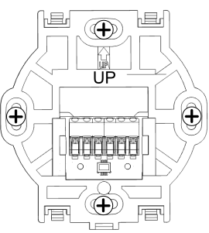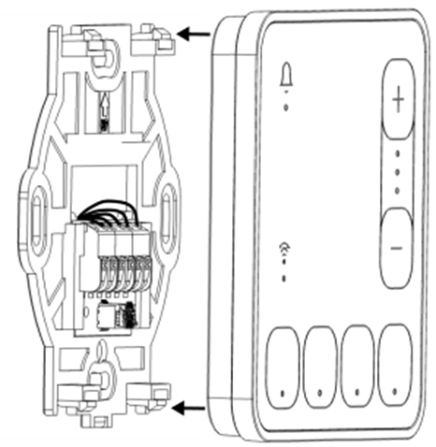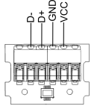
When the heat recovery unit is switched on, the LEDs on the SCP room control panel light up in sequence, indicating that the software is loading. This process takes approximately 10 seconds. If it takes significantly longer, check that the D+ and D- wires of the communication cable connecting the control panel to the heat recovery unit are correctly connected..
Removing the panel.
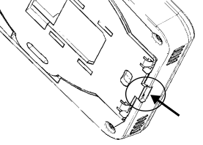
To detach the panel from the mounting surface, insert a flat object, such as a screwdriver, into the indicated slot in the mounting frame. This will release the mounting frame’s latches and allow you to remove the panel.

Controller operation
The heat recovery unit can be operated via:
- SCP room control panel – quick access to selected functions;
- Applikation Wanas Cloud ( iOS / Android) – via Bluetooth or Wi-Fi – initial set-up and adjustment;
- a web browser – accessible remotely via the internet and a Wi-Fi network – for the user.

Operation via SCP room control panel
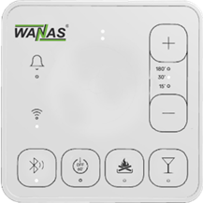  SCP panel with party function – compatible with software up to version S001.35 | 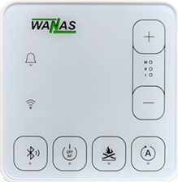  SCP panel with manual operation function – compatible with software from version S002.08
NOTE! It is possible to update an older control panel to the new software version. Once updated, the SCP control panel will have the same functionality as the new control panel – instead of ‘party’ mode, it will be possible to change gears manually.
IMPORTANT! Once you have updated to the new version of the control panel, it is not possible to revert to a previous version of the software.
The basic functions of the heat recovery unit are controlled by pressing the relevant function button on the SCP room panel. Once the heat recovery unit is started, the ventilation rate is controlled according to a schedule (default: mode 1), which can be freely configured via the Wanas Cloud app (Bluetooth / Wi-Fi) or via the econetcloud.eu web service (Wi-Fi). When a button on the SCP room control panel is pressed, the air handling unit switches to the operating mode corresponding to the selected timer function and then returns to operating according to the schedule.

The button symbols and LED indicators mean:
SCP panel with party function – compatible with software up to version S001.35 | SCP panel with manual operation function – compatible with software from version S002.08
- Switch the SCP room panel between Bluetooth and Wi-Fi modes by holding down the button for 5 seconds (all LEDs will light up).  - Shut down the air handling unit for 60 minutes (LED lit).  - activate the fireplace function for 3 minutes (LED lit).  - Activate party mode for a duration of 15–180 minutes (LED lit). If parental controls are enabled, the panel can be unlocked by holding down the button for 5 seconds.    - increasing or decreasing the operating time of party mode.  - indication of active alerts from the air handling unit, e.g. ‘replace filters’.  - an active connection via Bluetooth or Wi-Fi to the online service. | - Switch the SCP room panel between Bluetooth and Wi-Fi modes by holding down the button for 5 seconds (all LEDs will light up).  - Shut down the air handling unit for 60 minutes (LED lit).  - activate the fireplace function for 3 minutes (LED lit).  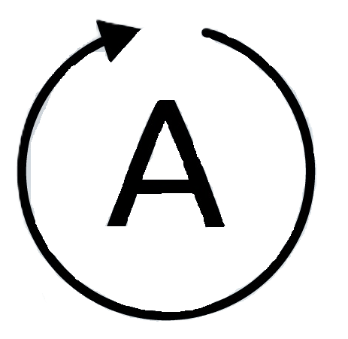 - Switching between schedule-based control and manual control on the SCP panel.  - changing gears on the unit in manual mode.  - indication of active alerts from the air handling unit, e.g. ‘replace filters’.  - an active connection via Bluetooth or Wi-Fi to the online service.

Using the mobile app (first-time set-up)
Aplication Wanas Cloud for Android i iOS enables full operation and configuration of the heat recovery unit via Bluetooth. The Wanas Cloud mobile app can be downloaded from Google Play or the App Store, depending on your operating system. Once you have downloaded the app, you must grant the necessary permissions and install it. Once the app is installed, enable Bluetooth and location services (GPS) and launch the app. You should also ensure that the SCP room panel is in Bluetooth communication mode, which is indicated by the rapidly flashing LED on the Bluetooth/WiFi mode selection button. Once the app is running, search for the SCP room panel and select it.
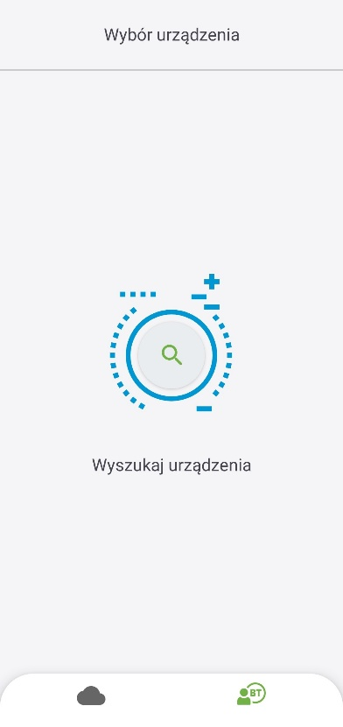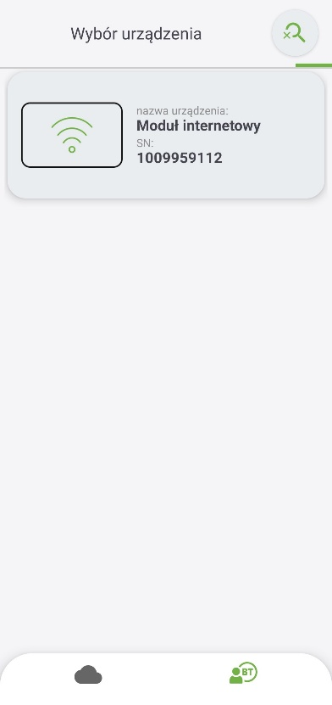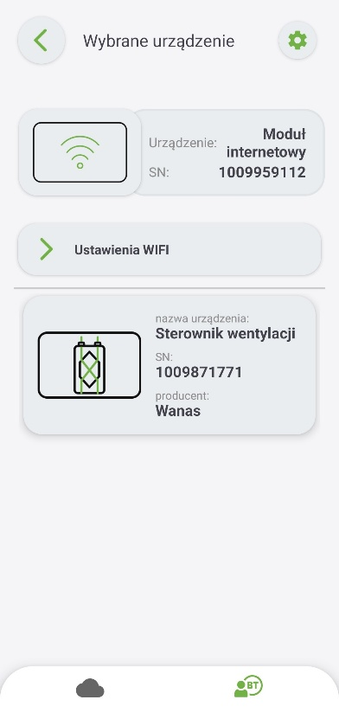
Adding an installation to ecoNET Cloud – a guide that enables users to easily create an account on the website www.econetcloud.eu and operate the heat recovery unit remotely via a web browser.
Setting ecoWiFi – SCP room panel settings. You can enter Wi-Fi network details, generate a password (token) required to link the heat recovery unit to your user account on econetcloud.eu, synchronise the time on the heat recovery unit with your phone, adjust the brightness of the LEDs, enable parental controls, and set the volume for button sounds and notifications.
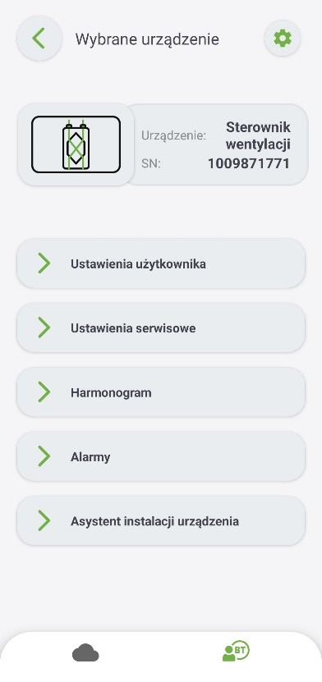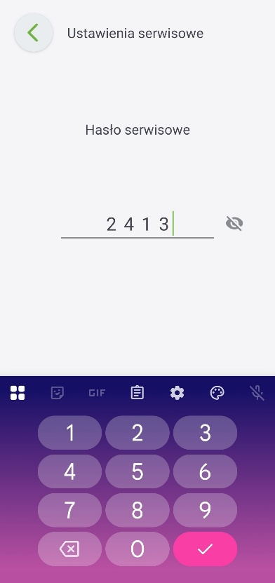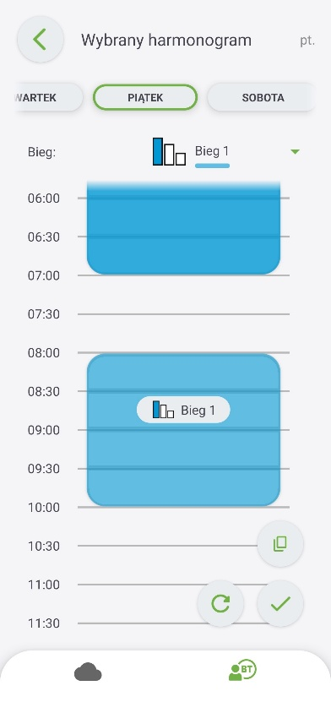
Ustawienia użytkownika – ustawienia temperatury komfortu do której dąży rekuperator, informacje o aktualnym stanie pracy rekuperatora oraz aktywacja i dezaktywacja przepustnicy bypass.
Harmonogram – ustawienia wydajności wentylatorów w zależności od godziny i dnia tygodnia.
Ustawienia serwisowe -ustawienia dla instalatora, zabezpieczone hasłem serwisowym 2413.
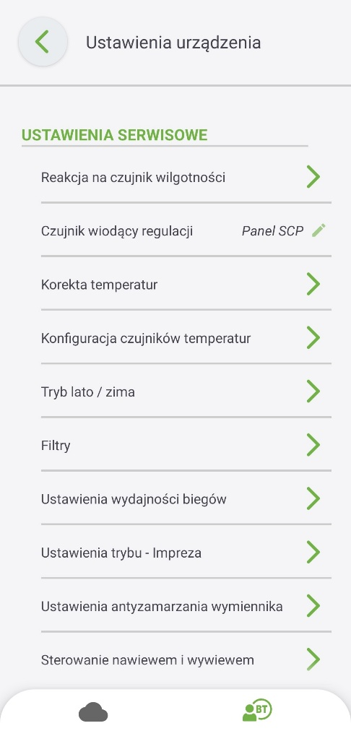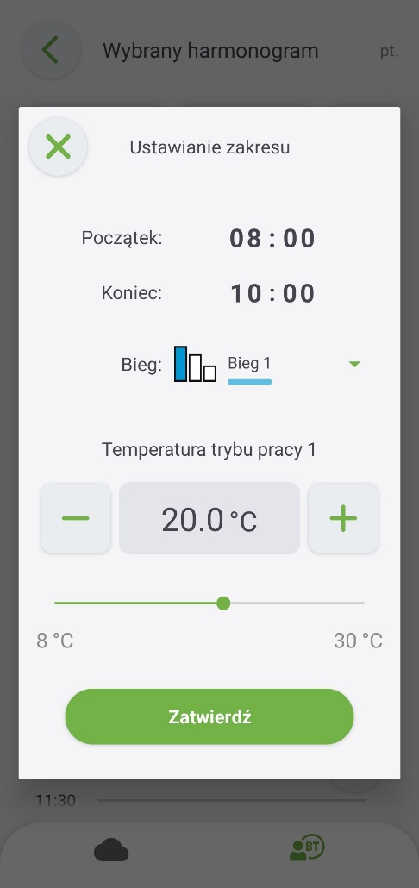
 | Installer menu parameters
Lead sensor for control | The sensor used to implement the function of achieving a comfortable temperature.
Summer/winter mode | The menu contains configuration settings for detecting summer and winter time.
Activating winter mode | The temperature below which the control unit will switch to winter mode
Summer mode activation hysteresis | The value that determines by how much the temperature must rise from the ‘winter mode activation temperature’ for the control unit to switch to summer mode.
Filters | The menu contains options relating to the replacement of air filters.
Gear performance settings | Set the flow rate for each speed in per cent or m³/h. The airflow rate should be adjusted to the building’s volume, the characteristics of the rooms and the number of occupants. The factory settings for the operating modes can be changed as required. Settings should be made on the assumption that GEAR II is intended to provide optimum ventilation, GEAR III to ventilate the building and GEAR I to provide minimum airflow when occupants are absent.
Heat exchanger anti-freeze settings | Settings relating to the settings for the heat exchanger anti-frost system.
Heat exchanger defrost function | Enable or disable the heat exchanger defrost function. The anti-freeze algorithm should always be enabled.
Initial fan settings | This parameter allows you to specify the fan start-up settings during the anti-freeze period.
Use of the preheater | Enabling or disabling the pre-heater.
Adjusting the speed of the supply fan | Change in the supply fan speed whilst the heat exchanger anti-freeze function is active.
Antifreeze activation temperature | When the outdoor temperature falls below the set point, the system goes into standby mode and regulates the operation of the unit to prevent the heat exchanger from freezing. In new buildings where humidity is high, it is recommended to set the activation temperature between 0°C and -3°C. Once the building has been dehumidified, the temperature can be lowered.
Supply and extract air control | Setting the control mode for fans: supply and extract.
Type of regulation | - Standard – percentage control of fan power.  - Constant flow – automatic control of fan speed to maintain a constant flow rate, separately for supply and extract air. Differential pressure sensors are required.
Hood mode settings | Fan speed settings in extractor hood mode. Logic state settings for the extractor hood input.
Air parameter sensor settings | Settings relating to the operation of the humidity sensor built into the SCP room panel.
Humidity sensor | The menu contains settings relating to the operation of the analogue humidity sensor.
Modbus settings | Settings relating to Modbus communication. You must set the Modbus address and your preferred baud rate (9600, 19200, 115200), the number of stop bits and the parity setting.
Modbus address | Settings relating to the Modbus address.
Transmission speed | Transmission speed for Modbus communication.
Number of stop bits | Stop bit settings.
Evenness | Checksum parity settings.
Enabling Modbus | Enabling and disabling Modbus protocol support.
Editing parameters | Permission to edit parameters via the Modbus protocol.
Control via the control unit | Authorisation to control the air handling unit via the Modbus protocol.
Manual control | Manual control allows you to set individual relay outputs manually.  Note: This menu should be used with caution, and outputs should be activated deliberately to avoid damaging the air handling unit..

Remote control of the heat recovery unit – via a web browser
To use the heat recovery unit’s remote control via the internet, you must connect the SCP room control panel to the internet via Wi-Fi.
The Wi-Fi connection should be configured in accordance with the guidelines below:
- Make sure that the SCP room panel is in Bluetooth pairing mode -LED button should rapidly blinking. If not, press and hold the button on the room control panel for about 5 seconds, to turn ON Bluetooth. After a dozen or so seconds, the SCP room panel will restart and the Bluetooth function will be activated.
- Install the dedicated mobile app Wanas Cloud and launch it on your mobile device, then turn on Bluetooth. You can download the app from the Google Play Store. The app also requires GPS location services to be enabled.
- In the mobile app, search for the heat recovery unit to connect to and confirm the connection
- Follow the ‘Adding an ecoNET CLOUD installation’ guide, following the steps in order
- Once you have completed the Wi-Fi configuration in the mobile app, switch the SCP room panel back to Wi-Fi mode by holding down the button for about 5 sek.
- Wait for a dozen or so seconds until the SCP room panel restarts, the Bluetooth function is disabled and the Wi-Fi function is enabled, in which:
- If buttons LED lit continuously, this indicates an active connection to the Wi-Fi network and to the website,
- If buttons LED is not on, there is no connection to the Wi-Fi network. Please check that your login details for the local Wi-Fi network are correct.
- If buttons LED flashes (more slowly than when Bluetooth is active), this means there is a Wi-Fi connection but no access to the website. Please check your internet connection.

- Go to the ‘Add website installation’ option and, in the left-hand sidebar, select ‘Settings’ .
- Click ‘+ Add component’ to add a heat recovery unit to the system. Adding a heat recovery unit will display tiles on the homepage of the website for configuring and operating the unit.
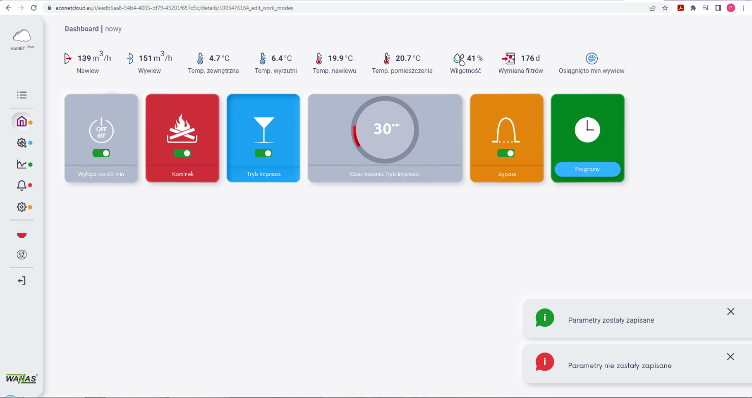
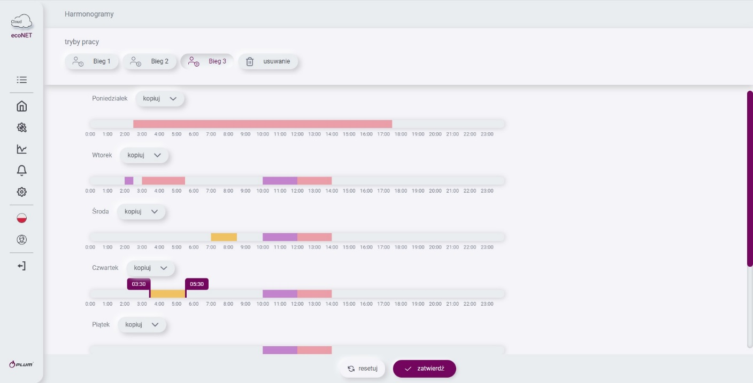
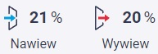 - current fan speed;
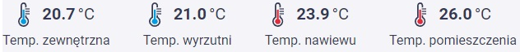 - current temperature;
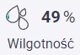 - current humidity;
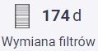- number of days remaining until the filters need replacing.
The settings and functions are the same as those described in section 3.2.

Time modes
The air handling unit operates according to a weekly programme, but time-based modes – such as ‘party’ or ‘fireplace’ – take precedence. Once the time-based mode has ended, the unit returns to operating according to the weekly programme.
- 60-minute Off mode: suspends the operation of the air handling unit; this mode can be used, for example, whilst the building’s occupants are away.
- Party Mode: when activated, this forces the boiler to operate in stage 3 for a specified period of time
- This mode can be used, for example, when there are a number of people in the room.
Fireplace: if this function is enabled, the supply fan will be set to maximum speed and the extract fan will be switched off for 3 minutes. This is intended to temporarily create positive pressure in the building, ensuring that no smoke escapes into the room whilst the fireplace is in use.

Bypass
Bypass – used to cool rooms at night in summer, when it is hot inside the house and the outside temperature is lower at night. When the electronic bypass is active, one fan operates (either the supply or extract fan, with air exchange taking place through an open window); the air does not recover heat via the heat exchanger and is fed directly into the rooms at a cool temperature. This function operates when the outside temperature is lower than the room temperature and when the outside temperature is higher than the bypass activation threshold. During the summer, to improve comfort, it is recommended to activate the bypass in the main menu, on the page www.econetcloud.eu .
- Winter mode – the temperature (6 degrees by default) below which winter mode will be activated.
- Summer mode activation hysteresis – the hysteresis value for mode change (default 14 degrees); if the outdoor temperature rises above the winter mode activation threshold plus the summer mode activation hysteresis, summer mode will be activated. In summer mode, the bypass and GWC can operate in cooling mode

Software update
Software updates for both the SCP room controller and the heat recovery unit’s main board must be carried out by using www.econetcloud.eu website. In the ‘Installation Settings’ tab, you will find an icon indicating that a newer version of the software is available. The update will be automatically downloaded and installed on the controller. The process will not result in the loss of any saved settings.

- Construction of an air-handling unit
- Air taken from rooms
- Air supply to rooms
- Filter ePM 10 50%
- Supply fan
- Heat exchanger
- Control board
- Preheater
- Bypass
- Exhaust fan
- Air exhausted outside
- Air intake from outside
- Filters ISO CORASE 75%

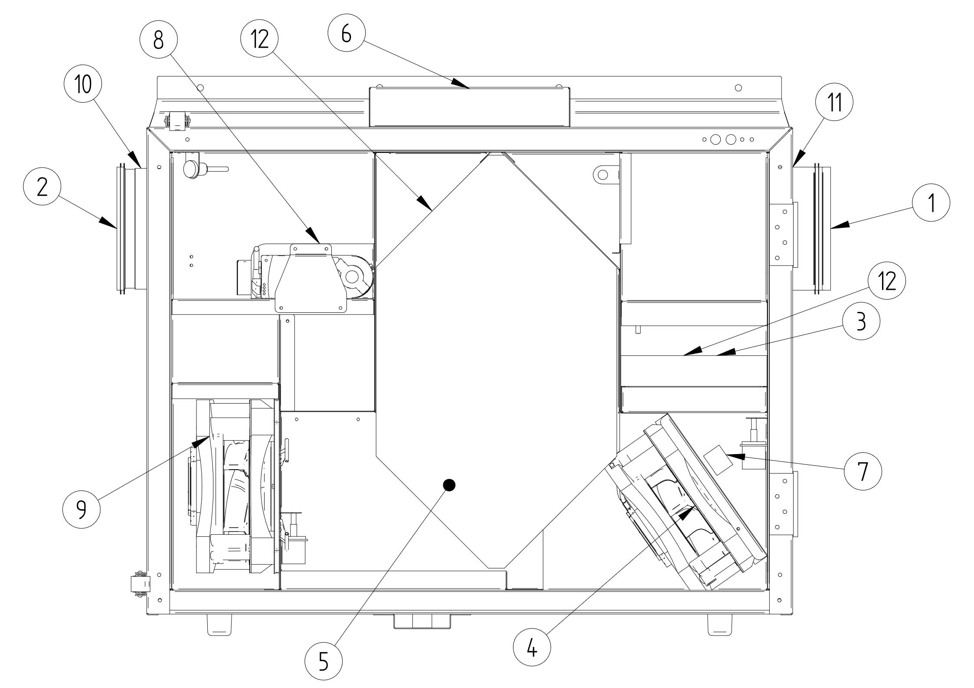

Electrical diagrams

Control board electric diagram
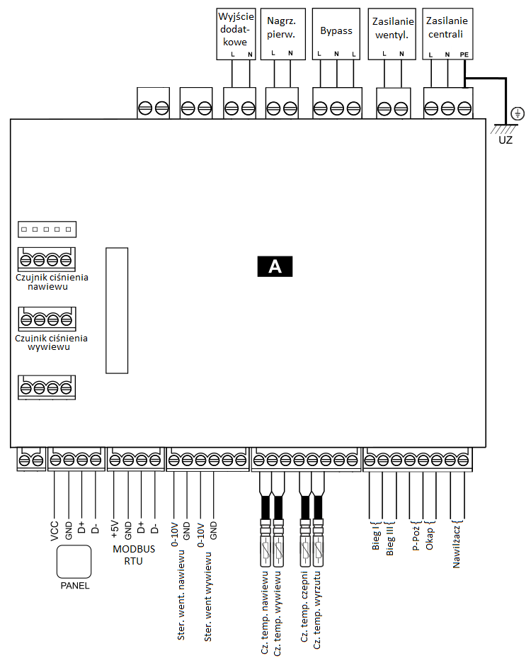

Diagram of additional elements connection to device
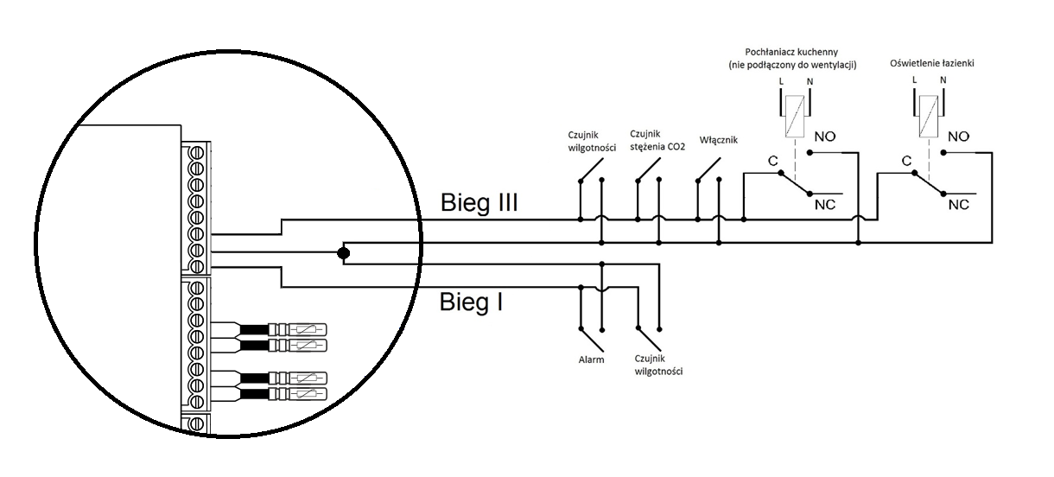
As soon as the contacts for Gear I or Gear III are closed, the control unit automatically adjusts its output accordingly.

Maintanance

Inspections and maintenance
Maintenance work must be carried out with the unit disconnected from the mains supply. Maintenance of the unit involves replacing the filters and humidifier pads, and checking the condition of the outdoor air intake. It is recommended that the filters be replaced every 180 days. They should, however, be vacuumed every 90 days. Filters that are excessively dirty may cause the air handling unit to operate more noisily and less efficiently. The external air intake of the system should be checked for dirt twice a year. During the summer season, the water level in the siphons should also be checked..

Exchander deassembly
The heat exchanger must be removed with the air handling unit disconnected from the 230 V mains supply. As the heat exchanger is a precise fit, it should be installed and removed by two people. To remove the heat exchanger, grasp its rear panel at the point marked in the diagram and pull it towards you, whilst ensuring that the heat exchanger does not shift.

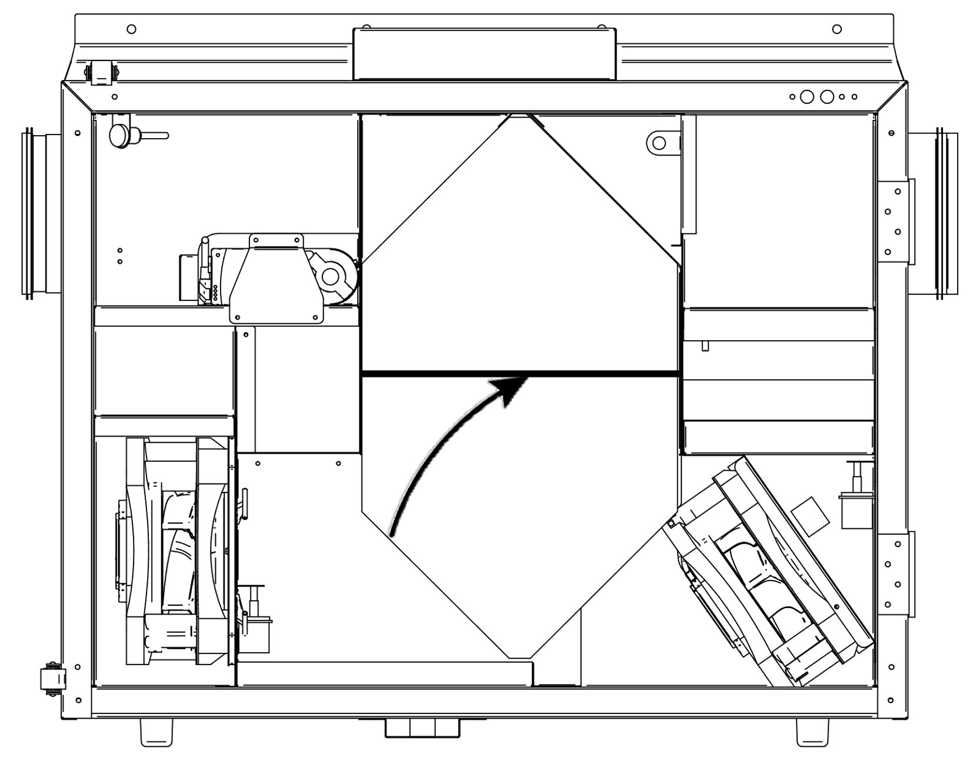

Modbus RTU
The heat recovery unit has a built-in software module that enables communication using the Modbus RTU protocol. This protocol allows the reading of a register or group of registers containing the current parameter values, and the writing of values to selected parameters. The heat recovery unit supports three Modbus commands: read command 0x03, single-register modification command 0x06 and register group modification command 0x10. Communication takes place via the unit’s isolated port (COM3 ISO), which is a slave port..
Default data transmission parameters:
Speed: 115200 b/s
Parity bit: none
Data bit: 8
Stop bit: 1
Controller address: 1
The table below contains a complete list of the controller’s Modbus parameters. The table is valid for software versions S001.02 and later.

List of Modbus RTU registers
Index BMS | AddressModbus | Variable name | Desciption | Signal Type | Value |  |  | Variable type | Remarks
 |  |  |  |  | Min. | Max. | Dom. | Variable type | Remarks
1 | 0 | Program version | Program version | O | 0 | 0xFFFF | 0 | hex | Format: SXXX.YYYXXX – high byte, YYY – low byte
2 | 2 | STATUS_OK | Work status | O | 0 | 1 | 1 | integer
 | 3 | AWARIA | Malfunction status | O | 0 | 1 | 0 | integer
 | 4 | WORK_MODE | Work gear | O | 0 | 6 | 3 | integer | 3 –gear1, 4 – gear2,  5 – gear3,
 | 5 | Tmain | Leading sensor | O | 0 | 2 | 0 | integer | 0 – supply sensor  1 – exhaust sensor,  100 – panel sensor
 | 6 | Tsup | Temo. inletu (T1) | O | -40.0 | 60.0 | 0.0 | integer | 999 - if the sensor fails
 | 7 | Texh | Tempoutlet (T2) | O | -40.0 | 60.0 | 0.0 | integer | 999 - if the sensor fails
 | 8 | Tinl | Temp. outside (T3) | O | -40.0 | 60.0 | 0.0 | integer | 999 - if the sensor fails
 | 9 | Tout | Temp. exhaust(T4) | O | -40.0 | 60.0 | 0.0 | integer | 999 - if the sensor fails
 | 10 | Trec | Temp GHE (T15) | O | -40.0 | 60.0 | 0.0 | integer | 999 - if the sensor fails
 | 11 | Theat | Temp.after secondary heater (T16) | O | -40.0 | 60.0 | 0.0 | integer | 999 - if the sensor fails
 | 12 | Tpanel | Main panel temp. | O | -40.0 | 60.0 | 0.0 | integer | 999 - if the sensor fails
 | 13 | Q1-limit | Air quality sensor  (Q1- 0/1) | O | 0 | 1 | 0 | integer | 0 – open contact  1 – closed contact
 | 15 | TR1 | Preheater Thermostat (N1) | O | 0 | 1 | 0 | integer | 0 – open contact  1 – closed contact
 | 16 | TR2 | Secondry heater Thermostat (N2) | O | 0 | 1 | 0 | integer | 0 – open contact  1 – closed contact
 | 17 | BYPASS | Bypass Actuator Status | O | 0 | 1 | 0 | integer | 0 - flow Off,  1 - flow. On
 | 18 | SAP | External signal SAP | O | 0 | 1 | 1 | integer | 0 – SAP,  1 – none SAP
 | 19 | IN1 | External signal IN1 | O | 0 | 1 | 0 | integer | 0 – no active  1 – active
 | 20 | IN2 | External signal IN2 | O | 0 | 1 | 0 | integer | 0 – no active  1 – active
 | 21 | ECO | External signal ECO (alarm unit) | O | 0 | 1 | 0 | integer | 0 – no active  1 – active
 | 22 | N1 | Preheater (N1) | O | 0 | 1 | 0 | integer | 0 – no active  1 – active
 | 23 | N2 | Secondary heater (N2) | O | 0 | 1 | 0 | integer | 0 – no active  1 – active
 | 24 | N2 control | Secondary heater settings (N2) | O | 0 | 100 | 0 | integer | Settings in %
 | 25 | Y1 control | Cooler settings (CH1) | O | 0 | 100 | 0 | integer | Settings in %
 | 26 | GWC | Ground-Source Heat Exchanger Actuator | O | 0 | 1 | 0 | integer | 0 – no active  1 – active
 | 27 | SBP1 | Heat Exchanger Bypass Actuator - Supply Air (SBP1) | O | 0 | 100 | 0 | integer | Settings in %
 | 28 | SM1 | Mixing Chamber Actuator (SM1) | O | 0 | 100 | 0 | integer | Settings in %
 | 29 | Clean | HEAT EXCHANGER CLEANING Mode | O | 0 | 1 | 0 | integer | 0 – no active  1 – active
 | 33 | Mode_OUT | Mode_OUT | I/O | 0 | 1 | 0 | integer | 0 – no active  1 – active
 | 34 | Mode_PARTY | Mode_PARTY | I/O | 0 | 1 | 0 | integer | 0 – no active  1 – active
 | 35 | Mode_OVERPRES | Mode FIREPLACE | I/O | 0 | 1 | 0 | integer | 0 – no active  1 – active
 | 39 | Temp_USER1 | Set temperature during gear 1 | I/O | 8 | 30 | 20 | integer | Unit °C
 | 40 | Temp_USER2 | Set temperature during gear 2 | I/O | 8 | 30 | 20 | integer | Unit °C
 | 41 | Temp_USER3 | Set temperature during gear 3 | I/O | 8 | 30 | 20 | integer | Unit °C
 | 43 | W1 | Supply fan, current control | O | 0 | 100 | 50 | integer | Settings in %
 | 44 | W2 | Exhaustfan, current control | O | 0 | 100 | 50 | integer | Settings in %
 | 45 | W1_EN | Permit for the operation of a supply fan (W1) | O | 0 | 1 | 1 | integer | 0 – no active  1 – active
 | 46 | W2_EN | Permit for the operation of a exhaust fan W2) | O | 0 | 1 | 1 | integer | 0 – no active  1 – active
 | 48 | Speed_W1_USER1 | Speed W1 in gear 1 | I/O | dyn. (15) | dyn. (100) | 15 | integer | Settings in %
 | 49 | Speed_W1_USER2 | Speed W1 in gear 2 | I/O | dyn. (15) | dyn. (100) | 40 | integer | Settings in %
 | 50 | Speed_W1_USER3 | Pręd Speed W1 in gear 3 | I/O | dyn. (15) | dyn. (100) | 100 | integer | Settings in %
 | 54 | Speed_W2_USER1 | Speed W2 in gear 1 | I/O | dyn. (15) | dyn. (100) | 15 | integer | Settings in %
 | 55 | Speed_W2_USER2 | Speed W2 in gear 2 | I/O | dyn. (15) | dyn. (100) | 40 | integer | Settings in %
 | 56 | Speed_W2_USER3 | Speed W2 in gear 3 | I/O | dyn. (15) | dyn. (100) | 100 | integer | Settings in %
 | 67 | Filter_time_remaining | Filter_time_remaining | O | 0 | 999 | - | integer | Unit: day
 | 68 | Service_time_remaining | Service_time_remaining | O | 0 | 999 | - | integer | Unit: day
 | 69 | GHE_Enable | GHE_Enable | I/O | 0 | 2 | 1 | integer | 0 - closed,  1 - open,  2 - auto
 | 70 | GHE_Winter | GHE Upper Activation Threshold - Winter | I/O | 5 | 20 | 8 | integer | Unit °C
 | 71 | GHE_Summer | GWC lower activation threshold - summer | I/O | 10 | 30 | 18 | integer | Unit °C
 | 72 | SM1_Enable | Activation of the mixing chamber (SM1) | I/O | 0 | 1 | 0 | integer | 0 – no active  1 – active
 | 73 | SM1_Limit | Mixing Chamber Actuator Opening Limit (SM1) | I/O | 0 | 100 | 100 | integer | Unit: %
 | 74 | BMS_adress | Device address for communication BMS | O | 0 | 247 | 1 | integer
 | 76 | BMS_change_en | Changing the settings from BMS | O | 0 | 1 | 1 | integer | 0 – turn OFF  1 – turn ON
 | 77 | BMS_STOP_en | START_STOP fromBMS | O | 0 | 1 | 1 | integer | 0 – turn OFF  1 – turn ON
 | 91 | P1_value | Pressure measured at the air inlet | O | 0 | 4000 | 0 | integer | Unit: Pa
 | 92 | P2_value | Pressure measured at the exhaust outlet | O | 0 | 4000 | 0 | integer | Unit: Pa
 | 93 | Flow1_value | Flow rate measured at the supply air outlet | O | 0 | 4000 | 0 | integer | Unit: m3/h
 | 94 | Flow2_value | Measured exhaust airflow | O | 0 | 4000 | 0 | integer | J Unit: m3/h
 | 97 | Flow1_setPoint | Set supply airflow | O | 0 | 4000 | 50 | integer | Unit: m3/h
 | 98 | Flow2_setPoint | Set exhaust airflow | O | 0 | 4000 | 50 | integer | Unit: m3/h
 | 107 | Reg_sett | Control Mode | I/O | 0 | 3 | 0 | integer | 0 – standard,  2 – constant flow
 | 108 | Flow_W1_USER1 | Set supply airflow – gear 1 | I/O | 0 | 4000 | 100 | integer | Jednostka: m3/h
 | 109 | Flow_W1_USER2 | Set supply airflow – gear 2 | I/O | 0 | 4000 | 200 | integer | Unit m3/h
 | 111 | Flow_W1_USER3 | Set supply airflow – gear 3 | I/O | 0 | 4000 | 1000 | integer | Unit: m3/h
 | 112 | Flow_W2_USER1 | Set exhaust airflow – gear 1 | I/O | 0 | 4000 | 100 | integer | Unit: m3/h
 | 113 | Flow_W2_USER2 | Set exhaust airflow – gear 2 | I/O | 0 | 4000 | 200 | integer | Unit: m3/h
 | 115 | Flow_W2_USER3 | Set exhaust airflow – gear 3 | I/O | 0 | 4000 | 1000 | integer | J Unit: m3/h
 | 116 | k_fac_W1 | Supply fan coefficient k | I/O | 0 | 1000 | 26 | float
 | 117 | k_fac_W2 | Exhaust fan coefficient k | I/O | 0 | 1000 | 38 | float
 | 118 | PSA_W1 | Supply Fan Start Level | I/O | dyn. (15) | dyn. (100) | 15 | integer | Settings in %
 | 119 | PSA_W2 | Exhaust fan startup level | I/O | dyn. (15) | dyn. (100) | 15 | integer | Settings in %

Warranty and service

Service
All faults must be reported to WANAS, providing a detailed description of the problem in the form „Zgłoszenia serwisowego” available on website www.wanas.pl in tab „Kontakt”. Complaints made during the warranty period will be considered within 14 days and resolved within 30 days of the date of submission. The code required to unlock the controller can be obtained from the retailer.
.

Warranty

- The manufacturer provides a 24-month warranty covering the correct operation of the device
- The warranty period begins on the date the user purchases the device
- The warranty is granted and valid upon presentation of the proof of purchase for the control unit
- The warranty does not cover faults arising from incorrect use, maintenance or installation of the device
- The air handling unit should operate continuously from the moment it is first switched on, except when maintenance work is being carried out.
- The manufacturer accepts no liability for faults arising from a power cut
- The warranty does not cover damage caused by power surges or lightning strikes
- The cost of an unjustified service call is borne by the customer
- The company provides maintenance services throughout Poland.
- The warranty does not cover devices in which spare parts not recommended by the manufacturer have been used. Information on spare parts is available in the service section.
- The warranty is valid provided that the user uses only genuine WANAS filters.

Contact the Service Department
Tel: | +48 535 958 222
Service Request | Kliknij tutaj

In devices 345, 545 i 1345 mounting brackets are fitted to casting.
Not apply to suspended units.
In units COMBO there ae 2 siphons in set.

