Operation and Maintenance Documentation
INSTALLATION AND OPERATING MANUAL
MINI Freon Heater-Cooler
MAXI Freon Heater-Cooler

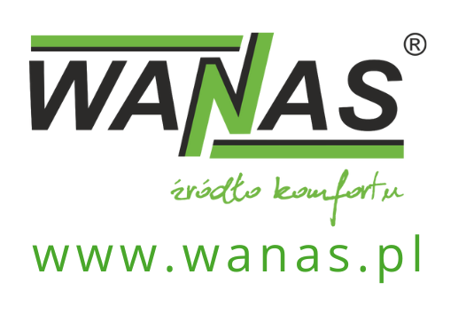
Contents
1. General Information 3
1.1. Introduction 3
1.2. Delivery 4
1.3. Safety 4
2. Unit dimensions 5
2.1. MINI Freon Heater-Cooler 5
2.2. MAXI Freon Heater-Cooler 6
2. Construction of the units 7
2.1. MINI Freon Heater-Cooler 7
2.2. MAXI Freon Heater-Cooler 7
3. Specifications 8
3.1. Specifications of the MINI Freon Heater-Cooler 8
3.2. Specifications of the MAXI freon heater-cooler 9
4. Function activation 10
4.1. Heating and cooling 10
5. Wiring diagrams 12
5.1. Connecting the Midea refrigerant heater-cooler 12
5.2. Connection to a Midea outdoor unit 13
5.3. Connecting a Gree refrigerant heater-cooler 14
1.1. Connection to a Gree outdoor unit 15
1.2. Connection diagram for the PT-1000 or W-1000 temperature sensor 16
2. Warranty and After-Sales Service 17
2.1. Service 17
2.2. Warranty 17

General Information

Introduction
All guidelines contained in the installation and operating manual, relating to installation, commissioning and safety, must be strictly observed.
The WANAS Maxi freon cooler is a device designed to extend mechanical ventilation systems with heat recovery by adding cooling and reheating functions to the supply air. The unit works in conjunction with WANAS air handling units, enabling improved user comfort through the regulation of the air temperature supplied to rooms.
For the unit to operate correctly, it must be used in conjunction with an external air-conditioning unit (condensing unit) and the AHU Kit control module. The cooler is designed for installation on the supply air duct, downstream of the heat recovery unit. The unit is controlled directly via the WANAS air-handling unit controller.
Advantages of the unit:
- the ability to cool and reheat supply air,
- the ability to dehumidify supply air during the summer,
- high cooling efficiency – the ability to reduce the air temperature downstream of the heat recovery unit by up to 17°C,
- aesthetically pleasing design consistent with WANAS air handling units,
- convenient and intuitive control via the WANAS heat recovery unit controller,
- a versatile design allowing the unit to be installed regardless of the direction of air flow,
- simple and convenient installation.
If you intend to dispose of this product, do not throw it away with ordinary household waste. In accordance with Directive 2012/19/EU (WEEE) in force in the European Union, electrical and electronic equipment must undergo a separate disposal process. The aim of the directive is to prevent the negative environmental impact of electronic waste through its collection, reuse, recycling and recovery. The device is marked with the crossed-out wheelie bin symbol, which serves as a reminder of the obligation to collect end-of-life equipment separately. For further information on collection points and how to dispose of electronic waste, please contact your local council or a waste management company. | 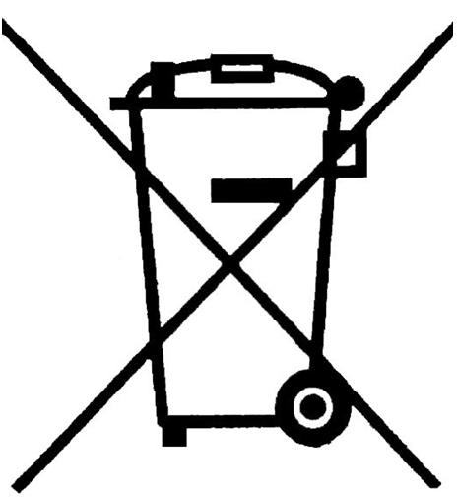
The manufacturer declares that the product complies with the ‘Low Voltage Directive 2014/35/EU (LVD)’﻿, concerning the safety of electrical equipment operating within a specified voltage range. The product meets the essential requirements of the directive and has been marked with the ‘CE’﻿ mark following a conformity assessment procedure. | 

Delivery
Before proceeding with the installation of the control unit, ensure that all components of the kit are present.
If any of the following components are missing, please contact the supplier of the unit.
Each unit is supplied complete with a mounting bracket for suspension, wall plugs for fixing the bracket, a siphon and a PT1000 temperature sensor.
For the unit to operate correctly, an external refrigeration unit with a maximum power of 3.5 kW for WANAS MINI and 5kW for WANAS MAXI and an external AHU Kit control module are required; these must be purchased separately.

Safety


- The manufacturer accepts no liability for damage resulting from incorrect installation or use of the product contrary to its intended purpose and these operating instructions; such damage shall not constitute grounds for a complaint or warranty repairs.
- The unit must be installed by suitably qualified personnel.
- The unit may only be operated by adults who have read the user manual.
- The heating and cooling unit must be installed in a location where the temperature is
between 5°C and 45°C. The humidity in the room must not cause condensation to form on the casing.
- It is forbidden to switch on the unit in a building where construction work is taking place.
- The drain trap must be securely attached to the heater-cooler; care must be taken to prevent it from being damaged. A damaged drain trap may result in water leakage and flooding. The room in which the unit is located must be fitted with a floor drain. Do not place any other electrical or electronic appliances underneath or in the immediate vicinity of the unit.
- Maintenance work should be carried out with the appliance disconnected from the 230 V mains supply.
- The manufacturer accepts no liability for damage resulting from direct or indirect actions by people or animals arising from failure to comply with these instructions, in particular the notes concerning the installation, operation and maintenance of the appliance.
- The chiller must be charged with R32 refrigerant.
- The requirements specified by the manufacturer of the refrigeration unit must be strictly observed.
- Before starting the cooler, the siphon must be filled.

Dimensions of the units

MINI Freon Heater-Cooler
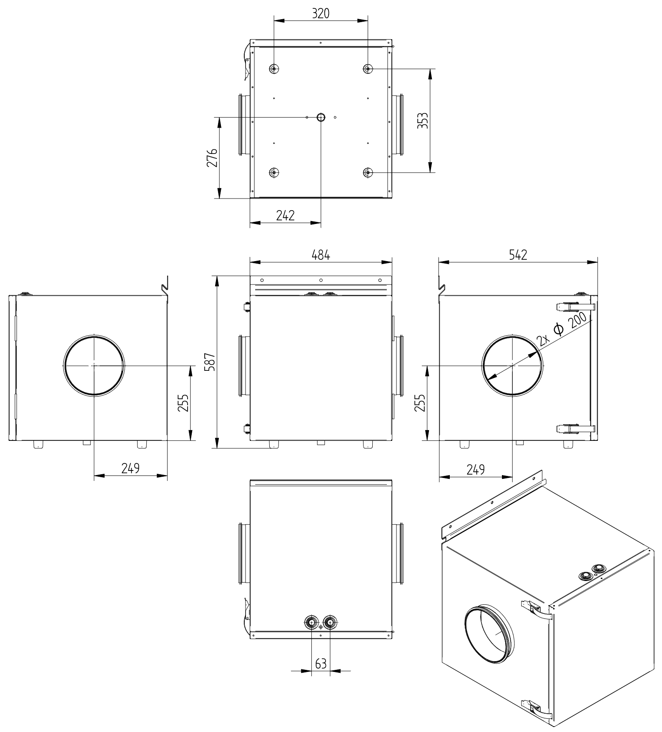

MAXI freon heater-cooler
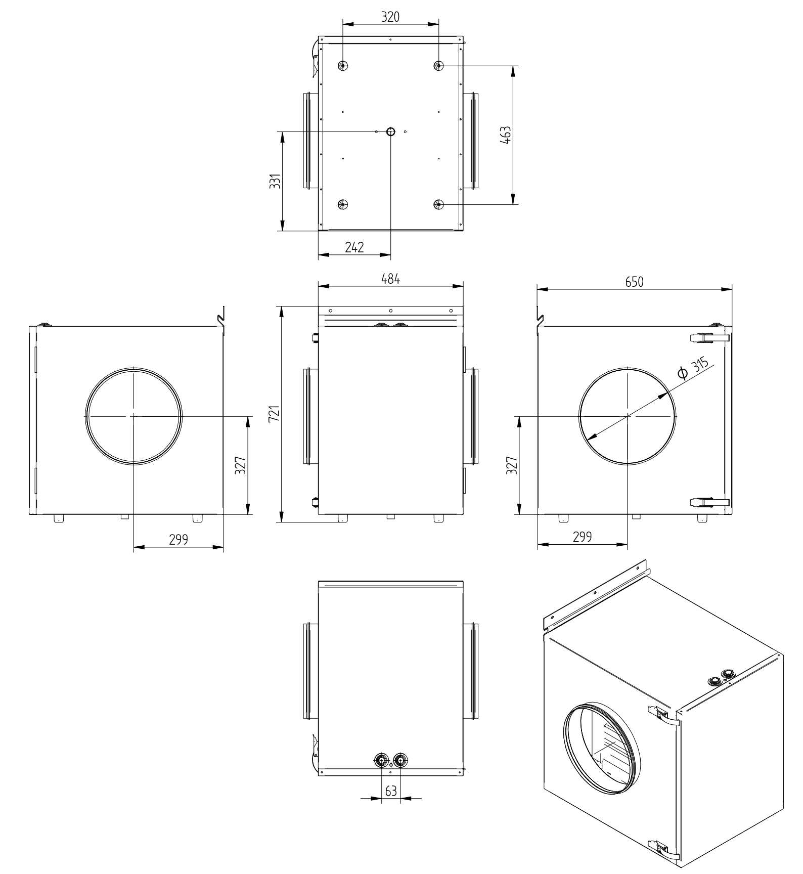

Construction of the units

MINI Freon Heater-Cooler
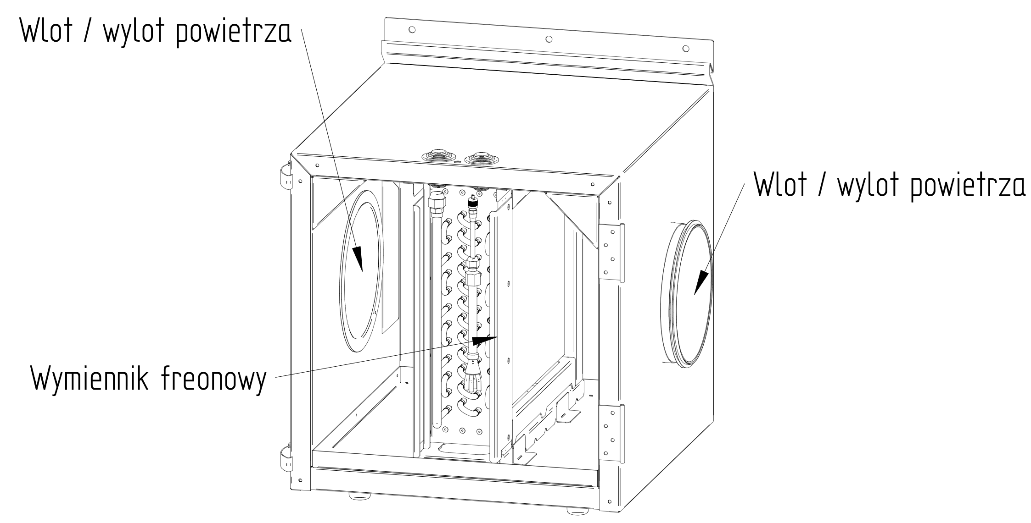

MAXI Freon Heater-Cooler
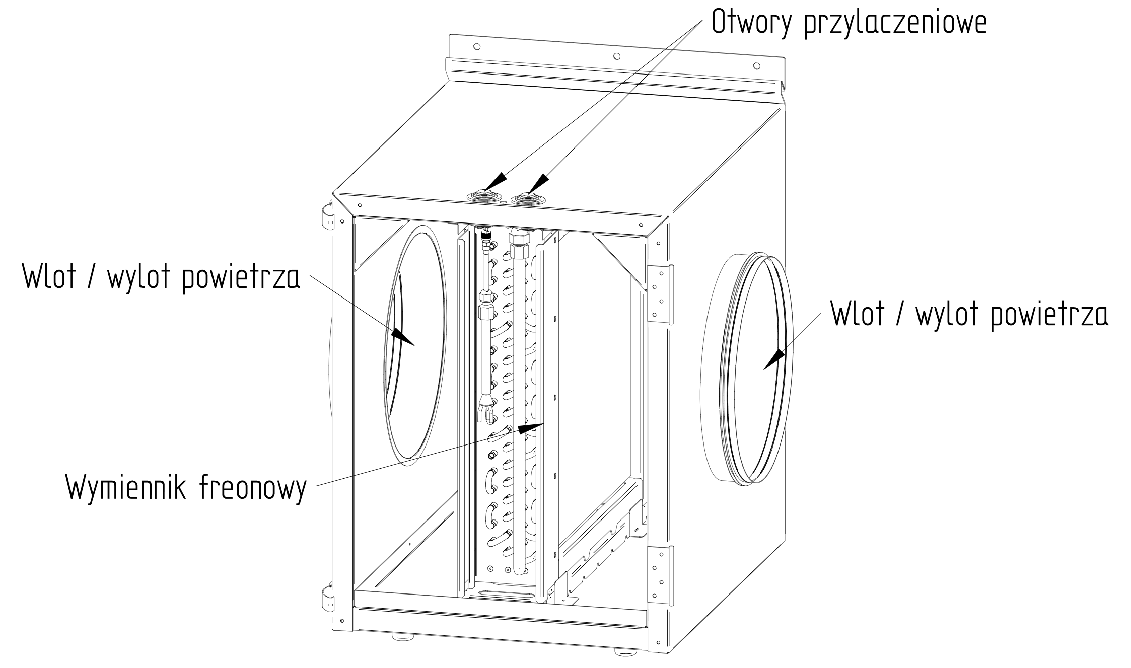

Specifications
 |  | WANAS MINI | WANAS MAXI
Recommended flow rate up to | $$\frac{m^{3}}{h}$$ | 600 | 1,300
Capacity up to | kW | 3.0 | 5.6
Power consumption | In | - | -
Weight | kg | 29.5 | 45.5
Connection layout | - | universal

Specifications of the MINI refrigerant heater-cooler
COOLING FUNCTION – R32
Air flow | Temperature before the heat exchanger | Humidity before the heat exchanger | Temperature after the heat exchanger | Humidity after the heat exchanger | Cooling capacity | Energy consumption
[m³/h] | °C | % | °C | % | [kW] | [W]
100 | 24.5 | 51.7 | 2.9 | 100 | 0.7 | 204
150 | 24.3 | 50.3 | 5.6 | 100 | 0.9 | 202
200 | 24 | 50.3 | 7.6 | 100 | 1.1 | 196
250 | 24.1 | 49.6 | 9.2 | 99.1 | 1.3 | 196
300 | 24.6 | 50.8 | 10 | 99.8 | 1.5 | 196
350 | 24.4 | 51.9 | 11.8 | 89.7 | 1.5 | 194
400 | 29.5 | 54.6 | 11 | 95.2 | 2.5 | 880
450 | 29.7 | 54 | 12.9 | 98.4 | 2.5 | 732
605 | 29.6 | 0 | 14.7 | 93.6 | 3.0 | 716
HEATING FUNCTION – R32
Air flow | Temperature before the heat exchanger | Humidity before heat exchanger | Temperature after heat exchanger | Humidity after the heat exchanger | Heating capacity | Energy consumption
[m³/h] | °C | % | °C | % | [kW] | [W]
100 | 24.5 | 51.7 | 2.9 | 100 | 0.7 | 204
150 | 24.3 | 50.3 | 5.6 | 100 | 0.9 | 202
200 | 24 | 50.3 | 7.6 | 100 | 1.1 | 196
250 | 24.1 | 49.6 | 9.2 | 99.1 | 1.3 | 196
300 | 24.6 | 50.8 | 10 | 99.8 | 1.5 | 196
350 | 24.4 | 51.9 | 11.8 | 89.7 | 1.5 | 194
400 | 29.5 | 54.6 | 11 | 95.2 | 2.5 | 880
450 | 29.7 | 54 | 12.9 | 98.4 | 2.5 | 732
605 | 29.6 | 0 | 14.7 | 93.6 | 3.0 | 716
Tests carried out on a test rig:
WANAS 555 H XF, WANAS MINII R32 heating and cooling unit with a freon heat exchanger, Midea X2-12N8D1-O outdoor unit and AHU Kit KA8140

Parameters of the MAXI freon air handler
COOLING FUNCTION – R32
Air flow | Temperature before the heat exchanger | Humidity before the heat exchanger | Temperature after the heat exchanger | Humidity after the heat exchanger | Cooling capacity | Energy consumption
[m³/h] | °C | % | °C | % | [kW] | [W]
450 | 25.7 | 25 | 11 | 45 | 2.2 | 426
630 | 26.8 | 28 | 10.7 | 47 | 3.4 | 655
710 | 27 | 28 | 9.7 | 47 | 4.1 | 710
880 | 26.3 | 28 | 11 | 44.2 | 4.5 | 708
980 | 26.3 | 28 | 11.9 | 42.4 | 4.7 | 715
1,140 | 26.3 | 28 | 12.7 | 40.8 | 5.2 | 720
1,240 | 26.3 | 28 | 13.3 | 39.6 | 5.4 | 732
1,360 | 26.3 | 28 | 14 | 38.3 | 5.6 | 735
HEATING FUNCTION – R32
Air flow | Temperature before the heat exchanger | Humidity before the heat exchanger | Temperature downstream of the heat exchanger | Humidity downstream of the heat exchanger | Heating capacity | Energy consumption
[m³/h] | °C | % | °C | % | [kW] | [W]
360 | 12.6 | 35.7 | 37.8 | 15.7 | 3.0 | 2,100
480 | 14.6 | 43 | 38 | 13.6 | 3.8 | 1,790
680 | 15 | 40 | 34 | 14 | 4.3 | 1,540
825 | 15 | 40 | 32.8 | 15 | 4.9 | 1,440
970 | 15.5 | 40 | 30.6 | 16 | 4.9 | 1,340
1,190 | 15 | 40 | 28 | 17 | 5.2 | 1,230
1,350 | 15 | 40 | 26 | 19 | 5.0 | 1160

- Tests carried out on a model set-up:
Wanas 1300H, WANAS MAXI R32 heater-cooler with a freon heat exchanger, Midea X3BP-18N8D0-O outdoor unit and AHU Kit KA8142

Function activation

Heating and cooling
This section is used to configure the control of the freon heat exchanger, which performs the function of heating or cooling the air supplied to the rooms. Control is achieved by modulating the intensity using a 0–10 V voltage on the heat recovery unit controller. Activating this function disables the standard algorithms for the Heating and Cooling functions. An outdoor unit is required to operate the heat pump functions. The system aims to achieve the comfort temperature set in the weekly programme.
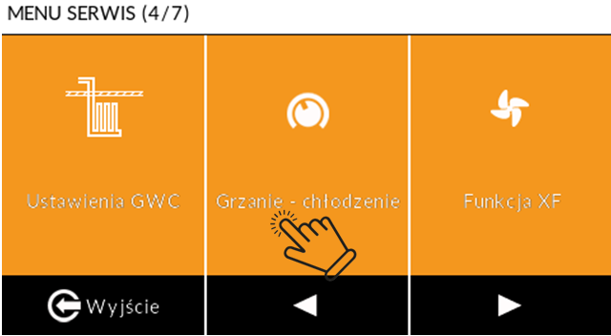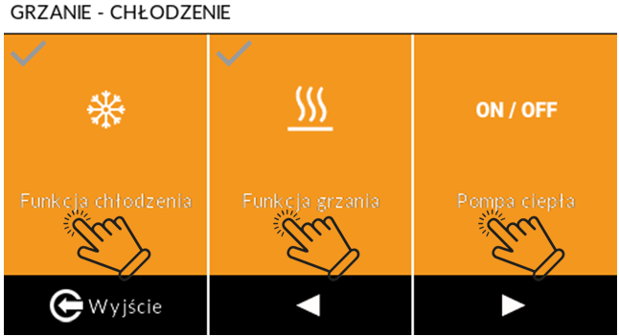
Menu Option | Purpose and Operation | Parameters and Technical Requirements
Control Type | Selection of control type depending on the manufacturer of the compatible control unit (unit) | Type I and Type II specify which outputs the voltage should be applied to and how the modes (HEATING/COOLING) are controlled.
System stabilisation time | This refers to the rate at which the 0–10 V voltage at the recuperator output increases. | This time is required for the system to stabilise. If the outdoor unit is switched off frequently, this time should be set to the maximum.
Minimum compressor running time | The time after which the compressor may be stopped again. | This prevents a reduction in the compressor’s service life due to excessively frequent on/off cycles.
Minimum compressor pause time | The minimum number of minutes after which the compressor may restart. | Required to stabilise the refrigerant pressure.
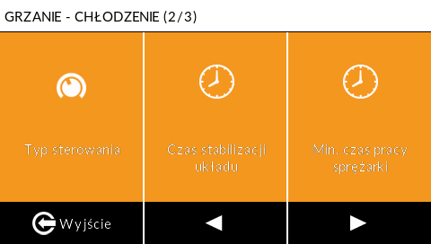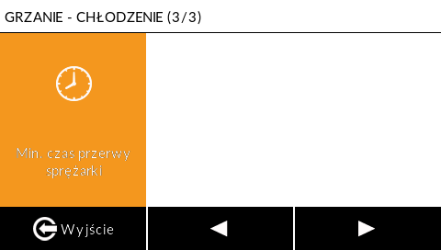
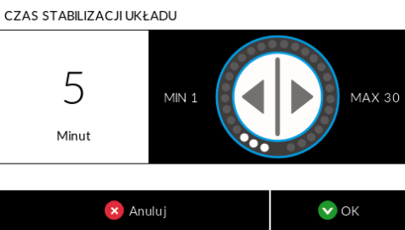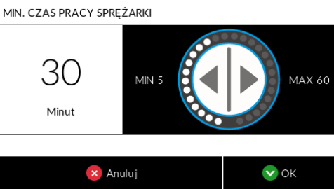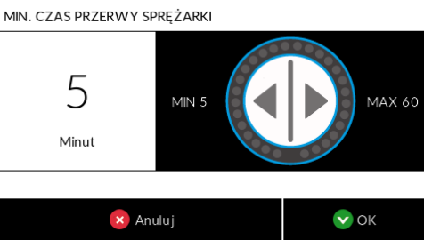
Control type | Outdoor unit
TYPE I | As per the outdoor unit manufacturer’s documentation
TYPE II | MIDEA, ROTENSO, KASAI, GREE

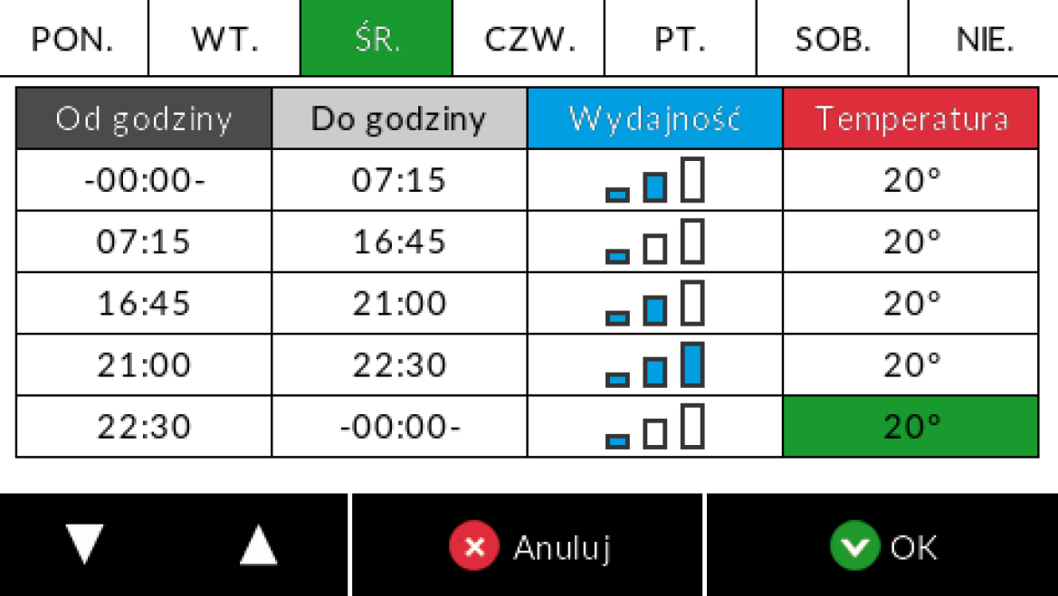 | Heating is activated when the room temperature is lower than the setting in the weekly programme.  The cooler is activated when the room temperature is higher than the setting in the programmes menu.  NOTE: The freon-based heater-cooler is not intended for heating the building, but only for pre-heating/pre-cooling the supply air. When installing the heater-cooler, an additional temperature sensor must be connected to the supply air duct one metre downstream of the heater. Connect the sensor to the EXTRA TEMP auxiliary temperature connector. Activate it in the service menu under the ‘EXTRA TEMP auxiliary sensor’ tab by selecting the ‘Supply air’ option.

Wiring diagrams

Connection of the Midea refrigerant heater-cooler
The diagram shows the connection to a Midea unit
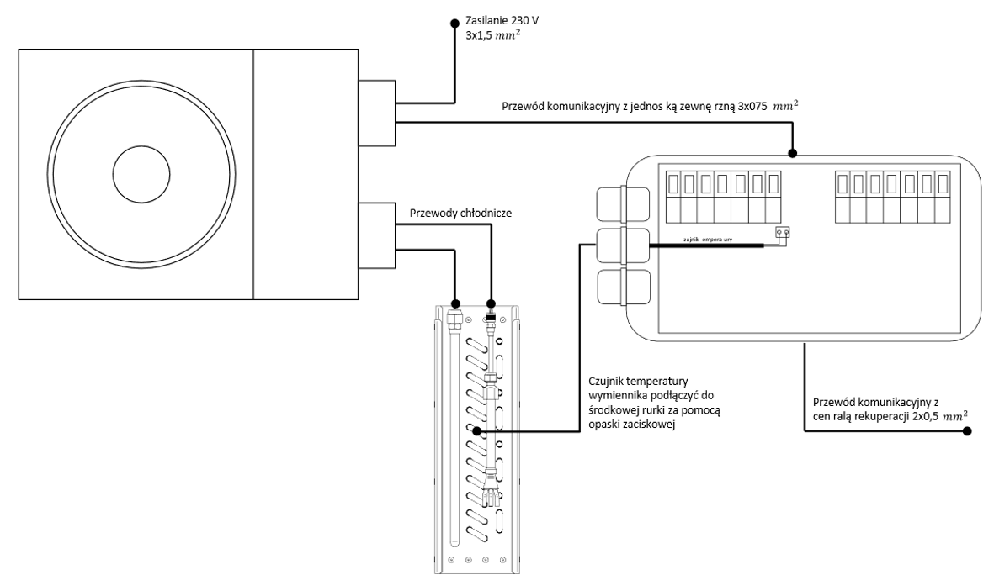
Communication cable to the heat recovery unit: 6x0.5 ${mm}^{2}$

Do not connect the freon heater/cooler controller to the ‘Cooler’ output on the heat recovery unit controller. This is a 230V power supply output and may permanently damage the freon heater/cooler controller.
NOTE: After connecting the system, carry out a nitrogen leak test, followed by a vacuum leak test at 0.5 bar. Charge the system with R32 refrigerant. If the distance from the outdoor unit exceeds 5 metres, top up the refrigerant: 12g of refrigerant for each additional metre of piping. Do not add any refrigerant if the distance is less than 5 metres.

Connection to a Midea outdoor unit
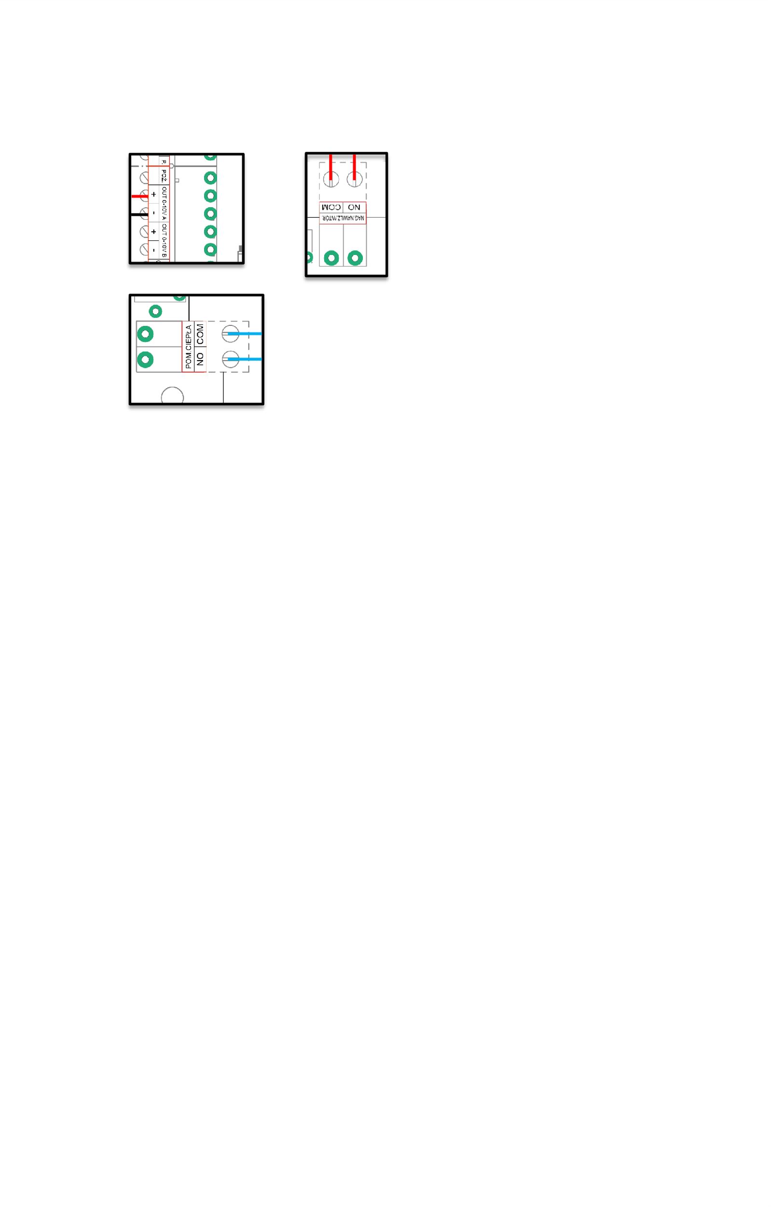
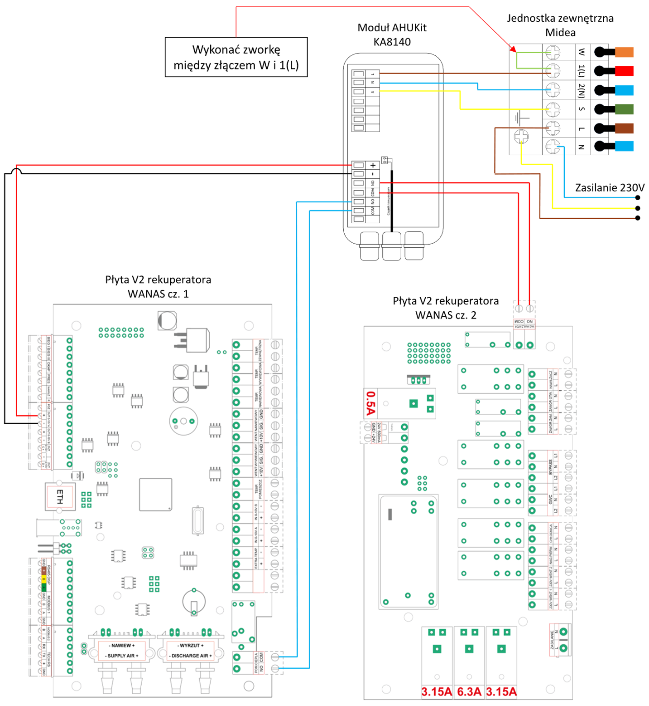

Connection of a Gree freon heater-cooler
The diagram shows the connection to a Gree unit
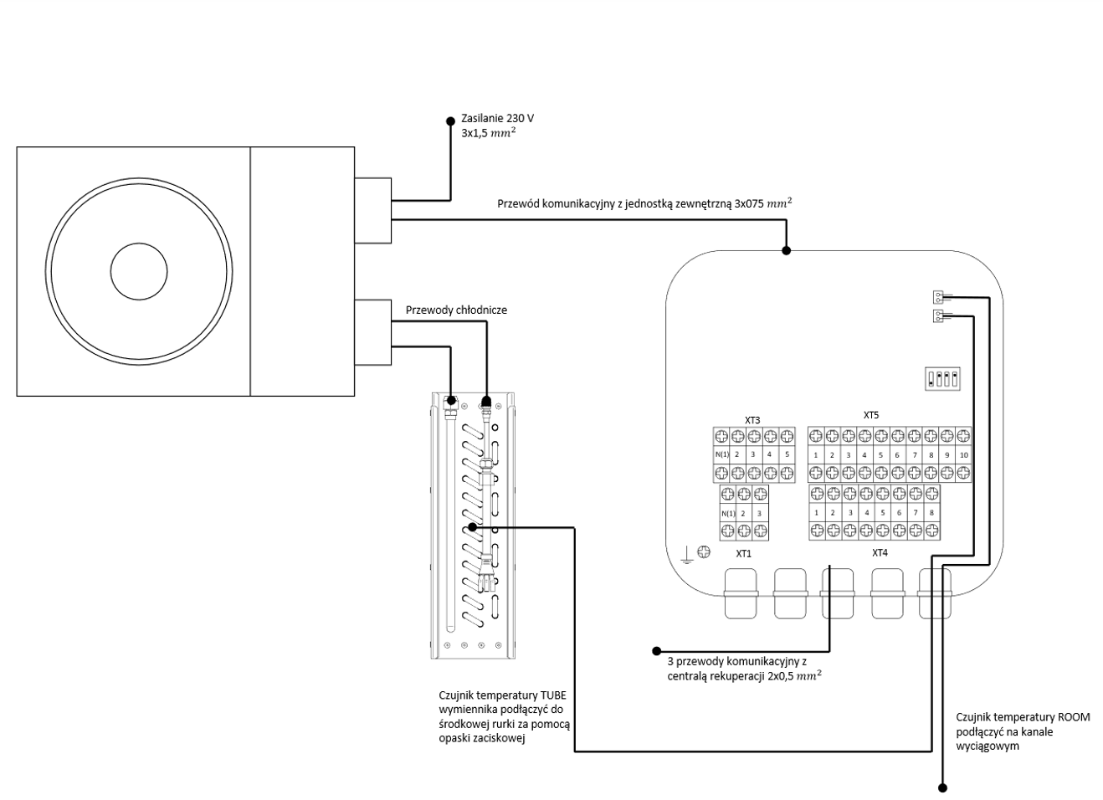
Do not connect the freon heater/cooler controller to the ‘Cooler’ output on the heat recovery unit controller. This is a 230V power supply output and may permanently damage the freon heater/cooler controller.
NOTE: After connecting the system, carry out a nitrogen leak test, followed by a vacuum leak test at 0.5 bar. Charge the system with R32 refrigerant. If the distance from the outdoor unit exceeds 5 metres, top up the refrigerant: 12g of refrigerant for each additional metre of piping. Do not add any refrigerant if the distance is less than 5 metres.

Connection to a Gree outdoor unit
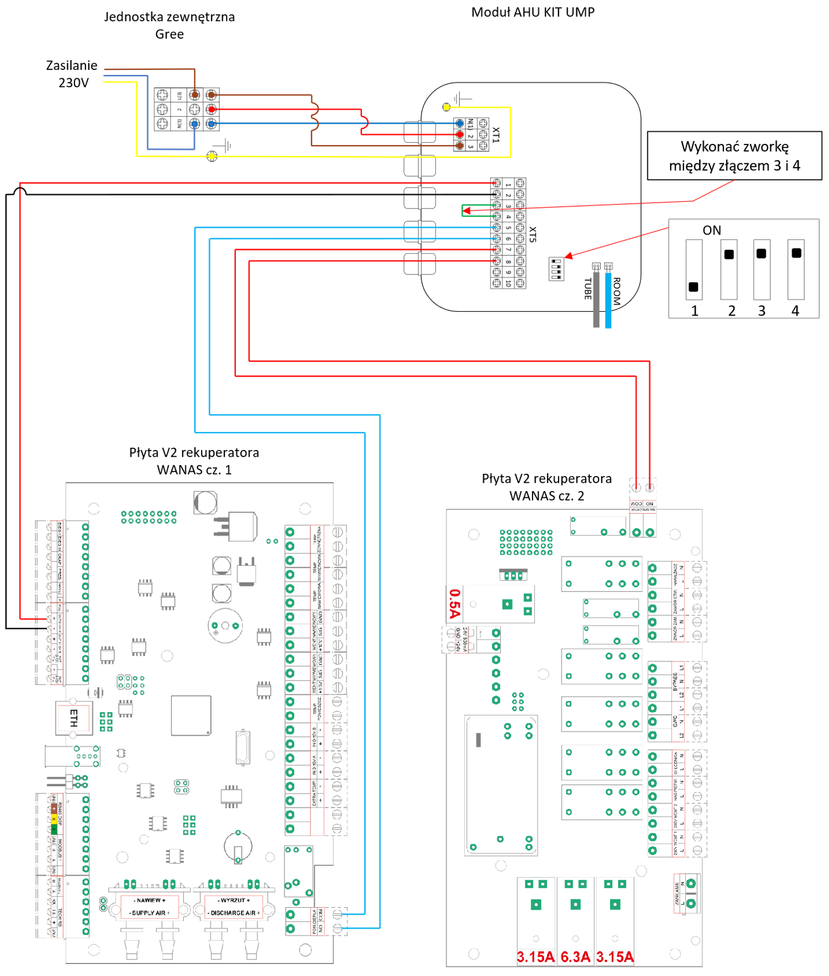

Wiring diagram for the PT-1000 or W-1000 temperature sensor
The outdoor temperature sensor is connected to the EXTRA TEMP connector.
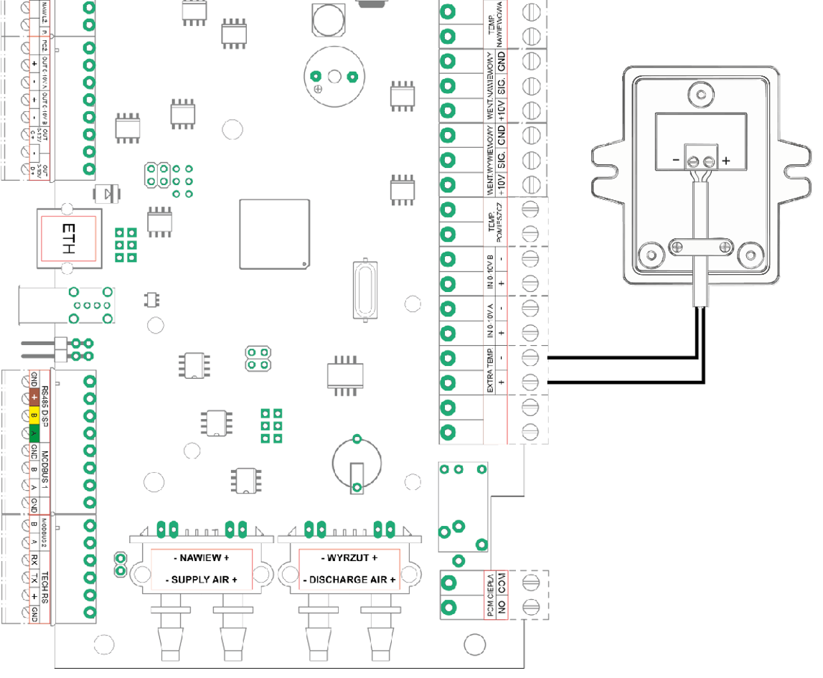

Warranty and Service

Service
All faults must be reported to WANAS with a detailed description of the problem using the ‘Service Request’ form available at www.wanas.pl under the ‘Contact’ tab. Claims made during the warranty period will be assessed within 14 days and resolved within 30 days of the date of submission.

Warranty
- The manufacturer provides a 24-month warranty covering the correct operation of the device.
- The warranty period is calculated from the date of purchase of the device by the user.
- The warranty is granted and valid upon presentation of the device’s proof of purchase.
- The warranty does not cover faults arising from incorrect use, maintenance or installation of the device.
- The cost of an unjustified service call shall be borne by the customer making the claim.
- The company provides servicing throughout Poland.

Contact the service department
Tel: | +48 535 958 222
Service request | Click here

