Operation and Maintenance Documentation
INSTALLATION AND OPERATING MANUAL
MINI Water Heater/Cooler
MAXI Water Heater/Cooler

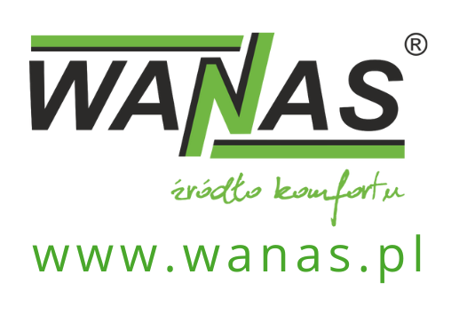
Contents
1. General information 3
1.1. Introduction 3
1.2. Delivery 4
1.3. Safety 4
2. Device dimensions 6
2.1. MINI water heater-cooler 6
2.2. MAXI water heater/cooler 7
2. Unit design 8
2.1. MINI water heater-cooler 8
2.2. MAXI water heater/cooler 8
3. Specifications 9
3.1. Specifications for the MINI water heater/cooler 9
3.1.1. Coolant – water 9
3.1.2. Working fluid – 40% ethylene glycol 10
3.2. MAXI water heater/cooler specifications 11
3.2.1. Medium – water 11
3.2.2. Working fluid – 40% ethylene glycol 12
4. Function activation 13
4.1. Heating and cooling 13
4.2. GHE 14
5. Electrical diagrams 16
5.1. ’s wiring diagram for connecting the heater-cooler in the supply air system (heating/cooling function) 16
5.2. Connection diagram for the heater-cooler at the air intake – configuration with GHE 17
5.3. Connection diagram for the PT-1000 or W-1000 temperature sensor 18
6. Warranty and Service 19
6.1. Service 19
6.2. Warranty 19

General information

Introduction
All guidelines contained in the installation and operating manual, relating to installation, commissioning and safety, must be strictly followed.
The WANAS water-cooled/heated unit is an air–water heat exchanger designed to cool or reheat supply air in mechanical ventilation systems with heat recovery.
The unit can be installed in two configurations:
- Installation on the supply air duct (downstream of the heat recovery unit)
In this configuration, the water-based heater-cooler operates as part of the system for cooling or reheating supply air. It can be supplied by a heat pump, a water buffer tank or another source of cooling/heating. When combined with a heat pump, it allows the use of the ground source’s coolness as a cooling medium, which ensures a highly economical reduction in supply air temperature whilst simultaneously regenerating the ground source.
- Installation on the air intake duct (upstream of the heat recovery unit)
In this configuration, the unit operates as a water-to-ground heat exchanger (water GWC). Installing it on the air intake side allows the outdoor air temperature to be pre-raised or pre-lowered before it is treated in the air handling unit, which improves the efficiency of the heat recovery unit and stabilises the operating parameters of the entire system.
ADVANTAGES:
- Comfort – the ability to lower the temperature inside the building during the summer.
- Energy savings – the most cost-effective method of cooling rooms using a ground-source heat pump. Energy is consumed solely to drive the circulation pump.
- Consistent design – the external appearance is in keeping with WANAS heat recovery units.
- Easy control – the unit is controlled via a controller, which is supplied as standard with every WANAS heat recovery unit.
- Convenient installation – the module can be installed in any orientation relative to the air flow; it is reversible
If you intend to dispose of this product, do not throw it away with ordinary household waste. In accordance with Directive 2012/19/EU (WEEE) in force within the European Union, electrical and electronic equipment must undergo a separate disposal process. The aim of the directive is to prevent the negative environmental impact of electronic waste through its collection, reuse, recycling and recovery. The appliance is marked with the crossed-out wheelie bin symbol, which serves as a reminder of the obligation to collect end-of-life equipment separately. For further information on collection points and how to dispose of electronic waste, please contact your local council or a waste management company. | 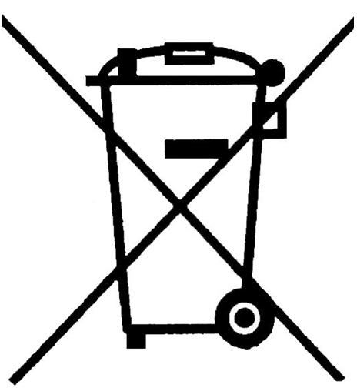
The manufacturer declares that the product complies with the ‘Low Voltage Directive 2014/35/EU (LVD)’﻿, concerning the safety of electrical equipment operating within a specified voltage range. The product meets the essential requirements of the directive and has been marked with the ‘CE’﻿ mark following a conformity assessment procedure. | 

Delivery
Before proceeding with the installation of the control unit, ensure that all components of the kit are present.
If any of the following components are missing, please contact the supplier of the unit.
Each unit in the kit is fitted with connection ports with automatic air vents – ¾-inch external thread, 4 ¾-inch gaskets, a mounting bracket, wall plugs for fixing the bracket, and a siphon.
You will need to purchase the W-1000 outdoor temperature sensor or the PT-1000 duct sensor separately.
Sensor name | Application | Link
W-1000 sensor | Required for the installation of an air-cooled or glycol-cooled GWC | WANAS Shop
PT-1000 sensor | Required for the installation of a cooler on the supply air duct | WANAS Shop

Safety


The manufacturer accepts no liability for damage resulting from incorrect installation or use of the product contrary to its intended purpose and these operating instructions; such damage shall not constitute grounds for a complaint or warranty repairs.
- The unit must be installed by suitably qualified personnel.
- The unit may only be operated by adults who have read the user manual.
- It is prohibited to install the unit in a system that does not have a functioning protective conductor and a residual current device.
- It is prohibited to install the controller below the heat recovery unit.
- The electrical installation to which the unit is connected must be fitted with surge protection.
- The heating and cooling unit must be installed in a location where the temperature is
between 5°C and 45°C. The humidity in the room must not cause condensation to form on the housing.
- It is forbidden to switch on the unit in a building where construction work is taking place.
- The siphon should be secured to the heat exchanger; care must be taken to prevent it from being damaged. A damaged drain may result in water leakage and flooding of the unit. The room in which the unit is located should be fitted with a floor drain. Do not place any other electrical or electronic equipment underneath or in the immediate vicinity of the unit.
- Maintenance work should be carried out with the unit disconnected from the 230 V mains supply.
- After carrying out maintenance work, always ensure that all water drainage connections are secure. The water supply should be checked regularly.
- In the event of a water leak, stop using the appliance and disconnect it from the mains supply. Then contact Wanas’s after-sales service.
- The manufacturer accepts no liability for damage resulting from direct or indirect actions by people or animals arising from failure to comply with these instructions, in particular the notes concerning the installation, operation and maintenance of the appliance.

Device dimensions

MINI water heater-cooler
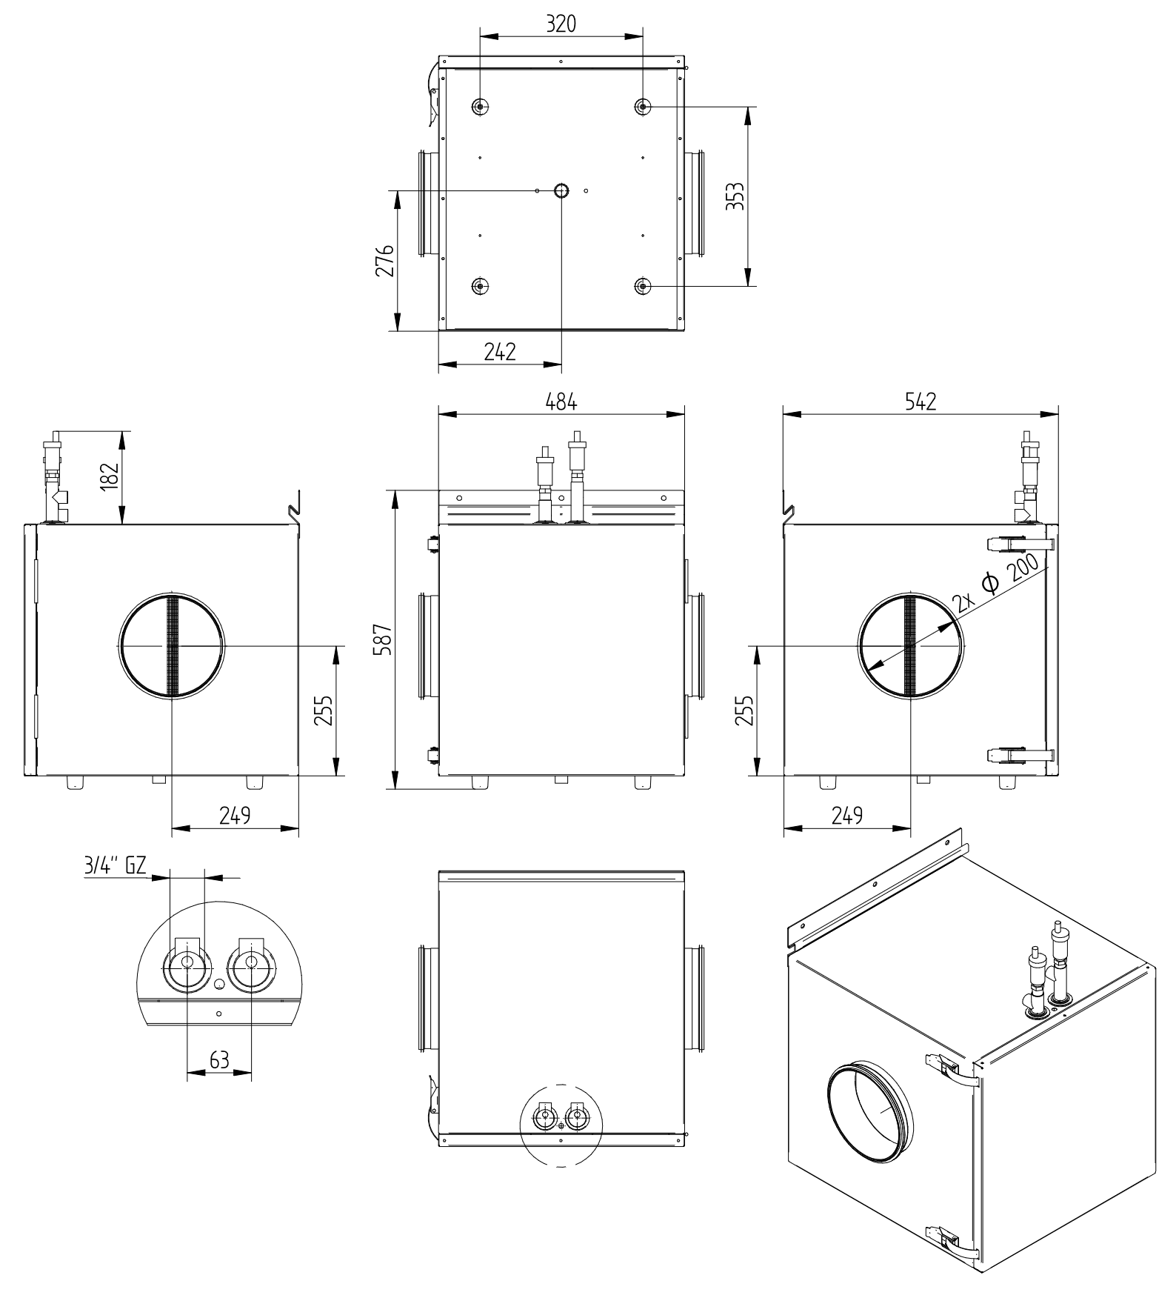

MAXI water heater/cooler
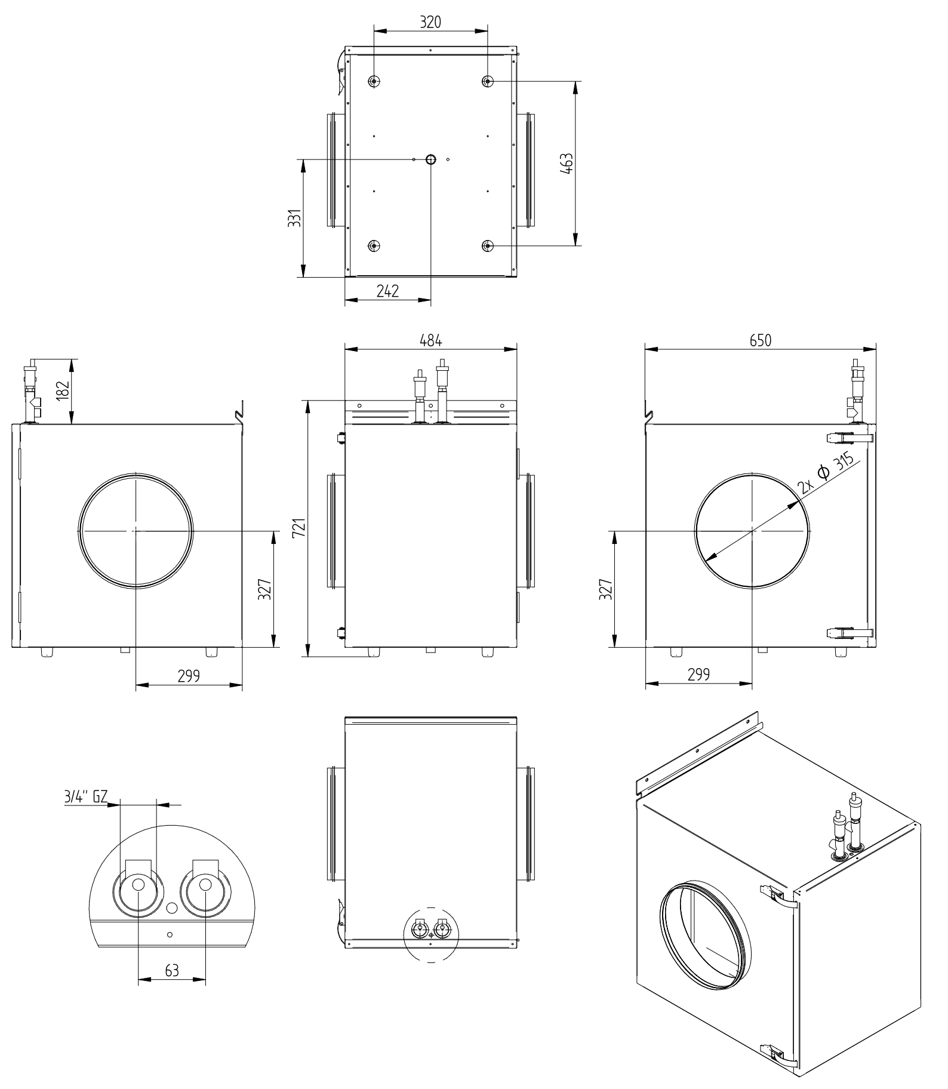
A – Air drawn from outside the building
B – Air drawn from the rooms
C – Air supplied to the rooms
D – Air discharged outside the building

Unit design

MINI water heater-cooler
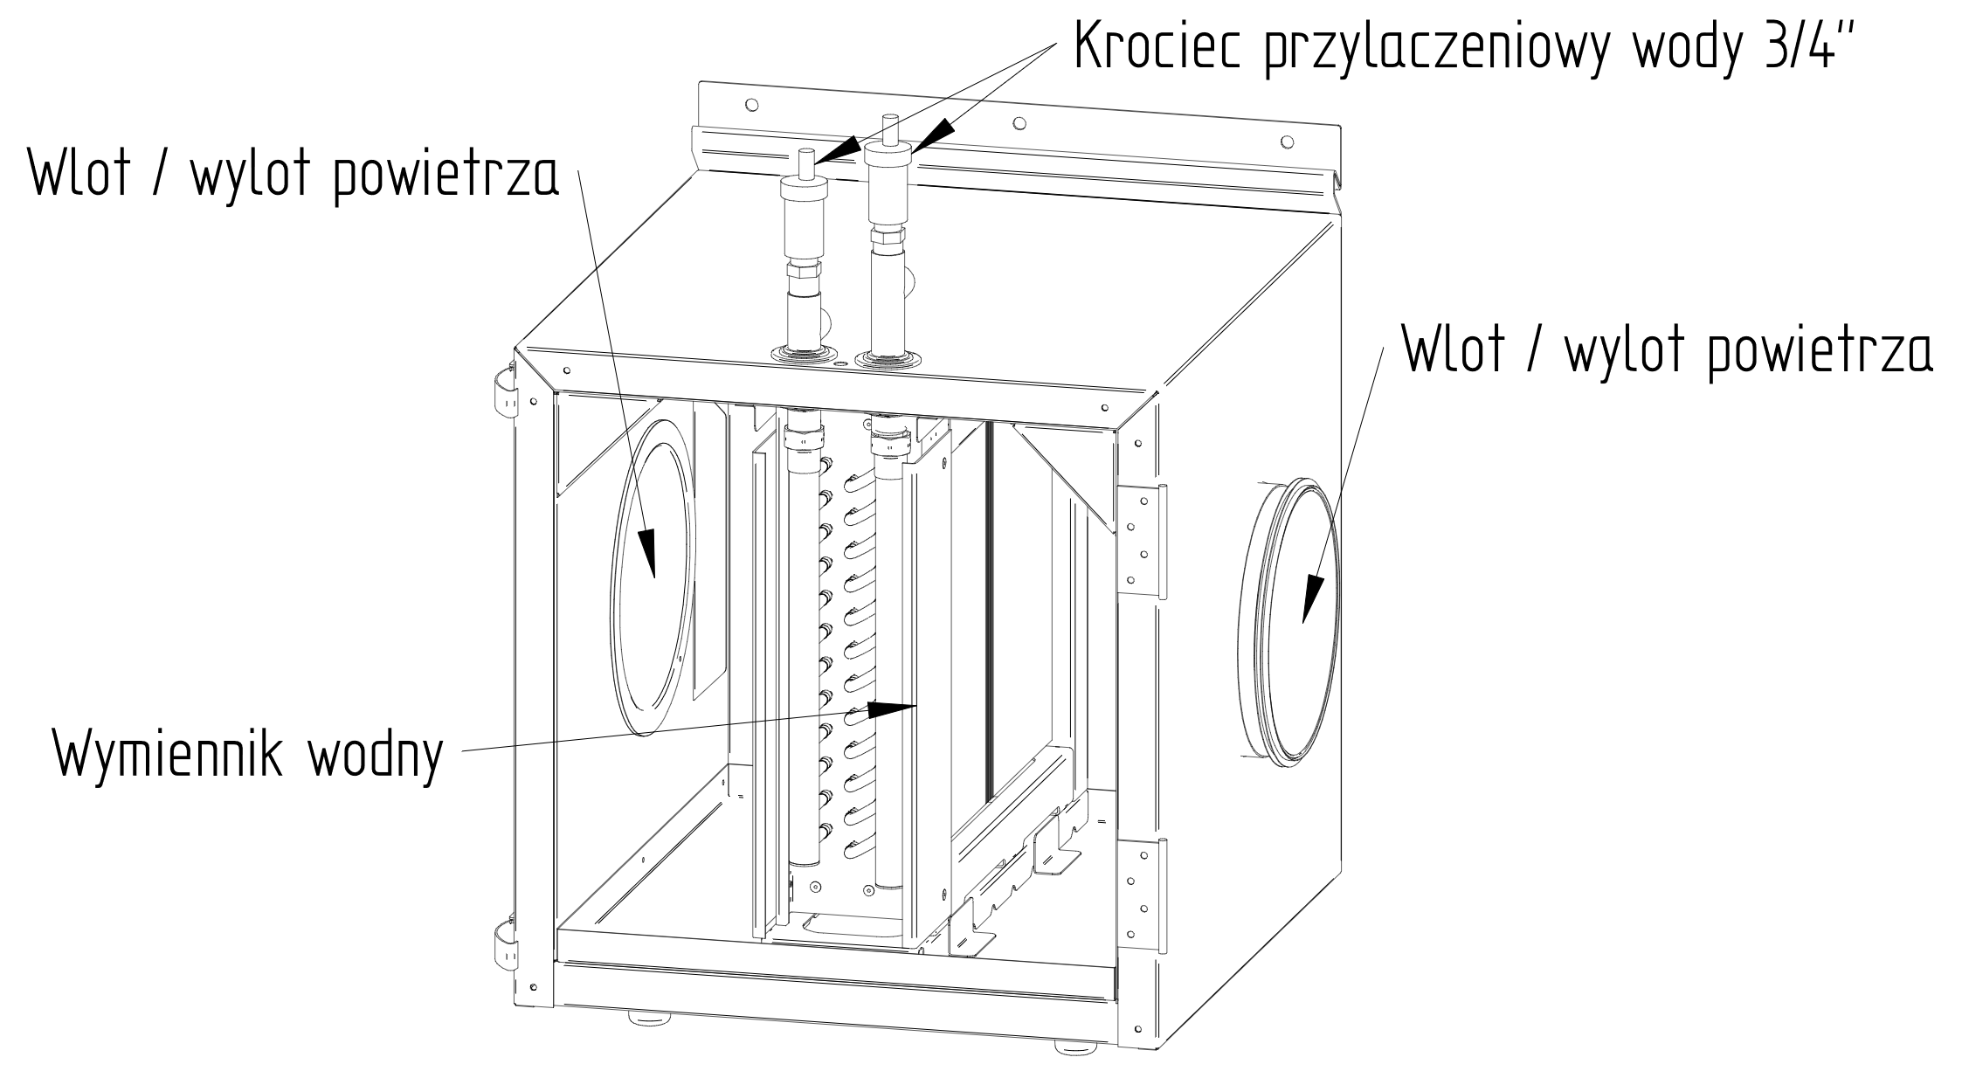

MAXI water heater/cooler
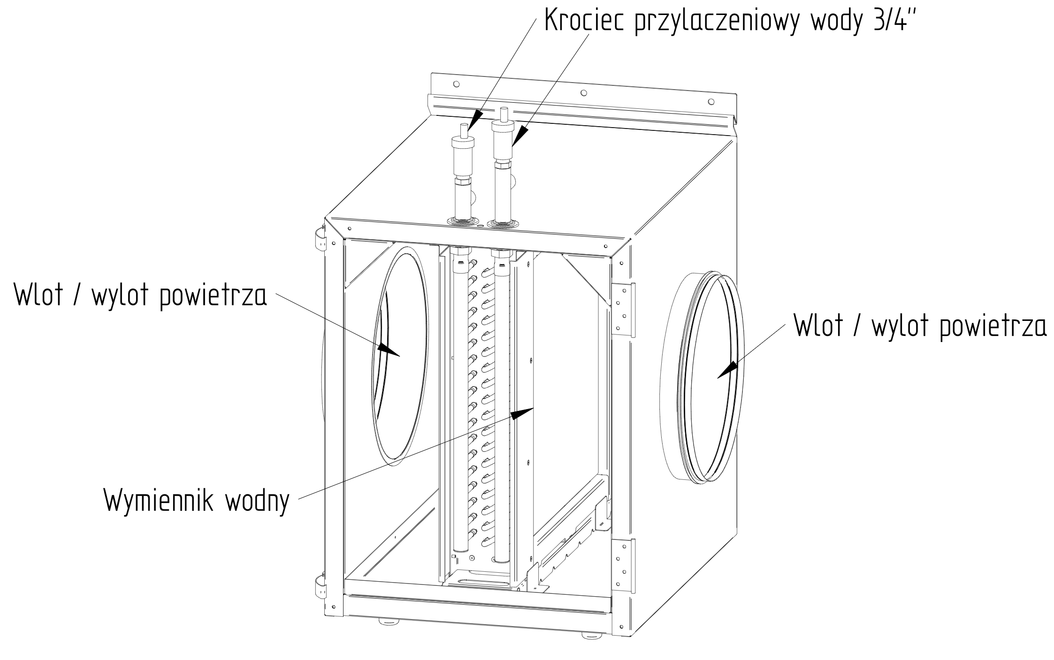

Specifications
 |  | WANAS MINI | WANAS MAXI
Recommended flow rate up to | $$\frac{m^{3}}{h}$$ | 600 | 1,300
Capacity up to | kW | 3.1 | 7.3
Power consumption | In | - | -
Weight | kg | 29.5 | 45.5
Connection layout | - | universal

Specifications for the MINI water heater/cooler

Coolant – water
COOLING FUNCTION – water medium
Air flow | Temperature before the heat exchanger | Humidity before the heat exchanger | Temperature after the heat exchanger | Humidity after the heat exchanger | Cooling capacity
[m³/h] | °C | % | °C | % | [kW]
100 | 28 | 35 | 9.6 | 93.5 | 0.7
150 | 28 | 35 | 10.8 | 90.1 | 1.0
200 | 28 | 35 | 11 | 89.4 | 1.3
250 | 28 | 35 | 11.3 | 88.5 | 1.6
300 | 28 | 35 | 11.6 | 87.5 | 1.8
350 | 28 | 35 | 11.9 | 86.5 | 2.1
400 | 28 | 35 | 12 | 85.5 | 2.3
450 | 28 | 35 | 12.6 | 84.5 | 2.5
600 | 28 | 35 | 13.3 | 82 | 3.1
HEATING FUNCTION – water medium
Air flow | Temperature before the heat exchanger | Humidity before the heat exchanger | Temperature downstream of the heat exchanger | Humidity after the heat exchanger | Heating capacity
[m³/h] | °C | % | °C | % | [kW]
100 | 18 | 50 | 39.1 | 14.7 | 0.7
150 | 18 | 50 | 37.5 | 16 | 1.0
200 | 18 | 50 | 36.3 | 17 | 1.3
250 | 18 | 50 | 35.3 | 18 | 1.5
300 | 18 | 50 | 34.8 | 18.5 | 1.7
350 | 18 | 50 | 34.6 | 18.7 | 2.0
400 | 18 | 50 | 34.3 | 19.1 | 2.2
450 | 18 | 50 | 34 | 19.4 | 2.5
654 | 18 | 50 | 33.1 | 20.4 | 3.1
For cooling: Supply water temperature 7°C. Return water temperature 8.2°C.
For heating: Supply water temperature 43°C, return water temperature 39°C.

Working fluid – 40% ethylene glycol
COOLING FUNCTION – 40% ethylene glycol
Air flow | Temperature before the heat exchanger | Humidity before the heat exchanger | Temperature after the heat exchanger | Humidity after the heat exchanger | Cooling capacity
[m³/h] | °C | % | °C | % | [kW]
100 | 28 | 35 | 8.7 | 93.8 | 0.8
150 | 28 | 35 | 10 | 90.5 | 1.1
200 | 28 | 35 | 11 | 87.6 | 1.3
250 | 28 | 35 | 11.9 | 85 | 1.5
300 | 28 | 35 | 12.6 | 82.6 | 1.7
350 | 28 | 35 | 13.2 | 80.8 | 1.9
400 | 28 | 35 | 13 | 81.5 | 2.2
450 | 28 | 35 | 13.1 | 81.1 | 2.4
600 | 28 | 35 | 13.7 | 79.4 | 3.1
HEATING FUNCTION – 40% ethylene glycol medium
Air flow | Temperature before the heat exchanger | Humidity before the heat exchanger | Temperature downstream of the heat exchanger | Humidity after the heat exchanger | Heating capacity
[m³/h] | °C | % | °C | % | [kW]
100 | 18 | 50 | 43.6 | 11.6 | 0.9
150 | 18 | 50 | 41.6 | 12.9 | 1.2
200 | 18 | 50 | 40.0 | 14 | 1.5
250 | 18 | 50 | 38.6 | 15 | 1.8
300 | 18 | 50 | 37.5 | 16 | 2.0
350 | 18 | 50 | 36.6 | 16.8 | 2.2
400 | 18 | 50 | 35.7 | 17.6 | 2.4
450 | 18 | 50 | 35 | 18.3 | 2.6
654 | 18 | 50 | 33.2 | 20.3 | 3.1
For cooling: Supply water temperature 6°C. Return water temperature 6.8°C.
For heating: Supply water temperature 49°C, return water temperature 44.5°C.

MAXI water heater/cooler specifications

Medium – water
COOLING FUNCTION – medium: water
Air flow | Temperature before the heat exchanger | Humidity before the heat exchanger | Temperature downstream of the heat exchanger | Humidity downstream of the heat exchanger | Cooling capacity
[m³/h] | °C | % | °C | % | [kW]
300 | 28 | 35 | 9.3 | 94.3 | 2.2
450 | 28 | 35 | 10 | 92.3 | 3.1
600 | 28 | 35 | 10.7 | 90.4 | 3.9
750 | 28 | 35 | 11.2 | 88.8 | 4.7
900 | 28 | 35 | 11.7 | 87.3 | 5.4
1,050 | 28 | 35 | 12.1 | 85.9 | 6.1
1,200 | 28 | 35 | 12.5 | 84.6 | 6.7
1,350 | 28 | 35 | 12.9 | 83.4 | 7.3
HEATING FUNCTION – water medium
Air flow | Temperature before the heat exchanger | Humidity before the heat exchanger | Temperature downstream of the heat exchanger | Humidity after the heat exchanger | Heating capacity
[m³/h] | °C | % | °C | % | [kW]
300 | 18 | 50 | 38.5 | 15.2 | 2.1
450 | 18 | 50 | 37.5 | 16 | 3.0
600 | 18 | 50 | 36.7 | 16.7 | 3.8
750 | 18 | 50 | 35.9 | 17.4 | 4.6
900 | 18 | 50 | 35.3 | 18 | 5.3
1,050 | 18 | 50 | 34.7 | 18.6 | 6.0
1,200 | 18 | 50 | 34.2 | 19.1 | 6.6
1,350 | 18 | 50 | 33.8 | 19.6 | 7.3
For cooling: Supply water temperature 7°C. Return water temperature 7.9°C.
For heating: Supply water temperature 43°C, return water temperature 40°C.

Working fluid – 40% ethylene glycol
COOLING FUNCTION – 40% ethylene glycol
Air flow | Temperature before the heat exchanger | Humidity before the heat exchanger | Temperature downstream of the heat exchanger | Humidity after the heat exchanger | Cooling capacity
[m³/h] | °C | % | °C | % | [kW]
300 | 28 | 35 | 10.0 | 90.3 | 2.1
450 | 28 | 35 | 11.2 | 86.8 | 2.9
600 | 28 | 35 | 11.2 | 86.9 | 3.8
750 | 28 | 35 | 11.6 | 85.6 | 4.6
900 | 28 | 35 | 12 | 84.3 | 5.4
1,050 | 28 | 35 | 12.4 | 83.1 | 6.1
1,200 | 28 | 35 | 12.8 | 81.9 | 6.7
1,350 | 28 | 35 | 13.2 | 80.7 | 7.3
HEATING FUNCTION – 40% ethylene glycol medium
Air flow | Temperature before the heat exchanger | Humidity before the heat exchanger | Temperature downstream of the heat exchanger | Humidity after the heat exchanger | Heating capacity
[m³/h] | °C | % | °C | % | [kW]
300 | 18 | 50 | 39.4 | 14.4 | 2.2
450 | 18 | 50 | 37.4 | 16.1 | 3.0
600 | 18 | 50 | 35.8 | 17.5 | 3.6
750 | 18 | 50 | 34.8 | 18.6 | 4.3
900 | 18 | 50 | 35 | 18.4 | 5.2
1,050 | 18 | 50 | 34.6 | 18.7 | 6.0
1,200 | 18 | 50 | 34.3 | 19.1 | 6.6
1,350 | 18 | 50 | 33.9 | 19.5 | 7.3
For cooling: Supply water temperature 5.9°C. Return water temperature 6.7°C.
For heating: Supply water temperature 46°C, return water temperature 42.6°C.

Function activation

Heating and cooling
This section is used for advanced configuration of the water heat exchanger. If a water heat exchanger is installed, the cooling and heating functions are activated (without a heat pump).
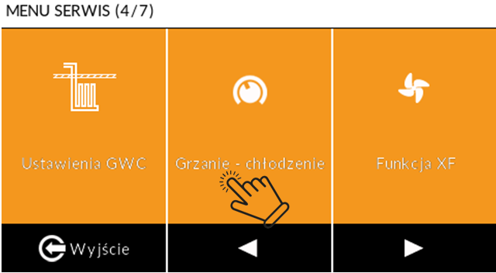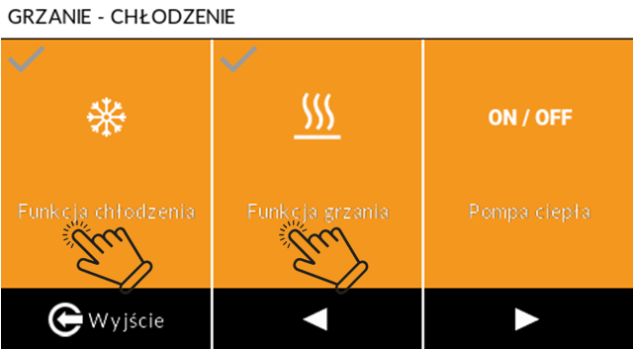
Activating these functions in the Service Menu causes the Heating and Cooling icons to appear in the user menu.
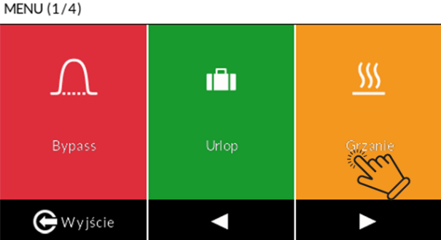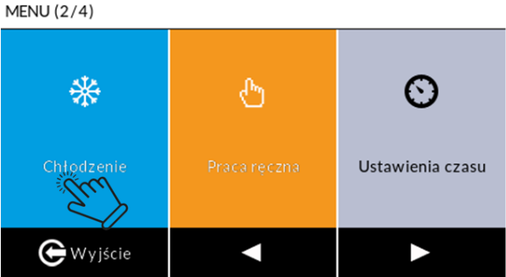
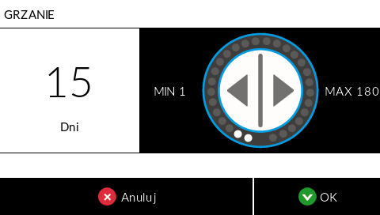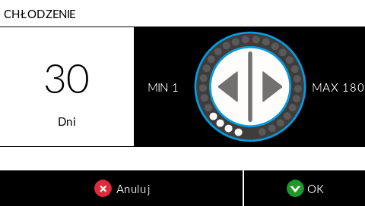
Once activated, the user can set the number of days for which the function is to remain active.
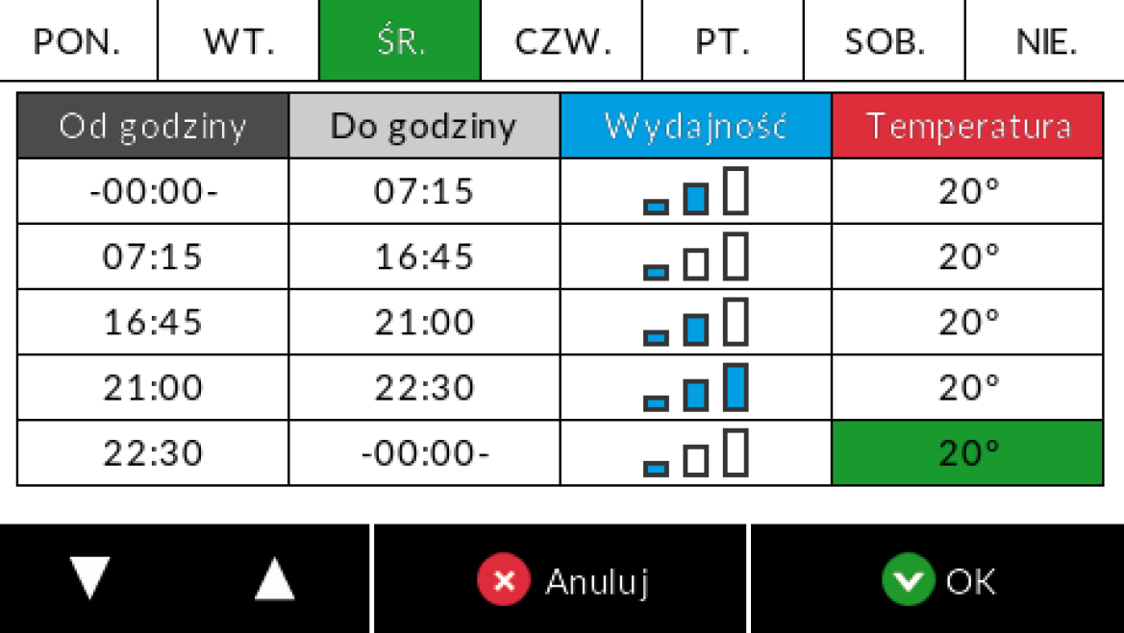 | Heating is activated when the room temperature is lower than the setting in the weekly programme.  The cooler is activated when the room temperature is higher than the setpoint in the programme menu.  NOTE: The water heater/cooler is not intended for heating the building, but only for preheating/pre-cooling the supply air. When installing the heater-cooler, an additional temperature sensor must be connected to the supply air duct one metre downstream of the heater. Connect the sensor to the EXTRA TEMP auxiliary temperature connector. Activate it in the service menu under the ‘EXTRA TEMP auxiliary sensor’ tab by selecting the ‘Supply air’ option.

GHE
The GHE function is activated in the service menu. Once the function has been activated in the service menu, its icon appears in the user menu.
The ‘GHE Settings’ section allows you to configure the temperature thresholds for the unit to automatically switch to drawing air from the Ground Heat Exchanger (GHE) instead of from the wall air intake.
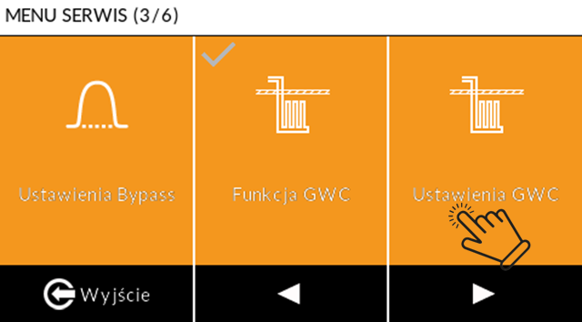
Menu Option | Purpose and Operation | Parameters and Technical Notes
Min. GHE temperature | Setting for the lower outdoor temperature threshold that activates the GWC during the winter. | The temperature below which GWC will activate.
Max. GHE temperature | Setting for the upper outdoor temperature threshold that activates GWC during the summer. | The temperature above which GWC will switch on.
Supply air fan speed adjustment for GHE | Allows the supply fan power to be increased to compensate for additional air resistance arising during airflow through the GWC. | The adjustment is set as a percentage (e.g. 0–100%). It is required if the flow resistance of the GWC differs from that of the wall air intake. The adjustment is only available when the XF function is inactive.
 | NOTE: When connecting the GHE to the main board, plug the W-1000 outdoor temperature sensor into the EXTRA TEMP connector and activate it in the Service Menu under the ‘EXTRA TEMP additional sensor’ tab by selecting the ‘Outdoor’ option. | The sensor should be positioned in a shaded area on the outside of the building, on the wall where the air intake is fitted. During the summer, when the GWC is switched on, the bypass always opens to prevent air from flowing through the heat exchanger and becoming overheated.
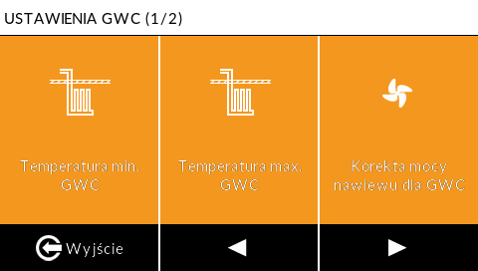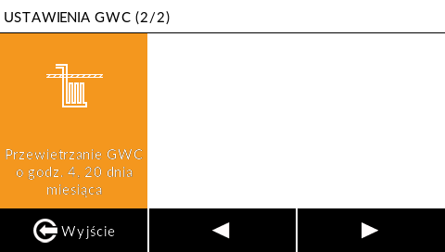
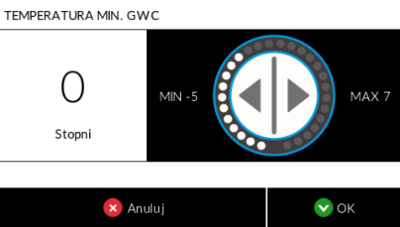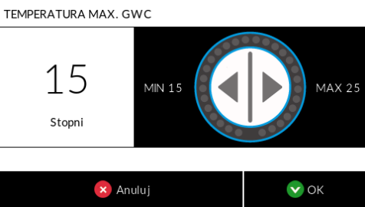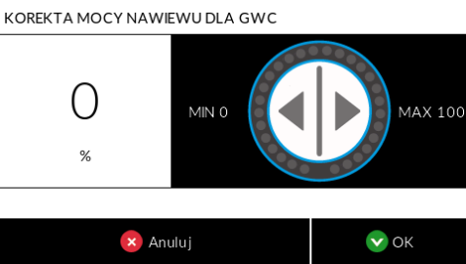

Electrical diagrams

’s wiring diagram for connecting the heater-cooler in the supply air system (heating/cooling function)
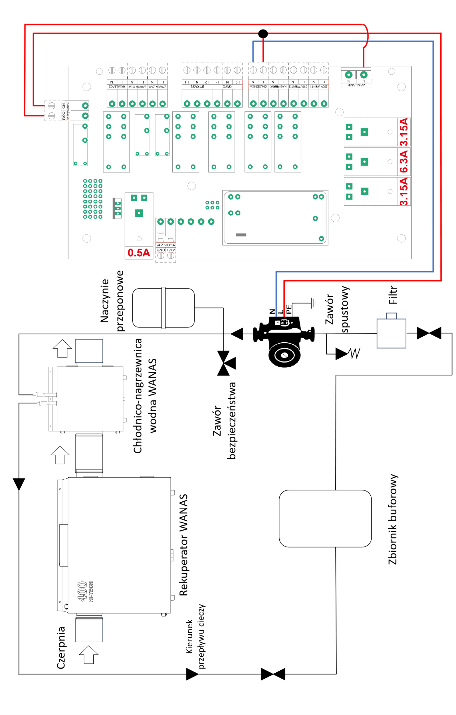

Connection diagram for the heater-cooler at the air intake – configuration with GHE
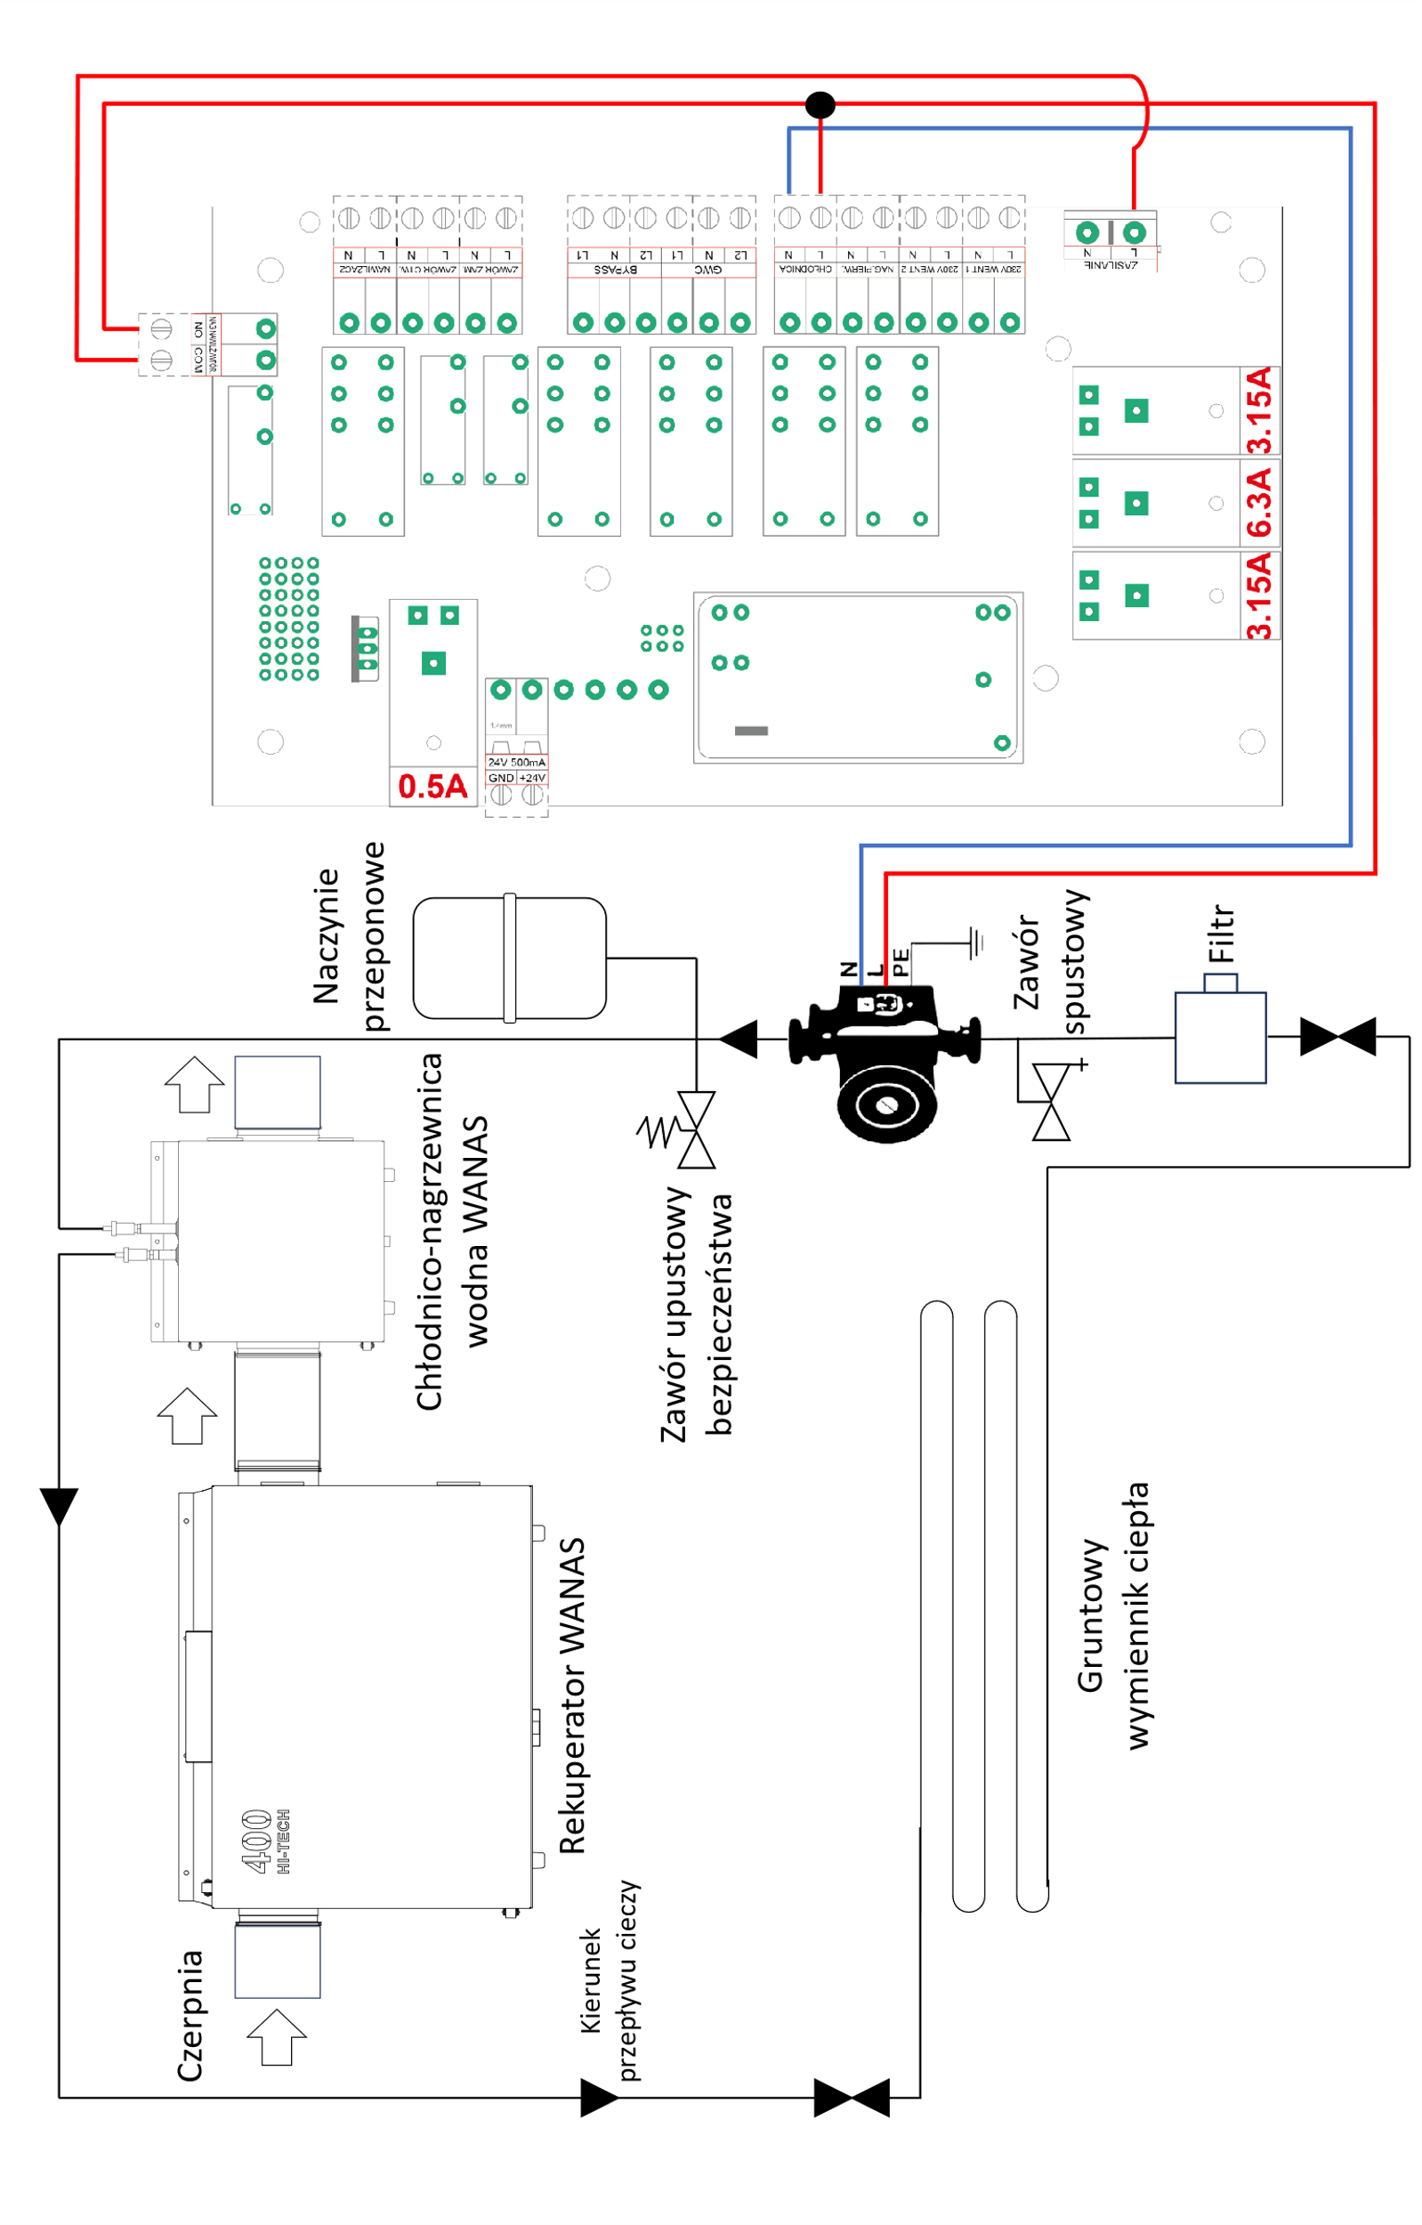
The heat exchanger, installed downstream of the heat recovery unit, is used exclusively in summer to cool the supply air entering the building.

Connection diagram for the PT-1000 or W-1000 temperature sensor
The outdoor temperature sensor is connected to the EXTRA TEMP connector.
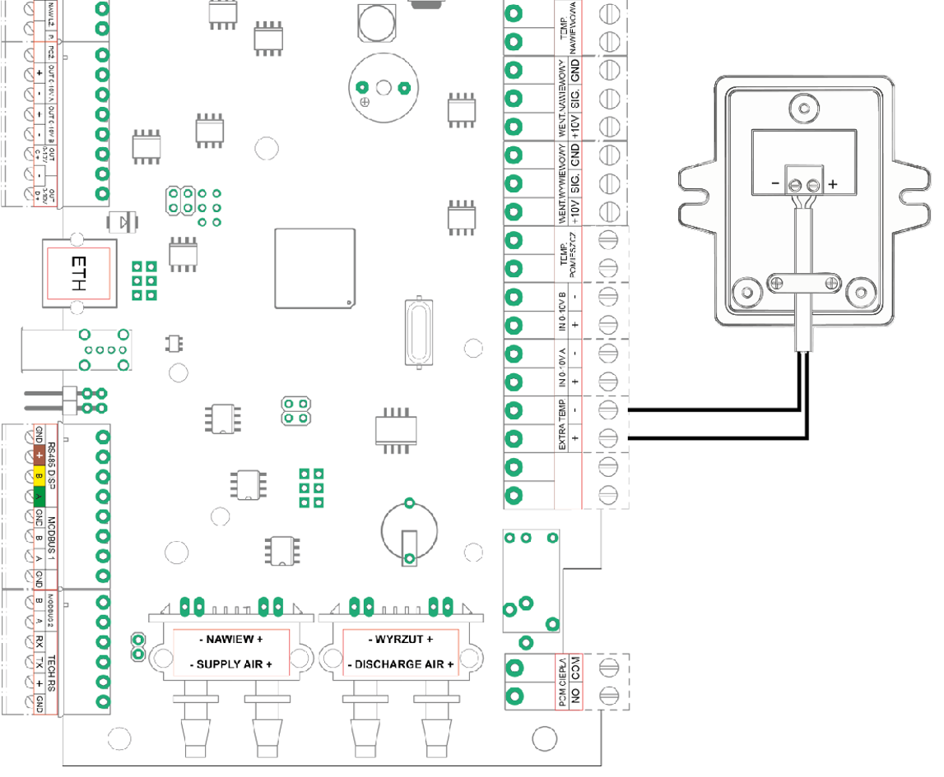

Warranty and Service

Service
All faults must be reported to WANAS with a detailed description of the problem using the ‘Service Request’ form available at www.wanas.pl under the ‘Contact’ tab. Claims made during the warranty period will be assessed within 14 days and resolved within 30 days of the date of submission.

Warranty
- The manufacturer provides a 24-month warranty covering the correct operation of the device.
- The warranty period is calculated from the date of purchase of the device by the user.
- The warranty is granted and remains valid upon presentation of the proof of purchase for the device.
- The warranty does not cover faults arising from incorrect operation, maintenance or installation of the device.
- The cost of an unjustified service call shall be borne by the customer making the claim.
- The company provides servicing throughout Poland.

Contact the service department
Tel: | +48 535 958 222
Service request | Click here

